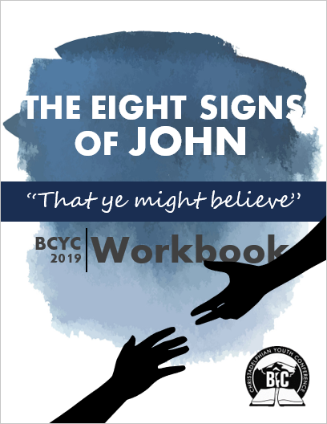
Table of Contents
Introduction
Preface for BCYC 2019 3
Bible Study Tips and Tools 5
Introduction from MYC 2006 6
Sign 1 – Water into Wine 9
Sign 2 – The Nobleman’s Son 16
Sign 3 – The Impotent Man 24
Sign 4 – The Feeding of the 5,000 31
Sign 5 – The Storm on Galilee 40
Sign 6 – The Man Born Blind 48
Sign 7 – The Raising of Lazarus 60
Sign 8 – The Great Harvest of Fish 73
Epilogue – “Written that Ye Might Believe” 84

Preface for BCYC 2019
December 2018
Dear Youth Conference Attendee,

We are so excited that you have chosen to undertake this study of the eight signs of John! This study has been very fascinating and motivating for us, so we are very glad that you get the opportunity to share in its power!

Without faith, it is impossible to please God (Heb. 11:6). Faith is required for our salvation (1 Pet. 1:9). Yet developing, maintaining, and growing our faith can be extremely difficult. We live in a world where faith in the God of the Bible is under attack from all sides, and however hard we try to remain strong, it is all too easy for doubts and fears to creep into our hearts and undermine our conviction. If you have a desire for your faith to be increased, then the Gospel of John is an ideal study for you to embark on!

In the center of the introduction to John’s Gospel, we read:

“He [Jesus] came unto his own, and his own received him not. But as many as received him, to them gave he power to become the sons of God, even to them which believe on his name.”
(John 1:11-12)

Most of the people of Israel rejected their promised messiah when he came. But there was a small group of people who did receive him, and because they did, they were given a very special status – they were called sons and daughters of God. Sadly, 2,000 years later, the majority of the people in our world still choose to reject Jesus. Today, however, we stand alongside the disciples of the 1st century as those who choose to receive him. But there is a crucial element that we need to have if we are to be given ‘power to become the sons of God’ – and that is belief in his name.

The Gospel of John is written for people who want to become the children of God. All that is written in it has been recorded for the benefit of those people. Out of the thousands of miracles Jesus performed in the three and a half years of his ministry, only eight are recorded in the Gospel of John, and they were chosen for a very specific purpose: “these [signs] are written, that ye might believe that Jesus is the Christ, the Son of God; and that believing ye might have life through his name” (John 20:31).

The reason we have chosen the Eight Signs of John as the topic for this year’s conference is that they have enormous power to generate belief in our hearts – and that belief is what enables us to become the sons and daughters of God.

The Workbook
The workbook is made up of eight sections, one for each sign, and a final summary section at the end. Each section follows the same structure:
- Reading and initial questions – Start by reading the given section and writing down at least 3 of your own questions about the reading.
- Discussion questions – This is where you do the bulk of your study. It follows the narrative of the sign with a variety of expositional and practical questions. This section always ends with a question about how faith is developed through the events of the sign.
- Conclusion questions – Summarizes the key points and lessons you took from the section.
- Further Study – Choose one of the topics provided to dig into on a deeper level on your own!

The Importance of Preparation
The discussion format at Youth Conference can be an extremely effective means of promoting the useful exchange of scriptural principles, and of encouraging one another in their application. This model depends for its success on all participants coming to Youth Conference prepared. Completion of your workbook is essential to promote profitable discussion.

Please ensure that the workbook in its entirety is completed in advance of the conference.

Going Deeper
This workbook will take you through the study of the eight signs of John, but we encourage you to go deeper in your own study. Think about the questions and expand on them. Perhaps think of your own questions and find answers to them. While it’s necessary that you complete this workbook and you will find great value in it, don’t limit your study to the workbook alone. If you are looking for more avenues to study we encourage you to work on some or all of the “Challenges from Christendom” questions in the optional appendix that can be found on the website.

The purpose of going through this workbook, as with all our Bible reading and study should be to change your life! So as you go through this study, apply the principles and lessons to your own life, and commit to effecting changes so that you can be a closer follower of our Lord and Saviour.

Recommended Resources:

Audio Class Series

- Eight Signs of John – John Martin
- Eight Signs of John – Trevor Pritchard
- Jesus: As John Saw Him – Nigel Patterson
- The Pursuit of Biblical Faith – Jason Bobis

Christadelphian Books
- Glimpses of the Master – Jason Hensley
- The Eight Signs of John – John Ullman

We would like to thank all those who were involved in producing this 2nd edition of this workbook – particularly Brother Jay Mayock, Jr., (one of the original writers) and the brethren who serve on the BCYC Committee.
It is our heartfelt prayer that as your understanding of our Lord Jesus Christ grows through your study of the eight signs of John, your faith might increase more and more until it becomes an unstoppable power for good in your life as we all await the final manifestation of the sons of God.

Your fellow Bible student, by grace,

Bro. Caleb Osborn – caleb.go98@gmail.com

This workbook was originally written for the 2006 Manitoulin Youth Conference. It has been edited and updated for BC Youth Conference 2019. For access to the original workbook, you can visit www.youthconference.com.
Bible Study Tools

Your Bible: Questions and references are from the KJV, but a few different reputable translations such as RSV or NASB or Rotherham’s would be helpful to have around to compare passages with.

Marginal References: If your Bible has marginal references, these are great resources. The Treasury of Scriptural Knowledge provides even more references.

Concordance: Strong’s, Englishman’s, and BDB. Englishman’s is particularly useful when you want to find all the places that word/number occurs and the actual English word translated in every case. Brown-Driver-Briggs Hebrew Definitions (BDB) which is used by Online Bible is also very helpful as it often gives more complete meanings.

Computer & Online tools: Bible software like Libronix, e-Sword (www.e-sword.net) or Online Bible. You can download all kinds of versions and dictionaries. Websites like www.blueletterbible.com have many resources as well.
Study Tips

Many have found the following three-step approach extremely helpful for Bible study:

Step 1 – Find the Facts; Step 2 – Establish the Principle; Step 3 – Apply the Exhortation

Following this process ensures that we first do a thorough background study (‘finding the facts’); that we then tie together these facts and from them develop spiritual principles (‘establishing the principle’); and finally that we consider how these principles apply to and affect our lives (‘applying the exhortation’).

Ask questions
Asking questions is one of the best ways to find deeper levels in Bible study. The workbook will guide you through a whole host of questions – but make sure you’re constantly asking questions of your own, and searching for the answers! Bring the fruits of your own questions with you to Youth Conference.

Balance of Personal and Group Study
Study groups are a good way to get motivated, and share lessons, insights and discoveries. They also are a fun and rewarding fellowship opportunity. Having said that, it is important that we develop the habit and skill in personal Bible Study. Be sure you have some balance in this area of your Youth Conference preparations.

Bible Marking Don’t forget to Bible mark any neat points you discover. You’re going to make some amazing discoveries – preserve them in your Bible margin!

Ask for Help! If you’re having trouble answering (or understanding!) a question, mark it and come back later. If you still are unable to make any progress, confer with a friend or ask someone for help! Feel free to contact the email on the previous page.

Pray Make sure to begin your studies in prayer.

Introduction from MYC 2006
There is one Lord, but there are four Gospels. Why?

The answer lies in the fact that each of the four Gospels tends to emphasize a different aspect of the Lord Jesus Christ and his ministry. For example, Matthew highlights Jesus’ role as king. This is apparent from the first verse of the first chapter where Jesus is shown to be in the line of David, as well as the promised seed of Abraham:

¹The book of the generation of Jesus Christ, the son of David, the son of Abraham (Matthew 1).

In contrast, Mark emphasizes Jesus as a suffering servant:

⁴⁵For even the Son of man came not to be ministered unto, but to minister, and to give his life a ransom for many (Mark 10).

Luke, on the other hand, depicts Jesus as the perfect man:

⁴⁷Now when the centurion saw what was done, he glorified God, saying, Certainly this was a righteous man (Luke 23).

The subject of our study is from the Book of John, which highlights Christ’s role as the Son of God. The unique status of our Lord is evident from the theme verse of John’s Gospel:

³¹But these are written, that ye might believe that Jesus is the Christ, the Son of God; and that believing ye might have life through his name (John 20).

Since the Gospel of John emphasizes Jesus’ role as Son of God, it is fitting that John’s narrative should be the most exalted portrayal of Jesus’ ministry. Although the Gospel of John complements the first three Gospels, it differs from them in a number of ways, so much so that Matthew, Mark, and Luke are referred to collectively as the synoptic Gospels, a term that distinguishes them from the Gospel of John.

The content of the Gospel of John suggests that it was written to Gentile believers who were familiar with the life of Jesus. John’s Gospel does not attempt to be a comprehensive retelling of the events that took place while Jesus was on the earth. Instead, only certain events are recorded, but the events in the narrative were selected so that the readers of the book might believe that Jesus was the Son of God in order that they might be saved.

The word “Believe” appears 86 times in the Gospel of John as compared to 32 times in all of the other Gospels combined. This shows that whereas the other Gospels sought to instruct people about the rudiments of Jesus’ ministry, John sought to take them to a greater spiritual understanding and to lead them to truly believe that Jesus is the Son of God.

There are only eight miracles recorded in the Gospel of John. (Luke, by contrast, has 21.) However, the text of John’s Gospel draws attention to the miracles it contains. Indeed, the word “miracles” appears nine times in John and never appears in the other Gospels. “Miracle” appears four times in John and only once in the Greek text of Mark and Luke.

The Greek word translated “miracle” in John is semeion (Strong’s Number 4592). This same Greek word is frequently translated “sign” elsewhere in the New Testament. (For example, it is translated as “sign” in 8 out of the 9 times that it appears in Luke.)

As a result, the eight miracles in John’s Gospel are frequently called the Eight Signs of John.

This term “sign” is used because these miracles are acted parables; that is, they contain lessons in symbol in addition to those given through the literal teaching of the account. This makes the study of the Eight Signs extremely profitable.

The Eight Signs of John are:

- Water into Wine – John 2: 1 – 11
- The Ruler’s Son Cured – John 4: 46 – 50
- The Impotent Man Made Whole – John 5: 1 – 15
- Feeding the 5,000 – John 6: 1 – 15
- Calming the Sea – John 6: 18 - 21
- Healing the Man Born Blind – John 9: 1 – 41
- The Raising of Lazarus – John 11: 1 – 46
- The Great Harvest of Fish – John 21: 1 – 14

Of the Eight Signs of John, the 1st, 2nd, 3rd, 6th, 7th, and 8th are unique to John’s Gospel. The 5th Sign, calming of the sea (at which time Jesus walked on water), is recorded in Matthew and Mark, and the feeding of the 5,000 (i.e., the 4th Sign) is the only miracle recorded in all four Gospels.

The Eight Signs are an integral part of the Gospel of John. They are linked to the discourses that surround them as well as to the “I am” statements of the Gospel (e.g., “I am the Bread of Life”).

There are many expositional resources that are available to you and which will help you get the most out of your studies of this wonderful subject. We particularly recommend:

- The Eight Signs of John by Bro. John Ullman; (Bro. Ullman fell asleep in the Lord while this Workbook was being completed, but he knew that the Eight Signs were the subject of the 2006 Manitoulin Youth Conference. He was delighted.)
- The Gospel of John by Bro. John Carter
- Studies in the Gospels by Bro. Harry Whittaker
- Nazareth Revisited by Bro. Robert Roberts
- “The Eight Signs of John” series in the Youth Speaks section of The Christadelphian Tidings magazine by Bro. Jay Mayock, Jr. and Bro. Ryan Mutter, which will begin December 2005 and run through the Winter, Spring, and early Summer months of 2006.
Another resource which you may find helpful (particularly for the harmony of the Gospels that it contains) is the Guide Book to the New Testament by Bro. H.P. Mansfield. Bible study is generally more profitable with Strong’s Concordance and a Bible dictionary close at hand. Both of these (as well as many other useful resources) are available online at www.biblestudytools.net.

May God guide you in your studies and bless you richly in them. We look forward to spending the 2006 Manitoulin Youth Conference with you, God willing.

In the Hope of Israel,

Bro. Jay Mayock, Jr.
Bro. Ryan Mutter

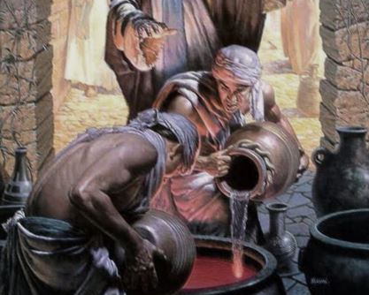

SIGN 1
Water Into Wine

The Account—John 2:1-11
SIGN 1
Water into Wine
“And the third day there was a marriage in Cana of Galilee”

QUESTIONS: List at least 3 questions that you have about the reading in the space below:

DISCUSSION QUESTIONS:

- In John 2:1, there is reference made to ‘the third day’:

  - Identify the progression of days beginning in John 1:

  - It has been suggested that ‘the third day’ that John records in 2:1 is the seventh day of his narrative to make up the first week in Jesus’ ministry. Is this sustainable?

  - Give some examples of Scripture’s use of the number three:

  - To what ideas is the number three attached in these passages?

e. Why would John use ‘the third day’ to identify the first sign that Jesus performed?

- In what city was the marriage held?

  - Which follower of Jesus was native to this city (use a concordance for help)?

  - By what name is he known in the other gospel accounts? What is the evidence for this?

  - Summarize the conversation this follower had with Jesus in John 1:

  - What event in Jacob’s life did Jesus allude to in his conversation?

  - When Jacob had this experience, what choice was he about to make?

  - How might this help us understand this follower’s role in the wedding at Cana?

- Jesus chose a wedding to begin his signs. Why do you think Jesus thought this was appropriate?

- Does Jesus’ response in John 2:4 seem unkind?

  - Give a brief description of the use of the word ‘woman’ in other parts of the gospel?

  - Do Jesus’ words in these instances seem unkind?

  - How do other translations render ‘what have I to do with thee?’

  - Where does the phrase ‘what have I to do with thee?’ appear in the Old Testament? What does the context suggest about the meaning of the phrase?

  - What point is Jesus trying to make with his mother? Where else does he make a similar point to her?

  - What is the significance of Jesus’ statement that his hour was not yet come? Where else in the book of John do we see reference to the hour of Jesus?

- Mary, the mother of Jesus, expressed confidence in our Lord when she said ‘unto the servants, Whatsoever he saith unto you, do it.’ Without knowing exactly what Jesus would do, she had faith that he would do something.

  - There are others in Scripture who were obedient to God, without knowing exactly how God would deliver them out of their situations. List and discuss one or two of them below:

  - Give a few examples of situations today where we may have to obey God’s principles without knowing what the outcome will be. What kind of faith does this require?

- Six stone waterpots ‘after the manner of the purifying of the Jews’ were used in this sign:

  - How much is a firkin?

  - Give some examples of Scripture’s use of the number six:

  - To what ideas is the number six attached in these passages?

  - What are ‘vessels’ like waterpots commonly symbolic of in Scripture? Give some examples:

  - Stone has a wide variety of meaning and application in Scripture. With what ideas do you see
‘stone’ connected in this sign?

  - Why do you think Scripture mentions that the waterpots were for the ‘purification of the Jews’?

  - Were the waterpots for drinking purposes?

- Careful reading yields the presence of two different wines, as well as water. With what ideas is each associated?

  - ‘They have no wine’—2:3

  - ‘Six waterpots of stone, after the manner of the purifying of the Jews’—2:6

  - ‘Thou hast kept the good wine until now’—2:10

- Where else in Scripture are lessons drawn from vessels? With what ideas are those passages associated, and how do they help us to better understand the message of the first sign (Try Isaiah 12 to start)?

- Where in Isaiah 29 is wine a symbol of doctrine?

- With what other ideas is wine associated in Scripture?

- Do you think that the vessels of wine represent our Lord in any capacity? Why or why not?

- Allegorically, how had the good wine been kept until the time of Jesus?

- Jesus ‘manifested forth his glory’ in this ‘beginning of miracles’:

  - How did Jesus show his glory by this first sign?

  - Study this Greek word for glory and include how it is used in John’s gospel account.

  - Moses asked the Lord to reveal His glory to him in Exodus 33:18. How did the Lord reveal His glory to Moses (see Exodus 34)?

- The signs of John were written with the express purpose of developing faith (John 20:30-31).
  - Whose faith was being developed in this sign? (2:11)

  - What do you think it was about this sign that inspired belief?

  - How can the same things strengthen your own faith?

SIGN 1 CONCLUSION
- Go back and review the questions you asked at the beginning of this section. Choose one of the questions and answer it in detail (at least one paragraph).

- What did you find most interesting from studying this sign?

- List at least 2 practical lessons you took from this sign.

- What did you learn about Jesus from this sign?
Subjects for Further Study

Choose one of the following subjects to study in detail and answer below:

- Choose another of the questions you asked at the beginning of this sign and answer it in detail.

- Study Discussion Question 3 in more detail. Include comments on the following:

  - The institution and purpose of marriage
  - The responsibility of marriage and shadow
  - The prayer of Jesus (John 17)
  - Some parables of marriage used by Jesus
  - The marriage supper of the Lamb
  - Marriage to our Lord—what it means to us as believers

- The first sign took place close to the time of Passover (John 2:12,13,23-25). The Passover, and the historical events around which the first Passover took place, is a theme seen throughout the New Testament. Study the Passover in more detail, and include comments on the following:

  - The institution of the Passover
  - The occurrence of the first Passover
  - The events following the Passover
  - NT references and echoes to the Passover
  - The relationship of the song of Moses to the Passover
  - Miracles of Jesus performed near the time of Passover
  - The Passover and our Lord—what it means to us as believers

- John the Baptist publicly declared Jesus as “the Lamb of God” (John 1:29). If John believed this, why did he send two of his disciples to Jesus to ask him if he was the one “that should come” (Luke 7:19-23)?

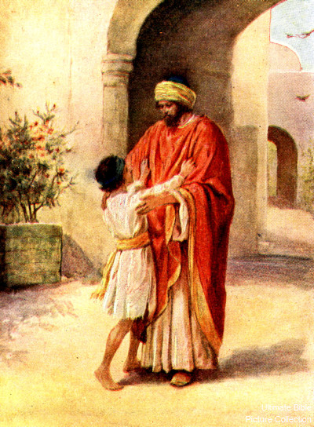
SIGN 2
The Nobleman’s Son

The Account—John 4:43-54
“There was a certain nobleman, whose son was sick at Capernaum”

QUESTIONS: List at least 3 questions that you have about the reading in the space below:

DISCUSSION QUESTIONS:

- Jesus spent two days in Sychar, a city of Samaria, before departing (John 4:39-40).

  - What in particular was significant about Sychar?

  - Who were the Samaritans? Where did they come from? Were they Jews or Gentiles? Explain:

  - From what region was Jesus traveling when he arrived in Samaria?

  - To what region was Jesus traveling when he stopped in Samaria?

  - Why do you think the text says that Jesus ‘must needs go through Samaria’?

- ‘Jesus himself testified, that a prophet hath no honour in his own country,’ but he returns to his own country—Galilee. How does this verse make sense despite its apparent contradiction?

- Why was Jesus well received in Galilee?

- Why are no details provided of Jesus’ Judean miracles? (John 2:23; 3:2; 4:45)

- Where are the disciples? Are they mentioned in this sign?

- Where does this sign fall in the chronology of Jesus’ ministry?

- After his first sign at Cana, Jesus visited Jerusalem for passover. He then traveled back down to Cana where he met the nobleman from Capernaum.

  - Why do you think Jesus returned to Cana, having already performed a sign there?

  - What kind of response would Jesus be seeking from the people?

- Study the Greek word for nobleman:

  - What does the word mean?

  - To which king would this nobleman be subject? (A Bible dictionary may be helpful.)

  - This king had a steward whose wife ‘ministered to him [Jesus] of their substance.’

    - Where are their names recorded in the gospels?

    - What evidence do we have this man could be the nobleman of John 4?

- From what city does the nobleman come to Jesus?

  - To what city does the nobleman travel to see Jesus?

  - How far did this man have to travel?

  - Why did the nobleman want Jesus to come with him to Capernaum to heal his son?

- Compare the initial attitude of the nobleman to that of the Samaritans. What signs and wonders had Jesus performed to convince them?

- When the nobleman ‘besought’ Jesus for help, Jesus said ‘Except ye see signs and wonders, ye will not believe.’

  - Does this response seem harsh?

  - Are there any other instances when Jesus challenges people in a similar way? Explain.

  - Respond to this statement: ‘Jesus was attempting to increase the nobleman’s faith, by lifting his thoughts beyond his mere power to heal.’

- Identify the nobleman’s progression of faith from his dialog with the Lord. How can we measure the nobleman’s faith through each of his reactions?

  - He ‘besought’ Jesus ‘that he would come down, and heal his son.’

  - ‘Sir, come down, ere my child die.’

  - ‘And the man believed the word that Jesus had spoken unto him, and he went his way.’

  - ‘Then enquired he of them the hour when he began to amend. And they said unto him, Yesterday at the seventh hour the fever left him. So the father knew that it was at the same hour, in the which Jesus said unto him, Thy son liveth: and himself believed, and his whole house.’

- This sign was Jesus’ answer to the nobleman’s request in verse 47:

  - How was the nobleman’s petition answered?

  - How was the nobleman’s petition not answered in the way he had initially hoped?

  - How was Jesus’ answer better than the nobleman’s hopes?

  - Sometimes God’s answer to our problem or need comes in a way that we don’t expect and didn’t ask for.
    - Discuss at least one other Scriptural example where a petition was answered an unexpected way:

    - What does these examples tell us about the kinds of prayers and petitions we make and what our attitude should be in making them?

    - What does these examples teach us about the answers and solutions God may give to our problems and needs?

- 1 Corinthians 1:22-23 speaks about the barriers of faith to the Jews and Gentiles respectively. What are they?

  - How can we be affected by these barriers today?

  - What are some practical ways we can overcome those barriers to our faith?

- Identify times in Scripture in which faith is demonstrated imperfectly:

- Discuss a moment in your life in which your faith had to grow:

- Name some other miracles that Jesus performed from a distance? Were these people Jews or Gentiles? Why might this be significant?

- John marks this as the second sign.

  - Jesus performed many miracles in Jerusalem before this sign, but they are not included in John’s numbering. Why might this be? What was the purpose of the signs that John records?

  - Give some examples of Scripture’s use of the number two:

  - To what ideas is the number two attached in these passages?

- The nobleman’s son was healed in the seventh hour:

  - When is the seventh hour?

  - Is this a Jewish or Roman measurement of time?

  - What spiritual significance can be attached to this fact?

- The nobleman’s son was ‘at the point of death.’

  - In spiritual language, what moral condition is being described? Explain.

  - In which other miracle(s) is someone ‘ready to die’?

  - Which ecclesia is warned to ‘strengthen the things which remain, that are ready to die’?

  - How did the Jews have a name that they lived, but were dead?

  - How can we have a name that we live, but in reality be spiritually dead?

- The nobleman’s whole house believes as a result of this sign:

  - What can we infer about the nobleman from his household’s belief?

  - Where else in the NT do we see a similar reaction to the truth?

  - Where else in the NT do we see an opposite reaction to the truth?

- The Jewish leaders are sometimes called ‘fathers’.

  - Find a few Scriptures that show this:

  - Though most Jewish leaders rejected, some demonstrated belief in Jesus despite being encumbered with their doubt and misunderstandings. List some examples of these leaders:

- Do we know for sure whether the nobleman was a Jew or a Gentile? Explain.

- Being a resident of Capernaum:

  - What other works of Jesus might this nobleman have witnessed?

  - Do you think the nobleman’s son ever met Jesus?

- What evidence do we have to support the idea that Capernaum was the base of Jesus’ operations in Galilee?

- The text is emphatic when it reads ‘this is again the second miracle that Jesus did, when he was come out of Judea into Galilee.’

  - Does Scripture connect Galilee to the Gentiles in any passages?

  - What OT prophecies predict this Galilean enlightenment?

- Whose faith was being developed in this sign (v. 50,53)?

  - What do you think it was about this sign that inspired belief?

  - How can the same things strengthen your own faith?

- SIGN 2 CONCLUSION
  - Go back and review the questions you asked at the beginning of this section. Choose one of the questions and answer it in detail (at least one paragraph).

  - What did you find most interesting from studying this sign?

  - List at least 2 practical lessons you took from this sign.

  - What did you learn about Jesus from this sign?

Subjects for Further Study

Choose one of the following subjects to study in detail and answer below:

- Choose another of the questions you asked at the beginning of this sign and answer it in detail.

- Study DISCUSSION QUESTION 16 in more detail. Include comments on the following:

  - How this experience helped you:
  - How this experience can help other people:

- Study DISCUSSION QUESTION 1a in more detail. Include comments on the following:

  - What does Sychar mean in Greek?
  - What is significant about the place ‘near to the parcel of ground that Jacob gave to his son Joseph’?
  - What OT city did Jacob give to Joseph?
  - How does that city factor into the history of the nation of Israel?
  - How do the events in John 4 relate to the prophetic blessing that Joseph received from Israel on his deathbed?

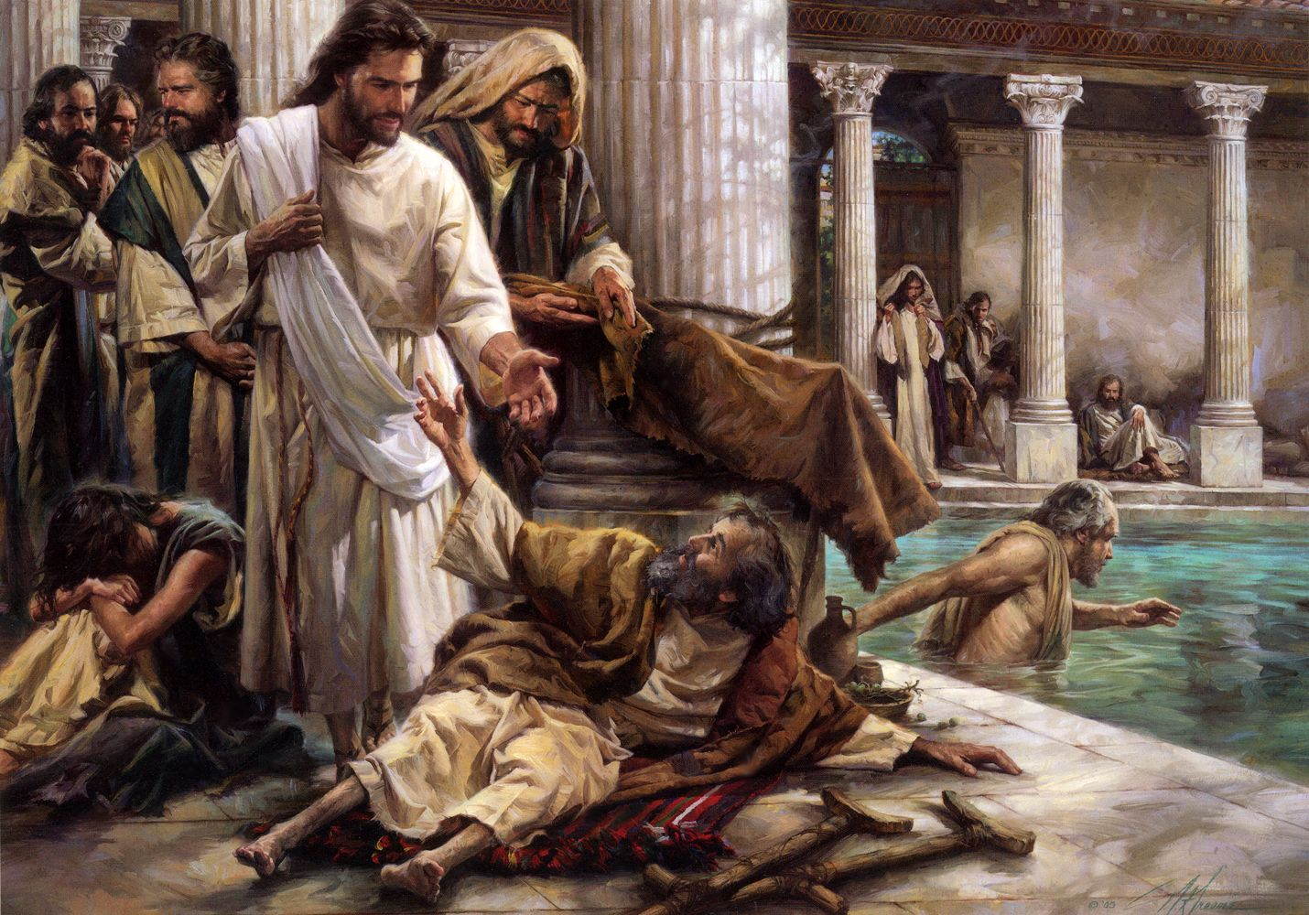

SIGN 3
The Impotent Man

The Account—John 5:1-16
“And a certain man was there, which had an infirmity thirty and eight years”

QUESTIONS: List 3 questions that you have about the reading in the space below:

DISCUSSION QUESTIONS:

- In John 5:1, there is reference made to ‘a feast of the Jews.’

  - Of which Jewish feast do you think this passage speaks?

  - Where else in John’s gospel are these time details given?

  - Why do you think it is called the feast “of the Jews”

- In Jerusalem there was a ‘sheep market’, as the AV calls it:

  - What was this ‘sheep market’?

  - Where does Nehemiah place the ‘sheep gate’?

- The pool by the ‘sheep market’ was called ‘Bethesda:’

  - What does Bethesda mean in its original tongue?

  - What are some suggestions as to the location of Bethesda?

- There were five porches at this location:

  - Give some examples of Scripture’s use of the number five:

  - To what ideas is the number five attached in theses passages?

  - What do you think the number five signifies here?

- Present at Bethesda was a multitude of impotent, blind, halt, and withered, waiting to be healed by the troubled water. Describe the maladies of the multitude, and discuss in what ways they can represent spiritual infirmities:

  - Impotent:

  - Blind:

  - Halt:

  - Withered:

- The infirmed man had been ill for ‘a long time’:

  - For how many years was the man infirmed?

  - Where in the history of Israel was this number significant?
  - Describe the context

- Jesus commanded the man to ‘rise’:

  - Where else does Jesus command others he healed to do the same? (Search using the same Greek word for ‘rise’.)

  - How can this command be taken allegorically?

- Jesus healed the infirmed man on the sabbath day. In order to avoid conflict, Jesus could have healed the man on any other day (his illness was not fatal), but he chose the sabbath:

  - Did the law prohibit the carrying of a bed on the sabbath?

  - Did Jesus break the sabbath?

  - Find other examples of Jesus healing or ‘working’ on the sabbath:

  - Why do you think Jesus healed on the sabbath?

- In v10-16, the Jews are more interested in the sabbath regimen than the healing that Jesus worked on it:

  - Where else can we find similar reactions from the leaders of the Jews?

  - What does this tell us about their character?

  - How can we fall into the same condemnation?

- If the healed man remained in his sins, a worse thing would come unto him (v.14):

  - Where else in Scripture is a ‘worse’ state described after a healing?

  - What is that ‘worse thing’?

  - How is it possible for us to fall into the same condemnation?

- How is the command ‘sin no more’ (v14) related to Jesus’ command to ‘rise’ (v8)?

- Did the healed man go to the temple to:

  - worship God who had healed him? Or (b.) find favor in the eyes of the Jews who had reprimanded him (v10)?

- Explain how Jesus’ words: ‘Behold, thou art made whole: sin no more, lest a worse thing come unto thee’ are:

  - An expression of mercy:

  - A warning to repent:

- In Jesus’ discourse to the Jews following the miracle, what doctrine does he emphasize?

- How is it fitting that Jesus would emphasize this doctrine after healing the infirmed man?

- ‘The hour is coming’ and ‘the hour is coming and now is’ are two phrases used by our Lord in John 5:

  - Identify where these phrases are in John 5:

  - To what ‘hour’ does Jesus refer in each use of the phrase?

  - Identify other places these phrases are used in John’s gospel:

- In v17-31, Jesus spoke about the two phases of our transformation:

  - What are these two phases of our transformation—one which ‘is coming and now is’, and the other which ‘is coming’?

  - What other passages speak of a transformation in the days of our mortality?

  - What other passages speak of a transformation in the age to come?

- The infirmed man was painfully aware of his own weakness:
  - Provide some examples of people who were made strong in their weakness:

  - Why is this understanding so essential in our collective walk to the kingdom?

- There is a remarkable parallel between the 3rd sign and the generation of Israelites that wandered for 38 years in the wilderness. Complete the table below (the first one is done for you, and there is space at the bottom for any more parallels you can find).

Impotent Man of John 6 | Israel in the Wilderness
v.5 Infirmity for 38 years | Deut. 2:14 Wasted away in the wilderness 38 years
v.6-7 | Heb. 3:18-19
v.3,6 | Deut. 7:6-9
v.8 | Deut. 2:25

- Whose faith do you think was being developed in this sign?

  - What do you think it was about this sign that inspired belief?

  - How can the same things strengthen your own faith?

- SIGN 3 CONCLUSION
  - Go back and review the questions you asked at the beginning of this section. Choose one of the questions and answer it in detail (at least one paragraph).

  - What did you find most interesting from studying this sign?

  - List at least 2 practical lessons you took from this sign.

  - What did you learn about Jesus from this sign?

Subjects for Further Study

Choose one of the following subjects to study in detail and answer below:

- Choose another of the questions you asked at the beginning of this sign and answer it in detail.

- In John 5:6, Jesus asks the impotent man, ‘Wilt thou be made whole?’

  - Why do you think Jesus asked this?
  - Are there other instances in Jesus’ life in which he asked similar questions—the answers to which seemed obvious? Why did he ask such obvious questions?

- There is some debate over the character of the healed man in John 5. Some believe that he is an example of a good conversion, and others of a betrayal.

  - Do some research and identify this debate.
  - How do you see the infirmed man?

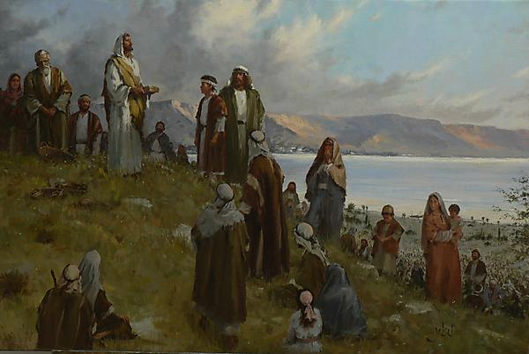

SIGN 4
Feeding the 5,000

The Account—John 6:1-14
“So the men sat down, in number about five thousand”

QUESTIONS: List 3 questions that you have about the reading in the space below:

DISCUSSION QUESTIONS:

- Identify where this account appears in the records of the other gospel writers:

- According to the other gospel accounts, who was murdered just before the fourth sign?

- What evidence is there to suggest that this event brought the thought of Jesus’ own sufferings to bear?

- Why do you think Jesus and the disciples departed into a desert place apart from everyone else?

- Do you think Jesus’ departure had anything to do with the death with which they were dealing?

- How was their retreat into a desert place cut short?

- How did the disciples respond?

- How did Jesus respond?

- How is Jesus’ response an exhortation for us?

- Jesus asked, ‘Whence shall we buy bread that these may eat?’

  - Why did Jesus ask this question if ‘he himself knew what he would do’?

  - Where else in the gospels does Jesus ask a question, the answer to which he already has? Why do you think Jesus does this?

- Phillip answers Jesus’ question in verse 7.
  - Describe his response. Does he have a good solution for the need of the people?

  - Look up the Greek word for “sufficient” in verse 7. Where else does Phillip use the same word?

  - Comment on Phillip’s use of this word in both passages. What could both contexts reveal about Phillip’s character, or what Christ was trying to teach him?

  - The best solution Phillip could come up with for the problem was “not sufficient”. The word for “sufficient” is used in 2 Cor. 12:9. Compare this verse to the context of the 4th sign in John 6, and comment on its significance.

  - What lesson can you learn from this interaction between Jesus and Phillip?

- During what season did this sign take place?

- Which feast of the Jews was nigh?

- A lad among the multitude had with him five barley loaves and two small fish:

  - Give some examples of Scripture’s use of the number five: (See Sign 3:4a)

  - To what ideas is the number five attached in these passages? (See Sign 3:4b)

  - Give some examples of Scripture’s use of the number two:

  - To what ideas is the number two attached in these passages?

- Why is John careful to record that the five loaves were of barley? Consider other scriptural examples where barley is found.

- According to other gospel accounts, how did Jesus have the men seated in this area of ‘much green grass’?

- Why is ‘much green grass’ an appropriate detail to record as so many people were present? In other words, what does grass represent in the Biblical system of symbol?

- Why do you think it is significant that 5000 men (beside women and children) were present for this sign?

- Read verses 22-71 of John 6:

  - How do these verses help us to understand the meaning of the miracle?

  - What was Jesus expressing to the multitude in symbol the day before?

- How does the fourth sign foreshadow the events in the last supper? In what way is the procedure and language similar? Find at least 4 ways in which these events are similar:

- What significance do you attribute to Jesus’ words in verse 12? Can you find similar language used in his discourse to the multitude in Capernaum the next day that would suggest a deep significance to these words?

- Twelve baskets were filled with the fragments of the bread after all were filled:

  - Why do you think that the Spirit by John records the number of the baskets?

  - Why do you think it is significant that the bread filled them all?

- Jesus declared himself to be ‘the bread of life’ (v35) and ‘the true bread from heaven’ (v32):

  - What was the ‘bread from heaven’ for which the multitude lusted?

  - What is manna called in Exodus 16:7? How is this significant when we come to the NT declaration of the true bread from heaven?

- Jesus used ‘the true bread from heaven’ and ‘the bread of God’ interchangeably (v32,33):

  - Where is ‘the bread of God’ found in the Old Testament?

  - What does it signify?

  - Who could eat it?

  - Who did Jesus say could eat the bread of God now?

- Why do you think the institution of Jesus’ memorial in bread and wine is not included among John’s detailed account of the night before Jesus was betrayed?

- Jesus declares himself to be the Son of man and the giver of everlasting life (v27)—from which OT passage(s) did Jesus refer to?

- Do you get the impression that the language Jesus used made it more difficult for the multitude to accept his words? Explain.

- Jesus said that his Father had ‘sealed’ him:

  - Where else in Scripture does this word occur?

  - What does this word mean in those contexts?

  - What do you think Jesus was saying when he spoke of God sealing him?

- Summarize the key points of this miracle, and express the significance of it as Jesus did in his discourse to the multitude:

- This is the fourth sign: Do you think this number is expressive of any significance within the framework of this miracle?

- What did Jesus mean when he said ‘whoso eateth my flesh, and drinketh my blood, hath eternal life’?

- Does the bread represent the Word? If so, how?

- How does Jesus emphasize the word of God as the meat for eternal life?

- Does the bread also represent us? If so, how?

- How is it possible for us to stumble in the same ways that the Jews stumbled at the words of Christ?

- Did the disciples understand his words? How do you know?

- How did the various disciples cope with their perception of Jesus’ difficult words?

- How can we today draw practical comfort and warning from their experiences?

- Whose faith do you think was being developed in this sign?

  - What do you think it was about this sign that inspired belief?

  - How can the same things strengthen your own faith?

- SIGN 4 CONCLUSION
  - Go back and review the questions you asked at the beginning of this section. Choose one of the questions and answer it in detail (at least one paragraph).

  - What did you find most interesting from studying this sign?

  - List at least 2 practical lessons you took from this sign.

  - What did you learn about Jesus from this sign?

Subjects for Further Study:

Choose at least one of the following subjects to study in detail and attach your notes to the workbook:

- Choose another of the questions you asked at the beginning of this sign and answer it in detail.

- John 6:14-15 records the immediate effect of the miracle on the multitude. What did they think? Why did Jesus depart to be alone? Why does Mark 6:45 say that Jesus forced his disciples into the boat? Why had their hearts been hardened ‘for they considered not the miracle of the loaves’ (Mark 6:52)?

- John 6:45 records Jesus’ words quoting from the prophets in which it is said that ‘they shall be all taught of God’. Where is this passage? How does the context of that chapter (and those following) have much to do with the events at this time in Jesus’ ministry?

- Study DISCUSSION QUESTION 28 in more detail. In particular, how might it relate to the events in Isaiah 8?

- Consider Peter’s response to Jesus (v66-71). Did Peter understand what Jesus was saying in his address to the multitude? If so, how do you know? If not, why did Peter and the eleven continue with Jesus? Does this relate to our walk to the kingdom, or does our present knowledge exempt us from such trials?

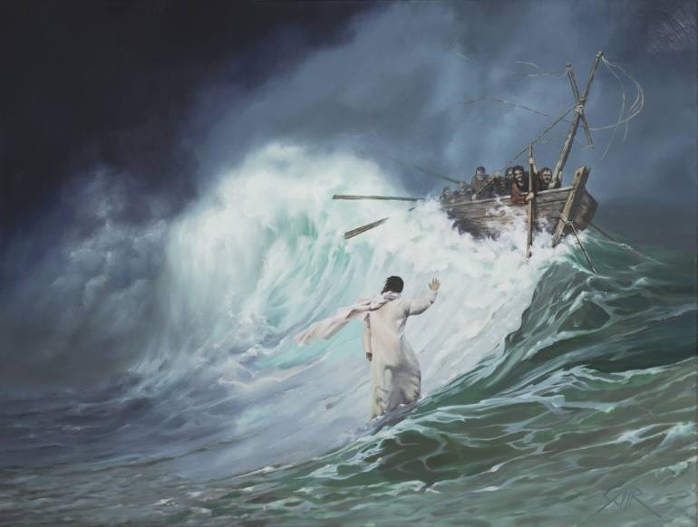

SIGN 5
The Storm on Galilee

The Account—John 6:15-21
“And it was now dark, and Jesus was not come to them.”

The events of John 6 occurred over a two-day period. During that short time, Jesus healed many sick people and performed two of his most notable miracles, the feeding of the 5,000 and walking on water. Like the other signs, the miracles recorded in this chapter contain lessons in symbol. The feeding of the 5,000, which is the fourth sign, is the only miracle recorded in all four Gospels. As such, it is a fitting symbol for Christ’s earthly ministry. Christ’s calming of the sea, which is the fifth sign, is symbolic of the time after Christ’s ascension, the time when he is no longer with his disciples, and they struggle in his absence. Its lessons, therefore, are of particular interest to us, as we weather life’s storms and await our Master’s coming.

QUESTIONS: List 3 questions you have about the reading in the space below:

DISCUSSION QUESTIONS:

- The Multitude’s Reaction:

After Jesus miraculously provided food to the multitude during the fourth sign, the people wanted to make him king. The reasons behind the multitude’s desire (and Christ’s reaction to them) teach us a great deal about spiritual thinking.

  - Why did Jesus not want the people to make him king at that time?

  - How did Jesus respond to the people’s desire to make him king? Why did he do this?

- The Disciples’ Reaction:

The multitude’s reaction to the feeding of the 5,000 is clearly stated: they wanted to make Jesus king, and they were prepared to use force to have their way. The disciples’ reaction is not as clearly stated, but it can still be determined.

  - Did Christ bring the disciples with him?

  - Mark 6:45 – 52 is a “parallel account;” that is, it tells the same story but with slightly different details. What does Mark 6:45 say Christ did with the disciples?

  - In the KJV, Mark 6:45 uses the word “constrained” when describing what Jesus did. What does this imply about the disciples’ attitude about the people’s wish to make Christ king?

  - Who did Christ seek to please, God or man? What do Psalm 16:8 and Psalm 73:25 say about how he did this?

- Light and Dark:

  - Where in John 6 does it first say what time it was when Christ put the disciples in the boat? What time was it?

  - This point is really emphasized. There is another verse in John 6 that indicates what time it was when Christ put the disciples in the boat. What is the verse? What does it say?

  - The concepts of “light” and “darkness” are important themes in the Gospel of John. Using a concordance, find and list the different occasions where “the light” is mentioned:

  - What does “light” represent in John?

  - What does “darkness” represent?

- The Journey Begins:

  - What does John 6 say the disciples’ destination was?

  - What does the name of the city mean?

  - Read Hebrews 11:9 – 10. What does the city represent there?

  - What might the city in John 6 represent?

- The Storm:

  - According to the parallel account in Matthew 14 (starting at verse 22), what became of the sea while the disciples were in the boat?

  - The sea is used as a symbol in Isaiah. What does it represent (use a concordance and look up “sea” and “seas” for help.)

  - Waters are used as a symbol in Revelation 17: 15. What do they represent?

  - The wind is used as a symbol in the New Testament. What does it represent in James?
\

  - What else does the wind represent in the New Testament. Provide at least one example.

  - The storm prevented the disciples from using their sails, so they had to row. What lessons can you take from the picture of the disciples rowing together in the storm?

- Meanwhile, Jesus:
  - Consider Mark 6:48. Was Jesus aware of what was going on with the disciples in the boat?

  - Is Jesus aware of the difficulties we face in the storms of life? Find some verses to support your answer.

  - How can this help you in your times of difficulty? Discuss.

  - Why do you think Jesus didn’t come immediately to the disciples’ aid, considering your answer to 5g?

- Jesus Appears
  - How far does John say the disciples rowed?

  - Where does Matthew say this put them?

  - During which watch did Jesus come to the disciples?

  - During which watch does the sun rise?

  - What does the Bible symbol of the rising sun represent? (Using a concordance, look up words like “sun,” “arise,” and “shine.”)

  - How did Christ appear to his disciples?

  - How did they respond?

  - Why is it significant that Jesus walked on water?

- Peter:

  - How did Jesus identify himself to the disciples?

  - What request did Peter make of Jesus in Matthew’s account?

  - How did Christ react to Peter’s request?

  - Did Christ approve or disapprove of Peter’s request? Support your answer.

  - Identify another time in Peter’s life when he acted in a similar fashion. (Hint: There is a great instance in the last chapter of the Gospel of John.)

  - What lessons can we learn that we can apply to our own lives from what happened with Peter in Matthew 14:28 – 31?

  - Jesus allowed the disciples to struggle for hours against the storm, but he rescued Peter immediately. Why? What does this teach us about how Jesus oversees our trials?

  - The events of John 6:22 – 71 happened the next day. Read John 6:51 – 71. What did the disciples, other than the Twelve, do?

  - What did Peter say about Christ’s words? In contrast, what had the people said about Christ’s words?

  - How might have Peter’s experience of trying to walk on water, failing, and then being rescued by Christ caused him to be so enthusiastic in his support of Christ?

It is significant that Peter chose to use the word “we” in his confession. There was no self-serving “I” or “me” in his remarks. Instead, he choose to identify with the others (i.e., “we believe”) and in so doing, he might have helped to shore up the faith of those disciples who might have been struggling. His words helped mold them into a unit. Although the disciples sometimes squabbled, Peter encouraged them then by affirming that they would follow Jesus together.

- Calming the Sea:

  - What happened when Jesus entered the ship?

  - Thinking back to the symbolic meaning of the sea, what might this represent?

  - Read Psalm 107:23 – 31. Discuss the parallels to events in the fifth sign of John.

- Whose faith do you think was being developed in this sign?

  - What do you think it was about this sign that inspired belief?

  - How can the same things strengthen your own faith?7

- SIGN 5 CONCLUSION
  - Go back and review the questions you asked at the beginning of this section. Choose one of the questions and answer it in detail (at least one paragraph).

  - What did you find most interesting from studying this sign?

  - List at least 2 practical lessons you took from this sign.

  - What did you learn about Jesus from this sign?

Subjects for Further Study

Choose one of the following subjects to study in detail and answer below:

- Choose another of the questions you asked at the beginning of this sign and answer it in detail.

- Study DISCUSSION QUESTION 1 in more detail. Include comments on the following:

- The anointing of David (e.g., Who choose him as king and decided when he would start ruling?)
- How Omri became king of Israel (e.g., Who choose him as king and decided when he would start ruling?)
- (Optional.) The Roman tradition of appointing kings by acclamation
- Whose example the people were following in John 6
- The relevance of Psalm 2:6 and Hosea 8: 3 – 4 (the NIV is clearer than the KJV) to this account

- The time the disciples spent on the water represents the time during which Jesus is away from believers, and we struggle in his absence. His appearance to the disciples is typical of his return. The disciples initially reacted to him in fear. Discuss what the Bible teaches about the return of Christ and about how people will react to it. What should the attitude of believers be about the return of Christ? Include comments on the following:

- What Jesus taught about how people will and/or should react to his coming in his discourses (e.g., the Sermon on the Mount)
- What Jesus taught about how people would and/or should react to his coming in one of his parables
- What another New Testament writer teaches about how we should react to Jesus at his coming
- What at least one Old Testament passage teaches about how people will and/or should react to Jesus at his coming. (See, for example, Daniel’s symbolic death, resurrection, and immortalization in Daniel 10: 8 – 12 and Brother John Thomas’ commentary on it in Anastasis.)

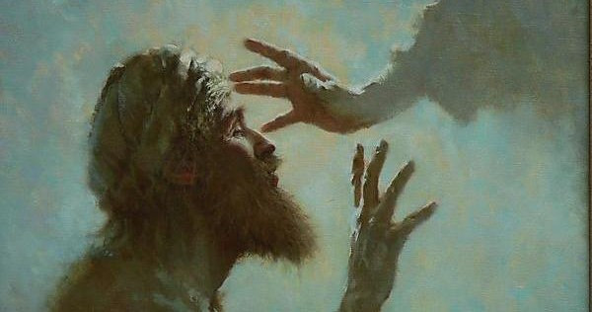
SIGN 6
The Man Born Blind

The Account—John 9:1-41
“I am the light of the world.”

The events of John 9 contrast those who receive spiritual sight with those who do not, and it shows how spiritual sight is acquired through the choices we make. The account teaches that while some choices are more important than others, spiritual sight is not developed as a result of one decision we make. Instead, it is the result of many choices that relate to both our actions and our attitude. This account demonstrates that God overthrows pride and willfulness but nurtures the humble heart and the mind that seeks to honor Him and to serve others above all else.

QUESTIONS: List 3 questions you might have about the reading in the space below:

DISCUSSION QUESTIONS:

- John 9:1 opens with the words, “And as Jesus passed by, he saw a man which was blind from his birth.”
  - Which phrase of verse 1 is also found in the last verse of the previous chapter?

  - Comment on the significance of that phrase, and how it connects chapter 8 with the events of chapter 9.

Chapter 8:59 and 9:1 clearly show the events of John 9 following directly on from chapter 8. Our comprehension of the meaning and purpose of the 6th sign as recorded in John 9 is greatly enhanced when we understand the basics of the discussion of the immediate context in chapter 8.

- The Debate Before the Sign:
  - After the incident of the woman taken in adultery in the beginning of John 8, the rest of the chapter becomes a debate between Jesus and the Jewish leaders. In the table below, summarize what each party (Jesus or the Jews) is saying throughout the chapter:
Jesus – v.12
The Jews – v. 13
Jesus -v.14-18
The Jews – v. 19a
Jesus – v.19b, 21
The Jews – v.22
Jesus – v.23-24
The Jews – v.25a
Jesus – v.25b-26
The Jews – v.27
Jesus – v.28-29
The Jews – v.30-31a
Jesus – v.31b-32
The Jews – v.33
Jesus – v.34-38
The Jews – v. 39a
Jesus – v.39b-41a
The Jews – v.41b
Jesus – v.42-47
The Jews – v.48
Jesus – v.49-51
The Jews – v.52-53
Jesus – v.54-56
The Jews – v.57
Jesus – v.58
The Jews – v. 59

- Did you notice any themes in this discussion?

- What do you think were the key issues that were being debated between Jesus and the Jews?

As you may have noticed, at the center of this debate was the question as to where Jesus came from. He claimed that he was from above, sent by God Himself – because God was His father. The Jews, of course refused to believe this. They asserted that far from being the son of God he was a Samaritan and had a devil – and they implied that he was born of fornication. They claimed that they were the children of Abraham, and that in contrast to Jesus who they implied was born of fornication, they had one father, even God. But Jesus accused them of being the children of the devil. So Both Jesus and The Jews claimed that God was their own father, while the other was of the devil. And the debate was never won by either side – the Jews tried to stone Jesus first. The events of the sixth sign in chapter 8 will ultimately decide the answer to the debate – and prove whether Jesus really was from God.

- John 9:1 records that Jesus noticed a blind man as he was walking away from the Temple. What does this indicate about Jesus’ character?

  - How can we be more like him in this way?

  - Read John 9:1 – 7. What acts of kindness does Jesus perform in these verses?

  - Jesus had just narrowly escaped death by stoning, but his very next action was one of compassion for another. Our natural inclination is not to respond to difficulties in our lives by showing kindness to others as Jesus did. How can we change our perspective and attitude so that we respond more like Jesus did?

- “Who sinned, that he was born blind?”:

- List two Bible characters that were punished with sickness because of sin.

- Provide a New Testament verse that says that sickness can be a punishment for sin.

\

- List two Bible characters who suffered from sickness that was not the direct result of wrongdoing.

- Jesus healed this man by having him wash in the pool of Siloam. There is a great passage in the Gospels where Jesus discusses the relationship of misfortune and sin and mentions “Siloam” in so doing. List the passage. What exhortation did he use the occasion to give?

- What lessons can we learn from what the Bible teaches about misfortune and wrongdoing? How should we react to sickness and adversity in our lives? How should we react to others when they experience these things?

- The disciples wondered whether the man’s sickness could have been due to wrongs done by his parents. What proverb did the people of Ezekiel’s day (see Ezekiel 18) use to express this concept? What was God’s opinion of the proverb? Why?

- Isaiah 42 talks about the work of the Messiah and healing the blind. Who do you think the blind man represents? Provide evidence from Isaiah 42.

- Given your answer to 3, why do you think it is significant that the man is characterized as being “blind from birth?”

- Jesus said that the man’s blindness was not the result of anyone’s sin. What do you think the blindness represents? (hint: you could say his blindness was his “misfortune, not his crime”)

- Christ said that the man had been born blind so “that the works of God should be made manifest in him.” The implication of this statement can be hard for us to accept: this man’s many years of sorrow, hardship, and exclusion from society had been a part of God’s purpose with him. Was this fair and just? Find some verses that help to explain the purpose of trials and hardship and comment on their meaning.

- Jesus (again) makes the statement, “I am the light of the world” in verse 5. Given that he had already said it in chapter 8, why do you think he said it again?

- How did Jesus heal the man?

- Why do you think Jesus chose to anoint the blind man’s eyes with clay as part of the miracle?

- Lessons in Symbol:

- Clay is an oft-used symbol in the Bible. What does it represent? List and discuss one or two supporting verses below.

- What is represented in Jesus’ command to the man to go wash?

- When a symbol is particularly important in an account in the Gospel of John, attention is frequently drawn to it in the text. (For example, in the fifth sign, the fact that it was dark at the time of the account is mentioned twice in the space of two verses.) In verse 7, attention is drawn to the pool of Siloam by stating what “Siloam” means. Why do you think we are told so clearly that Siloam means “sent”? (hint: remember what the debate of John chapter 8 was all about!)

- The Neighbors:

The man received his natural sight in an instant. His spiritual sight took longer to develop, however, although it was already growing by the time he washed in the pool. Just as baptism is not the end of our spiritual development, this man would grow in faith as he consistently chose to honor Christ during the divinely controlled trials he was about to endure.

- The man’s neighbors saw him after his encounter with Jesus. How did they react to him in verses 8 - 9?

- The man’s neighbors questioned him about the circumstances of his healing. He told them that Jesus had healed him. Although his plain declaration may seem like a trivial matter, it required faith. Even individuals of great faith have faltered when called upon to give proper credit to blessings given to them by God. Identify and discuss an individual in the Bible who did not give proper credit to God. Why did the person fail to do so?

- Why do you think the neighbors brought the man before the Pharisees?

- What mindset does Paul commend in Romans 12:12?

- Why does Paul say this mindset is important in 1 Corinthians 12:25 – 27?

- Was this mindset reflected in the neighbors’ interactions with the man born blind?

- Identify all the groups of people in this chapter who failed to reflect this mindset. Who was the only one to show compassion on the beggar?

- What can we learn from this?

- What did the man refer to Jesus as in verse 17? How does this reveal a growth in his faith from verse 11? What do you think caused his faith to grow?

- The Blind Man’s Parents:
- What does Isaiah 58:13 – 14 say the purpose of the Sabbath was?

- Why did the Jews call the parents in to testify?

- Why were the parents afraid?

- As a result of the parents’ fear, they deflected the attention of the authorities away from themselves and back onto their son. Being mindful of our own failings, we may feel hesitant to condemn them too strongly. Nevertheless, we must remember that we are called upon to be courageous in our advocacy and defense of the Truth. What does Revelation 21:7 – 8 say the fate of the fearful will be? What other types of people are put in the same category as the fearful?

- Why do you think an attitude of fearfulness is so abhorrent to God?

- What are some ways that we can overcome the fears that sometimes prevent us from speaking and standing for the truth?

- “Give God the praise”:

- The Jews brought the man born blind back in for further questioning in verse 24. They began by addressing him with the words, “Give God the praise.” This was a phrased reserved for serious judicial inquiries. During what incident in the history of Israel was a very similar phrase used? (Use a Bible search engine or a cross-reference for help – and replace praise with the word “glory”)

- (Optional.) A very similar phrase is used in Jeremiah 13:15 - 17. How does it relate to this account?

The man born blind was now under intense pressure. He had just received his sight after a lifetime of blindness. He had a choice of siding with the elders and enjoying some of the pleasures of this world for a season. (He had, after all, never experienced the “lust of the eyes.”) He also had the choice of siding with Christ and facing the implications of doing so.

- Choosing Christ:

- What did the man born blind say he was (by implication) in verse 27? How does this add to the progression of his faith that we discussed in question 13?

- Describe the attitude of the elders of the people in verses 24 – 34. How does it differ from what the Bible says the attitude of elders should be?

- Verses 30-33 record the beggar’s final argument, where he weighs the evidence and draws his own conclusion as to who Jesus was. List the key points of his statement, and his conclusion.

- What does his conclusion add to the growth of the beggar’s faith discussed in questions 13 and 16a?

- The man had endured a lifetime of blindness, but his words reveal that he possessed a vast knowledge of Scripture that he had acquired despite his disability. How does Psalm 66:18 – 20 relate to this account?

- What does Ecclesiastes 8:1 suggest might have made this man (who had only recently been a beggar) so bold in the presence of the elders?

- They Cast Him Out:
  - The Jews told the man, “Thou wast altogether born in sins.” Why do you think they say this? Consider what the disciples said in verse 2.

  - What is incredibly ironic about their statement? (Hint: read John 8:7-9)

  - The Jews “cast him out.” What were the consequences at that time of being put out of the synagogue? (Use a Bible encyclopedia or commentary for help. You may find John Gill’s commentary on John 9:22 and 34 helpful. It is available at: http://biblestudytools.net/ Commentaries/GillsExpositionoftheBible.)

  - The Jews had agreed that anyone who confessed that Jesus was the Christ would be put out of the synagogue (v.22). The beggar hadn’t actually done this – all he had done was argue quite conclusively that Jesus must be from God – he didn’t say anything about him being the Christ. So why do you think they cast him out?

The leaders said, “thou wast altogether born in sins, and dost thou teach us? (v.34). Remember the context – the Jews had just spent chapter 8 arguing with Jesus, trying to deny that he came from God, but the debate had never had a conclusive winner. Now, only a few hours later, this beggar had so simply and clearly proved to them that Jesus must come from God – there was no other possible explanation of the facts of the case. And the Pharisees could not refute his argument. We suggest that he was cast out, not for saying that Jesus was the Messiah, but he had, indeed, “taught” them. And that was something they would not abide – so they cast him out.

  - Read Isaiah 66:5, and describe how it can be applied to the beggar:

- Consider the immense courage it would take for a “nobody” like the beggar to stand up against the top religious leaders in the nation.
  - What do you think it was that inspired his courage? Consider 2 Cor. 4:13.

  - Read through the whole chapter of 2 Cor. 4 and note down as many connections as you can find between Paul’s teaching and the experience of the beggar in John 9.

  - What exhortations can you take from 2 Cor. 4 considering how it applies to the beggar, and to you?

- Christ learned of the man’s plight. He knew of his difficulty. So, he sought him out and found him. We see in Christ’s actions here an introduction to an aspect of him that is the focus of the next chapter. What aspect of Jesus is presented in the beginning of John 10?

- “Dost thou believe on the Son of God?” Jesus asked the man. The fact that Jesus would ask him this question shows just how far his spiritual vision exceeded that of the Jewish elders. When Christ confessed to them that he was the Son of God in Matthew 26:63 – 66, what did they do?

- What did the man refer to Jesus as in verse 36? How does this reveal a growth in his faith? What caused his faith to grow?

- How did the man respond to Jesus in verse 38? Looking at your answers to questions 13, 16a, 16d, and 21, summarize the progression of the beggar’s faith throughout the chapter.

- Back in verse 3, Jesus had said that the man had been born blind so that “the works of God might be made manifest in him.”
  - In John 6:28, Jesus was asked how to “work the works of God”. What was his answer in verse 29?

  - With Jesus’ answer in mind, at what point were “the works of God made manifest” in the beggar?

  - John 6:36, Jesus said that although the people had seen him, they believed him not. How was the beggar a contrast to those people?

  - Comment on how Jesus’ next words in John 6:37, 40 apply to the beggar:

- The Pharisees looked on and mocked. “Are we blind also?” they asked. Were these the same men who cast the man out of the synagogue? What do you think explains their attitude? What did Jesus say was the consequence of their attitude?

- The same choices that faced the man born blind and the Pharisees face us now. We, like him, have been called out of darkness. We, like the Pharisees, can find reasons to be proud and to exaggerate our own importance. We can choose to reject the Son of God and to treat his friends with contempt by choosing to ignore the evident display of God’s power. How have we seen God’s power displayed in our lives? What lessons can we learn from the man born blind about how we should react to it?

Christ appears twice in this account. At his first appearance, he gave instructions. At his second appearance, he pronounced judgment. Two categories of men, the man born blind and the Pharisees (who were in the majority) were before him. The category that each was in was based on the choices they made and was a reflection of the spiritual sight they had. Let us spend the remainder of the days we have on this earth in service to our God, looking to our Lord to lead us, and seeing with the eye of faith.

- Whose faith do you think was being developed in this sign?

  - What do you think it was about this sign that inspired belief?

  - How can the same things strengthen your own faith?7

- SIGN 6 CONCLUSION
  - Go back and review the questions you asked at the beginning of this section. Choose one of the questions and answer it in detail (at least one paragraph).

  - What did you find most interesting from studying this sign?

  - List at least 2 practical lessons you took from this sign.

  - What did you learn about Jesus from this sign?

Subjects for Further Study

Choose at least one of the following subjects to study in detail and answer below.

- Choose another of the questions you asked at the beginning of this sign and answer it in detail.

- There is a great deal of emphasis on natural descent in John 8 and 9. In John 8, the leaders of the people expressed pride in their ancestry and doubt about Jesus because of questions about his parentage. In John 9, the disciples wondered aloud whether the man’s disability was because of something his parents had done wrong, and the elders asserted his blindness was the result of his parents’ wrongdoing. What does the Bible say about natural descent, adoption, and how they relate to salvation? Be sure to discuss what Galatians 3 and Romans 11 teach about these subjects

- When we studied the 3rd sign in John 5, we saw in question 19 how the Impotent man represented natural Israel. In the 6th sign in John 9, the blind man goes through some similar circumstances, but responds very differently.

  - Compare and contrast the characters and events of the 3rd and 6th sign.
  - While the impotent man represented Natural Israel, the blind beggar would come to represent the experiences of individual gentiles over the past 2,000 years from when they first were converted/healed by the voice of Jesus, through their probation as their faith is tried and developed, through to the appearing of Jesus when their faith is turned to sight. Construct a table comparing the healing of the beggar and the conversion of the gentiles – us!

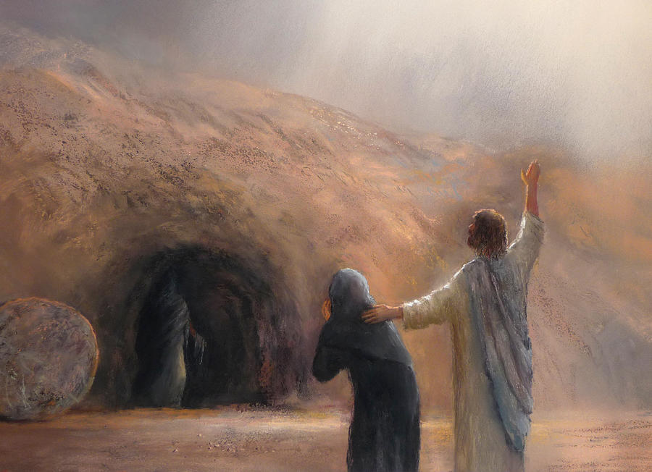

SIGN 7
The Raising of Lazarus

The Account—John 11:1-57
“Now a certain man was sick, named Lazarus, of Bethany, the town of Mary and her sister Martha.”
This account is a demonstration of the power that has been given to the Son of God, but it is also an exposition in symbol of the spiritual development of believers. In it we see how Christ interacts with his followers to increase their faith. And the lesson is powerfully made that if we maintain our faith even during difficult and confusing times, the power given to Jesus by his Father is able to deliver us from the sorrows of this life and ultimately to free us from the shackles of our mortality at his return.

QUESTIONS: List 3 questions you might have about the reading in the space below:

DISCUSSION QUESTIONS:

- Which Gospels record the raising of Lazarus? Why is this significant? See John 5:25.

- The events of John 11 occurred near the end of Jesus’ ministry:

- The nearest time marker to the account is John 10: 22. What season was it?

- Many translations (e.g., KJV, NIV) say that the events of John 10: 22 – 39 occurred at the “feast of dedication.” What else is this feast known as? (See The Complete Jewish Bible available on www.biblestudytools.net or the margin of the NIV for help.)

- What feast occurred at the time of Jesus’ crucifixion?

- In what season does that feast occur?

- The Family:

- John 11:2 mentions that Mary anointed Jesus’ feet with her hair. Where else in John does it mention this event?

- Which event came first - the anointing of Jesus’ feet or the raising of Lazarus? Support your answer with Scripture.

- Why does John record these events as he does?

- Lazarus lived in a house with his sisters, Mary and Martha. Who does the Bible say the house belonged to in Luke 10:38?

- Who does the Bible say the house belonged to in Mark 14:3?

- Offer an explanation that reconciles the answers given in 2d and 2e.

- The Sisters’ Message:

- Why did the sisters send a message to Jesus in verse 3?

- What did the message say?

- What did they ask Jesus to do?

- Why did the sisters send the message that they did? What attitude does it reflect?

- Identify an instance in the Bible where a righteous individual made a very specific request of God in prayer.

- Identify an instance in the Bible where a righteous individual spoke to God in prayer about a trying situation but made no specific request to Him.

- When is it appropriate to make specific requests to God in prayer? When is it appropriate to make mention of a situation without making a specific request?

- The Messengers Return:
- How did Jesus respond to the sisters’ message in verse 4?

- How do you think the sisters would have felt when they received His response? Bear in mind that since the messengers left 2 days before Jesus, they would have arrived 2 days before Jesus – so Lazarus had been dead for 2 days when they received the message!

- How would you react to the news if you were in the sisters’ position? How would your faith and confidence in God be affected?

- Two Days:
- Read John 10:40 – 41. What work was Jesus doing when the messenger came to him?

- Where was the work taking place?

- Read John 10:42. Was the work successful?

- Read John 11:6. What did Jesus do in response to the sisters’ message?

- What might the two days represent? See 2 Peter 3:8.

- How does this apply to us?

- Read John 11:17. How was Lazarus when the messenger returned with Jesus’ message?

- What does this represent symbolically?

- Why is John 11:5 inserted where it is in the account?

- We are told in verse 3 that Jesus loved Lazarus, and in verse 5 that he also loved Mary and Martha. On the surface, does Jesus appear to be acting like he loves him and his sisters in verse 6?

- How could Jesus’ actions in delaying to come to the family’s aid and allowing Lazarus to die be a manifestation of love? It is extremely important for us to understand the love of the Father and how He and His son show it to us. Refer to at least 3 bible passages or examples in your answer. Hebrews 12 might be a good place to start.

- Judea:

- Why did the disciples not want to return to Judea?

- Given the severity of their reason, would you have wanted to go to Judea with Jesus?

- Why did Jesus answer his disciples as he did in verses 9 and 10? What did he want them to understand?

- Why did Jesus say he wanted to go into Judea in verse 11?

- Why did the disciples object in verse 12?

- What did Jesus mean when he said that Lazarus was asleep?

- Find a chapter in the Bible where “asleep” is used in the same way. How many times is the word used in that way in the chapter?

- Thomas:

- What characteristics does Thomas display in verse 16?

- What language is the name “Thomas” from? What does it mean?
- What language is the name “Didymus” from? What does it mean?

- Where is the next place in the Gospel of John that this apostle is called both “Thomas” and “Didymus?”

- What characteristics does he display there?

- Do you think this apostle’s name is appropriate for him? Why or why not? James 1:6-8 may be helpful.

Thus, Jesus and the Twelve made their way to Bethany. When Mary and Martha heard that Jesus was coming, Martha rushed out to meet him. Mary, who was the quieter and more contemplative of the two, remained behind in the house.

- Martha:

- Martha’s spiritual discernment is sometimes underestimated because of a rebuke she once received from Jesus. Describe the exchange Martha had with Jesus in Luke 10: 38 – 42.

- What virtues does Martha display in the Luke 10 account?

- What mistake did Martha make in Luke 10?

- Returning to John 11, what had happened in Martha’s life after she sent the messenger to Jesus?

- Describe what Martha would have felt:

- What do her words to Jesus in verse 21 and 22 convey about her attitude towards him? How has her faith and trust in him been affected? Consider your answers to question 5.

- Read John 11: 23 – 24. What made Martha different from many of Jesus’ followers?

- What did Martha confess to Jesus in verse 27?

- Read John 10: 24 – 31. What does what Martha said reveal about her?

- What do you think Jesus wanted Martha to learn in this chapter? See also verses39-40. Do you think she learned it?

After making her confession, Martha departed to call her sister to Jesus. She did so secretly. There were many of the Jews, John’s term for the elders of the people, who were with Martha in the house, and she preferred not to alert them to Jesus’ presence for they sought to persecute him. Once called, Mary hastened to Jesus. Martha’s secret call to her and the words “The Master is come, and calleth for thee” are significant. Indeed, they may foreshadow the way in which we are called to meet the Lord at the Judgment Seat.

- Mary:

- Compare Mary’s words to Jesus in verse 32 with Martha’s words to him in verse 21. What does this suggest about what the two sisters had been discussing for the past 4 days?

- Based on these words, what kind of pain and confusion do you think they were feeling?

- When tragedy strikes, the sorrow and pain can be very debilitating, and often causes us to ask some very difficult questions. What lessons can we learn from the way these sisters handled grief?

- The KJV renders verse 33 as “When Jesus therefore saw her weeping, and the Jews also weeping which came with her, he groaned in the spirit, and was troubled.” What Greek word is translated “groaned?

- What Greek word is this word from? What does that word mean? (You may find http://www.biblestudytools.net/ helpful.)

- Using a concordance, look up the Greek word translated “groan” in the New Testament. Is it the same word as in 9c? What does the word mean?

- What does this suggest about what Jesus was feeling in verse 33?

- Why do you think he felt this way?

- At the Tomb:

- “Jesus wept.” Why do you think he wept? See your answers to 6j-k and Hebrews 4:15-16; 5:8.

- What can we learn from this, and what kind of encouragement does this provide?

- The elders did not miss this opportunity to mock Jesus. How they delighted in the display of his sadness. “Behold how he loved him!” They had no idea that Jesus loved Lazarus so, and yet this man who had confounded them time and again with his miracles was unable to deliver his friend from death (or so they thought). They wondered this sentiment out loud for all to hear in the hopes that doubt in Jesus would spread. Why was it especially cruel that they asked, “Could not this man, which opened the eyes of the blind, have caused that even this man should not have died?”

- Read John 11:38 – 42. How many prayers does it mention that Jesus offered in these verses? What was each prayer about?

- What lessons can we learn from these verses about dealing with adversaries?

- Name and discuss another Bible character who dealt with adversaries the same way.

- Resurrection:

- (Optional.) Lazarus had been dead for four days. What does that represent?

- Read John 11: 43 – 44. Describe the events of Lazarus’ resurrection.

- Give at least 3 similarities between the events of John 11 and those of the death and resurrection of Jesus.

- The purpose of the signs were so that the disciples would believe. When Christ was killed and laid in the grave, how could remembering this sign have encouraged them?

- Why is it significant that Lazarus came out of the grave still wearing his graveclothes? See John 20:6-7; 2 Cor. 5:4.

- Did the Jews all have the same reaction to the raising of Lazarus? Explain.

- The Council:

- What did the elders fear would happen as a result of Jesus’ ministry?

- What did the elders refer to the Temple as in verse 48?

- What did Jesus call the Temple in John 2:16?

The assemblage of chief priests and Pharisees debated various schemes for neutralizing the influence of Jesus, but none of them went far enough for Caiaphas, who was the high priest that year. He insisted that Jesus be put to death. “You know nothing at all! You do not realize that it is better for you that one man die for the people than that the whole nation perish” (NIV).

- Caiaphas said that Jesus’ death would save the nation from destruction. And he was right, but in a sense other than what he intended. Explain.

- Read John 11: 53 – 54. How did Jesus sacrifice of himself in giving life to Lazarus?

Yet there were some sweet moments for Jesus during the final, trying days of his ministry. John 12 opens with Jesus, Mary, and Martha enjoying a meal of fellowship together.

- A Vision of the Kingdom:
- Read John 12: 1 – 3. Who is at the meal? What are they doing?

- Explain why this might be a vision of the Kingdom. What do the different people at the meal represent?

- Whose faith do you think was being developed in this sign?

  - What do you think it was about this sign that inspired belief?

  - How can the same things strengthen your own faith?7

- SIGN 7 CONCLUSION
  - Go back and review the questions you asked at the beginning of this section. Choose one of the questions and answer it in detail (at least one paragraph).

  - What did you find most interesting from studying this sign?

  - List at least 2 practical lessons you took from this sign.

  - What did you learn about Jesus from this sign?

Subjects for Further Study

Choose at least one of the following subjects to study in detail and answer below:

- Choose another of the questions you asked at the beginning of this sign and answer it in detail.

- Study the family that is so central to this chapter in more detail. In particular

- Identify the meaning of Bethany, the town where the family lived, as well as the meaning of the names of the members of the family. How do the meaning of the names relate to the account?
- Read the account of Mary washing Jesus’ feet in John 12:1 – 7 as well as in the parallel account of Matthew 26:6 – 16. What disciple of Jesus appears in these accounts? There is some evidence that he was a member of the family. Discuss the evidence. Do you agree that this disciple was a member of the family?

- Find the instances where Thomas appears in the Gospel. Discuss his spiritual development. How is it similar to your own spiritual development?

- The faith of both the man born blind and the sisters of Lazarus was increased through suffering. Discuss how our faith grows through suffering. Include comments on the following:

- The Bible’s teaching about the importance of suffering
- The Bible’s assurances that God is with us during times of difficulty
- How Christ benefited from his suffering
- How at least two other Bible characters benefited from times of trial
- What we should do during times of suffering

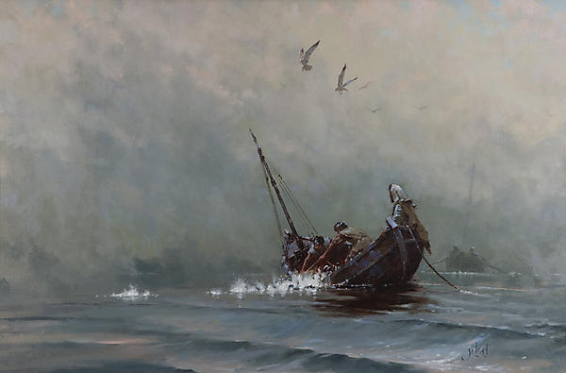
SIGN 8
The Great Harvest of Fish

The Account—John 21:1-19
“After these things Jesus shewed himself again”

Jesus had risen, and the disciples were about to go forth without his physical presence and spread the “things pertaining to the Kingdom of God.” The disciples had grown a great deal during the time they had spent with Jesus, but they still had lessons to learn. The eighth sign helped to prepare them for the work that was ahead.

QUESTIONS: List 3 questions you might have about the reading in the space below:

DISCUSSION QUESTIONS:

- “After these things:”

- What major events occurred between the seventh and the eighth signs?

- The eighth sign takes place in Galilee. Why were the disciples in Galilee? See Matthew 28:10.

- Verse 14 states that the events of John 21 were the third time that Jesus showed himself to his disciples after his resurrection. John 20 records the first two times he appeared to the disciples. How soon after the resurrection was the first appearance? The second?

- A number of appearances by Jesus after his resurrection are recorded in 1 Corinthians 15:4 – 8. List them.

- Where chronologically do the events of eighth sign occur in the above list?

- The Disciples:

- How many of the disciples were together in verses 2 and 3?

- Give some examples of Scripture’s use of this number.

- With what ideas is this number associated in these passages?

- Why do you think this number appears in this account the way it does?

- Peter and Thomas are mentioned first in the list of disciples. What did these two men have in common?

- “I go a fishing:”

- Who initiated the fishing expedition?

- Who led the way in preaching to the Jews after Christ’s ascension? See Acts 2.

- Who led the way in preaching to the Gentiles after Christ’s ascension? See Acts 10.

- Think back to the questions on the fifth sign. What does the sea represent in the Bible?

- What does the disciples’ fishing expedition represent?

- Nathaniel:

- Nathaniel was part of the fishing party. Where was he from?

- Look on a map. Where is that city located?

- Is it likely that Nathaniel was a trained fisherman? Why or why not?

- Why do you think Nathaniel was in the boat?

- What is the lesson for us?
\

- Hard Labor:

- What time was it when the disciples were fishing?

- Think back to the questions on the fifth sign again. What does darkness represent?

- What did Jesus ask the disciples if they had?

- Look up the Greek word in a concordance. What is it? What did Christ literally ask the disciples if they had?

- Why did you think Jesus asked them this?

- Jesus addressed the disciples as “children” in verse 5:

- What Greek word is translated “children” in John 4:12? What does the word mean?

- What Greek word is translated “children” in John 8:39? What does the word mean?

- What Greek word is translated “children” in John 21:5? What does the word mean?

- Later in his life, John addressed his readers with the word used in John 21:5. Where in his epistles does he do this? What message was he conveying to his readers there?

- Why do you think Jesus addressed his disciples as he did?

- The disciples were about to embark on a work of spreading the Gospel. For their efforts to succeed, they were going to have to obey Jesus, and that was not always going to be easy for them to do. However, obeying Jesus was necessary because he was the one who would cause their work to be successful. This sign was helping to teach this lesson.

- What did Jesus ask the disciples, specifically Peter, to do in Acts 10:9 – 23?

- Why would that have been difficult for him?

Imagine the disciples laboring throughout the night. They would have enjoyed moments of sweet fellowship for sure, but for the most part their work was hard. This is a depiction to us from God of the task of spreading the Gospel. He knows it is a work that is not always easy. But if we are faithful to His Son and obey Jesus’ commands, our work will ultimately be profitable because His power will make it so.

- The Great Harvest:

- What command did Jesus give the disciples in verse 6?

- What happened as a result?

- What is the significance of the right side of the boat? See Matthew 25:31 – 46.

- Luke 5:3 – 10 records an earlier miracle that is similar to the eighth sign in some respects, but also has some important differences. Where is Jesus in John 21? Where is he in Luke 5?

- How are the fish described in John 21:11? How are the fish described in Luke 5:6?

- What is the significance of the fish in John 21 being described as “great”? See Matthew 13:47 – 50.

- What happened to the support ships in Luke 5:7? Did the same thing happen in John 21:8?

- What happened to the nets in Luke 5:6? Did the same thing happen in John 21:11?

- It is clear that these accounts have symbolic meaning. (See Luke 5:10, for example.) Yet some of the symbols are different. What is Luke 5 depicting? What is John 21 depicting?

John 21:11 notes that there were 153 great fish caught in the net. These fish represent the saints who will be immortalized at Christ’s return. The most important aspects of their number (as it relates to the redeemed) are that 1) it is known of the Father, and 2) none of them are lost.

- What do you think is the significance of the number 153? (You may find a study book, such as Bro. John Ullman’s Eight Signs of John or Bro. Harry Whittaker’s Studies in the Gospels helpful in answering this question.)

- The disciples had not perceived the presence of Jesus when the miracle took place. What lesson can we learn from this? See Matthew 18:20.

- “It is the Lord.”

- Who realized that it was Jesus standing on the shore?

- John 21:7 says that Peter was “naked,” a term used in the Bible to describe one wearing only a tunic. What did he do before casting himself into the sea?

- Why do you thing he did this? See Ephesians 6:14.

- Powerful Imagery:

- What was waiting for Peter in verse 9 when he came to shore?

- At what important event in Peter’s life had there also been “a fire of coals?”

God, who created us, knows best how to teach us. Sometimes He does so using stunning visual images that remind us of our past. For example, the story of David and Bath-sheba really begins in 2 Samuel 10 when David sends comforters to Hanun the son of Nahash, king of Ammon. Those comforters are abused and a war between Israel and Ammon ensued. When David stayed back from the siege of the capital of Ammon, he met Bath-sheba. Years later when David fled from Absalom to Mahanaim, Shobi, another son of Nahash, brought him supplies (2 Samuel 17:27 – 29). Seeing a son of Nahash at that time must have stunned David, reminding him of the reason for his plight and reinforcing in his mind the awesome power of God.

- Discussion with Peter:

- In verse 15, Jesus asked Peter, “Simon, son of Jonas, lovest thou me more than these?” Do you think “these” refers to the catch of fishes, or the other disciples? Support your answer.

- What Greek word is translated “love” in Jesus’ question? What does the word mean?

- What was Peter’s answer?

- What Greek word is translated “love” in Peter’s response? What does the word mean?

- How did Jesus reply at the end of verse 15? Look up the Greek words in his reply. What do they mean?

- Jesus asked Peter a slightly different question in verse 16. How is his second question different from his first?

- What Greek word for “love” did Jesus use in his question? What Greek word did Peter use in his response?

- How did Jesus reply at the end of verse 16? Look up the Greek words in his reply. What do they mean?

- Jesus asked Peter a slightly different question in verse 17. Look at the Greek words. How is his third question different from his second?

- Why was Peter grieved at Jesus’ third question?

- What Greek word for “know” did Peter use in verses 15, 16, and once in 17? What does it mean?

- The second time Peter says “knowest” in verse 17 he uses a different Greek word. What is it? What does it mean?

- Why do you think he uses this word?

- How did Jesus reply at the end of verse 17? Look up the Greek words in his reply. What do they mean?

- What lesson do you think Jesus was trying to teach Peter?

- How do you think Jesus’ discourse with Peter relates to the eighth sign?

Although Jesus’ message to Peter (in verses 18 and 19) that his pilgrimage would end in violent death could have been distressing, Peter was nevertheless encouraged by it because Jesus told him that he would glorify God by his death. Peter knew by this that he would remain faithful to Christ to the end. Peter must have been greatly comforted by this knowledge because echoes of these words of Jesus appear throughout the remainder of his recorded life in Scripture.

- Glorifying God:

- Read Acts 12:1 – 11. What echo of John 21:18 appears in Acts 12:8?

- Peter wrote his second epistle at the end of his life. Where in 2 Peter 1 does it show that Peter was still thinking of the words Jesus spoke in John 21:18 – 19?

- Whose faith do you think was being developed in this sign?

  - What do you think it was about this sign that inspired belief?

  - How can the same things strengthen your own faith?

- SIGN 8 CONCLUSION
  - Go back and review the questions you asked at the beginning of this section. Choose one of the questions and answer it in detail (at least one paragraph).

  - What did you find most interesting from studying this sign?

  - List at least 2 practical lessons you took from this sign.

  - What did you learn about Jesus from this sign?

Subjects for Further Study

Choose at least one of the following subjects to study in detail and answer below

- Choose another of the questions you asked at the beginning of this sign and answer it in detail.

- The eighth sign leaves us with the message that although Christ is physically absent from us, he nevertheless has the preeminence over us. What are the implications of this for us in the way in which we conduct:

- Our personal lives
- Ourselves in the home
- Ourselves in the ecclesia
- Ourselves in the world

- The eighth sign contains powerful lessons about preaching the Gospel. Study the conversion of a person in the Bible and discuss the lessons you learned from it.

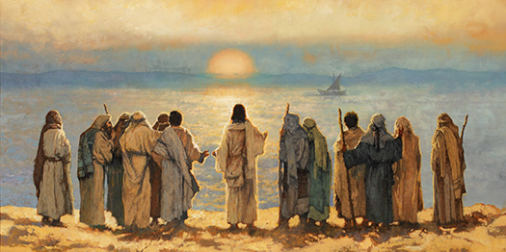

EPILOGUE
“That Ye Might Believe”

Workbook Conclusion
- Eight Signs in John
  - Give some examples of Scripture’s use of the number eight:

  - With what ideas is this number associated in these passages?

  - Why do you think there are eight signs in John?

- Written that We Might Believe
  - John 20:30-31 makes it clear that the purpose of recording the signs in John was to inspire belief in the reader. Look back over your workbook, especially at the conclusion of each sign. What are the 3 most important things you have learned about faith from this study?

- What are at least 3 ways this study has helped to strengthen and build your personal faith?

- Knowing Jesus:
  - Each of these signs reveals much about the character and life of our Lord Jesus Christ. John 17:3 says that it is eternal life to know God and his Son, Jesus. What stood out to you about the Son of God as you studied these signs?

  - Do you feel like you know Jesus’ better now than you did before this study? Explain.

  - In what ways have you been inspired to follow the example of our Savior? Explain.

- Moving Forward:
  - You’ve invested many hours in studying the Eight Signs of John. Hopefully you have gained a lot of knowledge you didn’t have at the beginning. But if all you gained from this study is increased knowledge, it was a waste of time! Take some time to look back over the workbook (especially the conclusion questions about the lessons you found powerful from each sign), and then write down at least 5 key lessons from this study that you will apply to your life.
    - .

    - .

    - .

    - .

    - .

  - Write down at least 3 specific ways you will try to change your life as a result of this study.
    - .

    - .

    - .

”Synoptic” is from the Greek word sunoptikos and means "seeing together," or "having a common view of.”

