A WORD ABOUT CHRONOLOGIES
Don’t get frustrated if you have trouble in the first couple pages of the workbook and you wonder why we spend so much time on the chronology. We first have to get the setting of the stories in history so that we can understand the wonderful workings of our God, and the great faith of these Bible characters as they were living under pressure. The good news is that the chronology parts don’t last long, and you might even find them interesting!
Always keep Appendix A (the chronology that links everything together) handy during your study and Appendix F (pieces together Ezra, Nehemiah & Esther).
Disclaimer: There is some uncertainty about the chronology of this period we will study. We have carefully considered the arguments for each alternative, and decided to adopt the version presented in Appendix A (as presented by bro H.P. Mansfield in The Story of the Bible). Bro. Michael Ashton give a summary of the various chronologies in his book The Exiles Return (pages 205-211), but he follows “the 60-year gap” view, which has Ezra returning some 60 years after the temple is finished.
REFERENCES
Christadelphian Books
Story of the Bible (H. P. Mansfield) [Vol 4 page 137 through Vol 5 page 68)
Nehemiah (Ron Abel)
Haggai, Zechariah and Malachi (H. P. Mansfield – Expositor)
The Prophets After the Exile (John Carter) - follows the “60 year gap” theory
The Exiles Return (Michael Ashton) – follows the “60 year gap” theory

Christadelphian Audio Classes (can be downloaded free from christadelphianbibletalks.com)
There are many good Bible classes covering this period on this website. Just do a search for “Ezra” or “Nehemiah” or “Haggai” or “Zechariah” or “Malachi” or “Esther” and you will find plenty to keep you listening till Youth Conference begins!

Non-Christadelphian Resources
The Bible Commentary (edited by F.C. Cook) – also known as Speaker’s Commentary [this can be downloaded free from classicchristianlibrary.com.

It’s also very useful to have access to a computer with Bible software on it. This saves hours of time finding references and looking up words in Strong’s or Bible Dictionaries!
Note: Scriptural references used in the Workbook are from the New King James Version

Table of Contents

Part One
# | Workbook Section | To get the context, read….
1 | Kings & Things: Getting our Bearings | -----
2 | The Captivity of Zion | 2 Kings 23:28 to 25:30
3 | The Exiles Return | Ezra 1-3
4 | The Work Ceases | Ezra 4
5 | The Prophets | Haggai 1-2; Zechariah 1-6
6 | The Final Push | Ezra 5-6
7 | Ezra Returns | Ezra 7-8
8 | Solving Ecclesial Problems | Ezra 9-10

Part Two
# | Workbook Section | To get the context, read….
9 | God Motivates more Exiles to Return | Esther
10 | Nehemiah Returns | Nehemiah 1-2
11 | Let us Arise and Build | Nehemiah 3-6
12 | Renewal, Dedication & Reforms | Nehemiah 8-12
13 | Principles of Separation | Nehemiah 13

Section 1 - Kings and Things - Getting Our Bearings
“Then those who feared the LORD spoke to one another, and the LORD listened and heard them. So a book of remembrance was written before Him for those who fear the LORD, and who meditate on His name.” Mal 3:16
Objective:
- To get acquainted with the story of the Exiles
- To build a framework for our study and understand how all the pieces fit together
- To wade through all the technical stuff as painlessly as possible so we can get into the meat of our study

Introduction
In our study of the Return of the Exiles it is crucial that we understand the historical and scriptural context of Ezra and Nehemiah. Only then can the characters of our story become real and dynamic, and the principles we learn from their experiences become meaningful to our own lives.
However, we appreciate that not everyone enjoys history or tedious chronologies. With this in mind, we’ve done a lot of the legwork for you. Please use the chronology chart, hand-in-hand with your open Bible, as a reference throughout your study. The chronology chart can be found in Appendix A. You will find it very useful in helping to integrate all the material which we will be studying.
In addition, one exercise that will greatly benefit you later in the study is to color in any “time markers”. Details to color would include any references to particular months, years, festivals or events, and to the reign of kings; anything that will help us flag the passage of time. This will enable us to get a handle on what’s happening and when.
e.g. Ezra 4:7- “In the reign of Artaxerxes, in the beginning of his reign, they wrote an accusation against the inhabitants of Judah and Jerusalem.”
A list of verses with important time markers can be found in Appendix B. There are only a few so it shouldn’t take much time, but it will prove to be invaluable later on (and it makes a great CYC activity too!) Please note that some verses have more than one item.
Exercise 1.1 - 1.5 (Optional) Bible Marking in Appendix B

Putting the Pieces Together
Our study of The Return of the Exiles encompasses nine books of the Bible: 2 Kings, 2 Chronicles, Ezra, Nehemiah, Esther, Daniel, Haggai, Zechariah and Malachi. Each book helps us to see the story from a unique perspective, and enables us to understand how everything fits together. It will be a challenge to integrate all these sections of scripture but for now we just want to get acquainted with the story of the Exiles and to establish a basic framework for our study.

This is how our study fits together chronologically:

Fill in the blanks, using your Bible and the chronology chart in Appendix A as a reference:
The story of the Exiles begins in 605 BC; the year the Babylonian invasions began. 20 years later, there was nothing left. Judah’s population had been systematically deported, it’s cities destroyed. Even the Temple had been looted and burnt to the ground. The remnant of God’s people had been resettled throughout the Babylonian Empire and for a generation the Jews lived as exiles in a foreign land. For some, each passing year made them yearn more intensely for their lost homeland. For others, Babylonian society offered too exciting a temptation to resist, and they eventually assimilated with the world around them.
50 years passed. Then in 536 BC, literally overnight, their world changed forever. The great city of Babylon fell to the armies of the Medo-Persian Empire (see Daniel 5). The Persian general Cyrus soon became king, and in the ______ year of his reign he made the famous proclamation allowing the Exiles to return to Judah under the leadership of _______________ (who was also known as Zerubbabel).
Many of the Exiles leapt at the opportunity to return. After a long and arduous journey, the Jews arrived back in the Land. But it was nothing like they remembered. Instead they found a desolate wasteland; the City of Jerusalem a heap of overgrown rubble. The Exiles soon set about the work of restoring their nation. Nearly two years after they arrived, they laid the foundation of the __________. However, because of intense adversity and opposition from their enemies, they became discouraged. The work was stopped for _____ years until eventually, through the influence of the prophets ____________ and _______________, the work to rebuild the Temple was revived. Having overcome their apathy and discouragement, the people finally complete the Temple in _____ BC, ______ years after originally being destroyed by the Babylonians (as foretold by the prophet Jeremiah).
After the Temple was dedicated in Ezra 6, some people think there is a significant gap of 60 years in the record, while others believe Ezra 7 occurs immediately after Ezra 6. You will find expositors (both Christadelphian and others) differ on this issue. (Appendix A does not follow the gap theory). Although the Persian king of Ezra 6 is __________ and the king of Ezra 7 is called ___________________, it is possible that these are the same person. Ezra 1-6 was about events before Ezra returned, and then Ezra was present for the events of Ezra 6-10. The Jews in the land may have called the Persian king, Darius, while Ezra and many others in Persia referred to the same king as Artaxerxes. The writer of the book of Esther may have referred to this same king as Ahasuerus. These are just titles like “king” or “prime minister” and do not refer to any specific individual. It makes a lot of sense that as soon as the temple was finished, Ezra returned to work in the new temple. Some time between Ezra 10 and Nehemiah 1, the story of Esther probably occurred. When Ezra returned to work in the temple he had trouble getting Levites and others to return with him. So God used Haman to convince more Jews to leave their comfortable life in Persia, and return to Israel. According to Esther 3:12; 4:3, Haman’s plot for genocide not only affected those in Shushan, but all the Jews throughout the whole Empire. Ezra returned in the ________ year of Artaxerxes, and then Nehemiah came to build the walls in the __________ year of this same king. Nehemiah is governor in Jerusalem for approximately ______ years, during which time he works closely with Ezra to build up and strengthen the ecclesia of Judah. They encounter many serious issues and difficulties, but continue to work patiently and faithfully with their brothers and sisters.
Nehemiah is then temporarily recalled to Shushan by King Artaxerxes for an unknown period of time. The prophet ___________ likely prophesied during his absence. When he returns, Nehemiah finds that much of his efforts had been undone, and the people had once again slipped into spiritual decay. Refusing to admit defeat, Nehemiah throws himself back into the work.
Nehemiah’s heart-felt prayer “Remember me, O my God, for good” concludes the story of the Exiles on an unfinished note. Were Ezra and Nehemiah ultimately successful? We don’t know. But their spirit of faithful perseverance lives on today. In the face of declining morals, problems in the ecclesia, in CYC, at home, or in our personal lives, we must keep patiently working together in hope, no matter how discouraged or alone we may feel. The majority of our study focuses on what we can learn from the principles we see in action in their lives and in their ecclesia.

Section 2 – The Captivity of Zion
Objective:
- To look at how, but more importantly, why God’s people were sent into captivity in Babylon
- To understand how the Exile was all about a spiritual transformation
- To see how the Exiles’ experiences parallel our own struggles to uphold our faith today

“I was crushed by their adulterous heart which has departed from Me, and by their
eyes which played the harlot after their idols; they will loathe themselves for the evils
which they committed in all their abominations. And they shall know that I am the
LORD; I have not said in vain that I would bring this calamity upon them.” Ezekiel 6:9-10

The Story Begins...
At the very birth of Israel as a nation, the LORD declared the attributes of His character to Moses on Mount Sinai. For hundreds of years these principles have defined God’s relationship with His people.
- Read Exodus 34:5-7. These principles of God’s character are manifested in the way He responds to the decisions that Israel makes. Think of some specific examples in Israel’s history that demonstrate the outworking of God’s character.

- God choses to reveal His character in Ex 34 after he could have justly wiped out the nation of Israel. Why does God show His people so much mercy? What should we learn from this about how we treat each other?

“Behold the Goodness and Severity of God”
- The cycle of “Sin, Suffering, Seek, Save” was not confined to the time of the Judges, but continued when Israel became a kingdom. We can see this cycle in action in 2 Chron.12:1-7,12. How did the Children of Israel sin in v.1? How did they suffer in v.2? Instead of a judge, who did God send in v.5? And how did God respond in vs.7,12?

- Read Jer.7:25-28 (keep in mind that Jeremiah prophesied during Judah’s last days). Why was God ready to give up on His people?
Right up to the last minute, God pleaded with His people to turn back to Him but they would not hear. He wanted to show them mercy, but they refused to accept His kindness. Judah’s fate was effectively sealed when Jeremiah wrote a scroll and sent it to Jehoiakim, one of the last kings of Judah (Jer.36:1-2).
- How did Jehoiakim react? (see vs.21-24)

- What was God’s response? (see vs.29-31)

An Ecclesia in Ruins
The ecclesia of Judah was in ruin, with many devoid of spiritual understanding. It is remarkable that only 20 years earlier the nation had experienced a great spiritual revival under King Josiah. But now, after that brief flicker of hope, the light had finally gone out. The time for repentance was past; Judah’s lampstand was about to be extinguished. Review the following list which paints a dismal picture of the factors that eventually contributed to Judah’s spiritual- and national- downfall.
Problem | Reference
Unresponsive to God’s Word | Jer.7:23-26
Injustice and treachery rampant | Isa.59:4,13-15; Eze.22:9
Violence and murder | Isa.59:6-7; Eze.22:6
Oppression of the poor and destitute | Jer.22:17; Eze.22:7,29
People did not know God | Hosea 4:6; Isa.5:13; 44:18-19; cp. Jer.22:16
Despised God’s holy things, profaned the Sabbath | Eze.22:8; 20:16
Apathy and complacency towards the Truth | Zeph.1:12
False worship and abominable lifestyles | Eze.16:36; 23:37; Jer.32:35
Unfaithfulness and betrayal of God | Eze.16:31-32; 23:30
Hypocritical lip-service to the Truth | Eze.23:38-39
Utter failure of spiritual leadership | Micah 3:9-11

Acts 28:26-27 indicates the hearts of the people had grown dull, their ears were hard of hearing, and their eyes were closed. Similarly, Hosea 4:6 says that the ecclesia of Judah was destroyed because they had lost all sense of spiritual perspective.

- Our own ecclesias can lose perspective as well. Why do you think this loss of spiritual perspective occurs? By reflecting on how the brothers and sisters in Judah got to this point, brainstorm on what negative factors (or lack of positive influences) in our lives can lead us down this path too, and how we might overcome these negative factors.

Kingdom of Judah Destroyed
- In January, 588 BC, Nebuchadnezzar’s army arrived at the walls of Jerusalem. They began a brutal siege which lasted for nearly two years. Read 2 Kings 24:18-25:30 and fill in the table:
2 Kings 25 | What Happened To...
v.7 | Zedekiah the King:
v.18-21 | Seraiah ** the High Priest:
v.11 | Surviving remnant of Jerusalem:
v.12, 24-26 | Poorest of the Land:

- ** Note: One of Seraiah’s sons is mentioned in Ezra 7:1. Who is he and why is this significant?

Exiled from the Promised Land
Between 598-582 BC, an estimated 15,000-25,000 Jews were deported to Babylon in several waves.
(Optional) Read the account of Judah’s last days in Appendix D to help you appreciate the turmoil of this horrible chapter in Israel’s history.
- Take a moment and try to enter into their experience. As one of the few survivors of the siege, what would you have witnessed? What would you have smelled, heard, or felt? What had happened to your family and friends?

Life in Babylon
- Jeremiah sent a letter to the exiles in Babylon after Jerusalem was destroyed. Read Jer.29:4-7 and note the key points of his message. What do you think life was like in Babylon?

- Thought Provoker: If God’s motivation was simply to punish His people, wouldn’t it have been enough to destroy them in the siege? Why then did He send them into captivity? Based on Jer.29:10-14, what do you think God tried to accomplish by the captivity?

Key Principle...
God was not so much sending His people away but rather bringing them back to Him spiritually. The Jews had already “exiled” themselves from Him through sin- i.e. they had already made the journey to Babylon in their hearts. The Exile was all about the process of repentance and reconciliation, a spiritual transformation.

- Babylon was all about assimilation, the pressure to conform. Sadly, many of the exiles adapted to life away from Jerusalem. But there were a few who maintained their faith in God while in Babylon. Daniel is a stellar example of a young person who upheld God’s principles against the challenge of the world. How did Nebuchadnezzar try to pressure him and his friends to conform (Dan.1)?

- How did they overcome this pressure, and what can we learn from this? (e.g. Rom.12:2 cp. 2 Cor.4:16-18)

A Work in Progress
- God often uses adversity and difficulty to help us grow spiritually (Heb.12:8-11; 2 Cor.4:17). How do you think the exiles’ experiences in Babylon helped to develop their faith? How is this true for us?

- On the whole, the experience of the Exile helped God’s people to see the foolishness of their previous way of life. The following table shows which problems the Jews struggled with before, and after, the Exile. Use the verses provided to determine just how much (or how little!) the Exile actually changed the people:
Problem | Before ? | After? | Reference
Unresponsive to God’s Word | ✓ | ✗ | Neh.9:1-3
Injustice and treachery rampant | ✓ |  | Mal.2:10
Violence and murder | ✓ |  | n/a
Oppression of the poor and destitute | ✓ |  | Neh.5:1-5
People did not know God | ✓ |  | Jer.24:5-7
Despised God’s holy things, profaned the Sabbath | ✓ |  | Mal.1:12-12; 2:11
Apathy and complacency towards the Truth | ✓ |  | Hag.1:2-5 but Ezra 3:10-11
False worship and abominable lifestyles | ✓ |  | n/a
Unfaithfulness and betrayal of God | ✓ |  | n/a
Hypocritical lip-service to the Truth | ✓ |  | Mal.2:11-12
Utter failure of spiritual leadership | ✓ |  | Ezra 9:2 but Neh.2:17-18

As we’ll see later on, there were additional problems which raised their ugly heads after the Exile:
Problem | Reference
Not separate from the world | Neh.6:17-19
Marriage outside the Truth | Neh.13:23-27
Divorce and breakdown of family unit | Mal.2:4-16
Children being lost to the world | Neh.13:23-24

People with rough edges... like us.
This sets the scene for the rest of the workbook. Our study is about people; people who are real and dynamic; people who change, for the better or for the worse; people who have high points and low points, who struggle with their faith and who make mistakes; people who do the best they can, but often fall short. This study is about people like us.

Section 3 – The Exiles Return
Objectives
- To see how prophecy comes true in powerful, incredible ways and how we can learn to put our full confidence in God’s promises
- To examine the faith the Exiles demonstrated by leaving Babylon
- To learn from the resolve, integrity, and dynamics of ecclesial life which we see in Ezra 3

‘When the LORD brought back the Captivity of Zion we were like
those who dream... Those who sow in tears shall reap in joy!’ Psalm 126

Introduction
The books of Jeremiah, Lamentations, Ezekiel and Daniel were all written when Judah was in exile. Each of these books adds a different perspective: Jeremiah ended up with the surviving lowest-class Jews in Egypt, where he was taken against his will; Ezekiel was among the middle-class exiles in Babylon; and the young princes Daniel, Hananiah, Mishael and Azariah rose to prominence in the court of king Nebuchadnezzar.

When Prophecy Comes True...
For many years daily life in Babylon dragged on. Slowly, the exiles became accustomed to their new surroundings; they managed to build a new life for themselves, finding employment and building homes and families. A generation passed. Then a miracle happened.
- What earth-shattering event happens in Daniel 5:30-31?

- Read Jer.25:11,12 and Jer.51 (note vs.28,47-58 in particular). Compare this to Jer.33:7-11. For those who knew their prophecy, how would they have felt when they saw these 'current events' taking place? (What would the fall of Babylon have implied about their future?)

- When does Dan.9 take place? (see vs.1-2)

- Read Dan.9:16-19. Moved by his understanding of Jeremiah’s 70-year prophecy, and electrified by the “signs of the times” around him, Daniel turns to God in heart-felt prayer. What does Daniel specifically pray for? What evidence is there that he had Jer.29:12-14 in mind?

Dan.6 (the story of Daniel and the lions’ den) probably takes place at this time (cp. v.1). As Daniel rocketed to prominence in the court of Darius the Mede, many of the other officials began to resent Daniel. They plotted to destroy him:
- How did they plan to trap Daniel? (see vs.5,7,11)

- What likely was the obvious thing Daniel was praying for in v.10? Do you think this is a link to chapter 9? Support your answer.

That very same year, only months later, an amazing thing happened: the Jews were given permission to return to their homeland. The Exile was over! The new world superpower, the Medo-Persian Empire, was actually a federation of two distinct tribes (the Persians eventually dominated the Medes).
Answered Prayer

What an amazing example of answered prayer! Daniel was now an old man, but he lived to see the day when his brethren headed back to the land of his birth. What emotions must have flooded his heart! No doubt his thoughts went back to the days of his youth, when, as a young man, he was torn from his home and dragged away to Babylon. Now, decades later, towards the end of his life, he was witnessing God’s answer to so, so many prayers.

“We hope for what we do not see, we eagerly wait for it with perseverance” (Romans 8:25)

- The fulfillment of prophecy clearly had a profound effect upon Daniel and many of his fellow exiles. Rev.19:10 says that “the testimony of Jesus is the spirit of prophecy.” What does this mean to you, and how do you think prophecy can be the same motivating force today that it was for Daniel and the exiles so many years ago?

“Cyrus, My Shepherd”
Cyrus the Great is a remarkable figure in both the scriptural narrative and in the annals of history. Under his leadership the Persian Empire rose to dominate world affairs and he was renowned for being a prudent and effective ruler. He allowed his subjects to continue their cultural traditions and to enjoy religious freedom. In fact, when he conquered the Babylonians, he claimed to be sent by their god Marduk and was welcomed by many as a liberator.
- Isaiah mentions Cyrus by name 120 years before he was even born! Not only does Isaiah name Cyrus, but he actually details his character and his work. Read Isaiah 44:26-45:4 and jot down the key details of this prophecy.

- Isa.45:3 indicates that Cyrus would come to know about the God of Israel. The Jewish historian Josephus says that Cyrus was actually shown a copy of Isaiah’s prophecy. Which influential Jew would have been in a perfect position to open Cyrus’ eyes to these things?
Josephus Writes...
“Accordingly, when Cyrus read [Isaiah’s prophecy] and admired the divine power, a earnest desire and ambition seized upon him to fulfill what was so written; so he called for the most eminent Jews that were in Babylon, and said to them that he gave them leave to go back to their country, and to rebuild their city Jerusalem, and the temple of God...”

- Ezra 1:1 says that “the Lord stirred up the spirit of Cyrus king of Persia, so that he made a proclamation...”. The same Hebrew word for “stirred up” is used again in v.5. What is the idea behind this word? Based on what we’ve been looking at, how do you think God was stirring up, or moving these people, and how should this apply to us?

- The Bible presents Cyrus as a type of Christ as below. You may want to mark these in your Bible:
Cyrus | Jesus
Prophesied of 120 years beforehand  Isa.44:28 | Prophesied of from the beginning of the world  Gen.3:15
“He is my shepherd” Isa.44:28 | “I am the good shepherd” John 10:11
Born among shepherds | Shepherds present at birth Luke 2:8-20
Name signifies “like the heir” | The Heir Matt.21:38
“He shall perform all my pleasure” Isa.44:28 | Dedicated His life to God’s will John 5:36; Deut.18:18
God’s “Anointed” Isa.45:1 | Messiah means “Anointed”
God held Cyrus’ right hand Isa.45:1 | Sits at God’s right hand Rom.8:34
Nations given into his hand Isa.41:2-3; 45:1-2 | Psalm 2, Psalm 8
Destroyer of the Power of Babylon | Revelation 17-18
Savior of Jerusalem | Matt.5:48
Liberator of the Jews | Rom.11:26
Lover of Justice and Righteousness | 2 Sam.23:3; Isa.32:1

A Journey of Faith
In 536 BC, Cyrus made his famous decree which permitted the exiles to return to their homeland. This brings us to the beginning of the Book of Ezra. Chapter 1 records how the exiles left Babylon under the leadership of Zerubbabel (a.k.a Sheshbazzar), and Chapter 2 gives a detailed account of the names and families of those who made the journey back to Judah. In a sense this section can be seen as a “roll call of faith” (like Heb.11), because these are the people who had enough faith to leave Babylon and strike out into the unknown. Many of these names keep popping up throughout the books of Ezra and Nehemiah. It will be interesting to trace how they develop spiritually and we will come back to these chapters later.
- According to Ezra 1:3-6, not all the exiles returned to the Land of Judah. How many went back with Zerubbabel? (see Ezra 2:64-65)

- In contrast to the cushy lifestyle they enjoyed in Babylon, with all the services of a modern society, what were the conditions like back in Judah? (e.g. Jer.33:10; 9:11). How would you have felt?

- When they first arrive in the land, the exiles resettle “their cities” (Ezra 2:70). Why didn’t they all just stay at Jerusalem- what was significant about the need to specifically return to “their” cities? (hint: Neh.11:20) (P.S. This is an awesome fulfillment of Jer.32:1,6-15!)

Don’t forget to Bible mark any neat points you discover! You’ll be glad you did when you’re sitting in discussion groups at Conference!

- Not willing to give up their comfortable lifestyle, some elected to stay in Babylon. By not going back to the Land, what were they throwing away? Which other Bible character did this? (see Gen.25:29-34), and how can we effectively do the same thing today? (Hint: Heb.12:14-17)

- Think about the incredible implications this decision would have on others, especially on their children! If you decided to stay, it meant your children would grow up in Babylon. Also, this personal decision would greatly influence your friends’ own decision whether or not to go back. How can your decisions now affect your family’s future and your friends’ well-being? (e.g. I take a job now that is going to make it hard for me to get out to CYC, or to have family time once I have kids)

Zerubbabel and Jeshua
Zerubbabel is an obscure but significant character in the Bible. For example, his name pops up in the list of Christ’s ancestors in Matt.1:11-13. He was a direct descendant of King David, and therefore a royal heir to the throne of Israel. We also know that he plays a prominent role in the story of the exiles. Lets find out a little more about Zerubbabel:
- According to Matt.1, who was his grandfather, and what had happened to him? see 2 Kings 24:15-17; 25:27-30.

- What does the name Zerubbabel mean?

- We can learn a lot about someone by how they react to different situations in their life. Read Ezra 3:2,8 and 4:1-4,24; 5:1-2. Based on the characteristics he displays in these verses, describe what kind of man you think Zerubbabel was.

As we just saw from Ezra 3:2, Zerubbabel worked closely with Jeshua (or Joshua), the high priest. As we’ll see throughout our study, Jeshua and his family are not cut and dry- they are very... human.
- Who was Jeshua’s father, and what was his family background? (cp. Ezra 3:2; 1 Chron.6:13-15)

- How is Jeshua related to Ezra? (Ezra 7:1)

- Jeshua, along with his sons and brothers, provide stellar leadership and are initially very active in the work of rebuilding the Temple (Ezra 3:8). But years later, some of his family were implicated in leading Judah astray. What were they involved with, and what insight does this give us into the character of this priestly family? see Ezra 10:18

Also, in the time of Nehemiah, the high priest Eliashib, who is Jeshua’s great-grandson, constantly undermines Nehemiah’s efforts to build up the ecclesia (see Neh.13:7,28-29). Sadly, Malachi 2:7-8 seems to be a direct condemnation of Jeshua’s descendants, even though Jeshua himself is commended, and appears as a type of the Messiah (cp. Zech.6:11-13).

“As One Man”- Ecclesial unity
We now get into Ezra 3 when the exiles arrived back in the Land after the long journey from Babylon.
- Read Ezra 3. When does this chapter take place?

- Compare Ezra 2:70 with 3:1. The exiles gathered together at Jerusalem “as one man”. This phrase is significant because it shows how the ecclesia was united in their resolve to do God’s work (see also Neh.8:1). Think about what this expression really means, and then consider 1Cor.12:12-27. Write down your thoughts.

- As we can see from Ezra 3, the exiles are able to accomplish a great deal when they work together as one unit. The exiles were able to achieve more by working together than they could have done by working as individuals, and the result is phenomenal. You could say that, in many respects, Ezra 3 is the picture of ideal ecclesial life. After reading this chapter, jot down all the things that they were doing right.

- The lesson is clear: in ecclesial life we must work together for the glory of God. As members of the body of Christ, we all have something to contribute to our community. Brainstorm on the following:
- What are some practical benefits of true Christian fellowship?

- How does division and asserting individual agendas take away from these benefits?

- What are some practical ways that you can contribute to our worldwide family?

The Altar: Beginning with the Basics
One of the first things the exiles do when they return to the Land is to rebuild the Altar (Ezra 3:2-3).
- It specifically says that they “set the altar on its bases (or sockets)”. What does this mean? Does this indicate they were establishing something new or restoring something old? What “instruction manual” were they using (v.2)?

- Ezra 3:2,6 says they began to offer the Burnt Offering, which signifies total dedication to God. What were they in effect saying to God by presenting this particular offering?

- Compare Ps.141:1-2, Exo.29:41-43, and Ezra 3:3. These verses relate particular sacrifices and offerings to communication with God through prayer. The first thing the exiles do when they go back is to rebuild the altar. They wanted to reopen communication with God. What’s the lesson for us?

The Seventh Month
As we see from Ezra 3:1,6, the exiles had gathered at the ruins of Jerusalem in the seventh month, the Hebrew month Tishri. This corresponds to our September/ October. There are 13 days of religious significance during this busy month. In Appendix E there is a chart which briefly summarizes the meaning of these events and helps us to appreciate why the exiles began their work of renewal and restoration during this special month.
- Ezra 3:4 says that the exiles specifically kept the Feast of Tabernacles. What was this event designed to remind God’s people of and why was it appropriate to commemorate this as they began to reclaim their homeland and restore their nation? Use Lev.23:34-43 as a reference.

Laying the Foundations
- How long have the exiles been in the Land when they begin to rebuild the Temple?

- This is clearly a spiritual high point for the Judean ecclesia. One of the factors that must have contributed to this is strong spiritual leadership from people who are actively involved in the work. Who was providing this spiritual leadership? see Ezra 3:8-11

- The response of the people is phenomenal. How do they respond in v.11?

Many years later the exiles once again “gather together as one man” (Neh.8). A great spiritual revival takes place and the people are lifted up to spiritual heights. The common denominator is strong spiritual leadership. This underscores the immense importance of leadership in our ecclesias. This is a theme which we will constantly come across throughout our study and hopefully discuss in depth in our groups at Conference.
- Why did the older brothers and sisters in the ecclesia weep? Comment on Haggai 2:3 and Zech.4:9-10 in your answer.

- Think about Zech.4:9-10 in more detail. What does it mean to “despise the day of small things”? How could we potentially “despise the day of small things” in our relationships with our friends, families, ecclesias, or at work or school?

Concluding Thoughts
As we have seen, the Exile had a profound effect upon the Jews. For some, the challenges of Babylon caused a change of heart and drew them back to God. As the years passed they yearned more intensely for the Land of Promise. For others, however, the immediate pleasures offered by Babylon presented an irresistible alternative to the God of Israel and the far-off hope of one day returning to a ruined city.
As the 70 years drew to an end, the trials of the captivity gave way to the excitement of the return- the dawn of a new age for God’s people- a second chance. Many of the exiles left behind the Babylonian world and struck out in faith for the Promised Land, following the footsteps of their forefather Abraham. They had high hopes, no doubt inspired by the grand words of the prophets who told of Zion’s future glory. And they got off to a great start. The Judean ecclesia was energized by a pioneering spirit and everyone fell into line behind the strong spiritual leadership provided by Zerubbabel and the Levites. They opened up communication with God through prayer, kept the Feast of Tabernacles, and set about rebuilding the Temple, working together as one man, united by their hope and faith.
However, we leave Chapter 3 with the ominous words “the people shouted with a great shout, and the sound was heard afar off...”. Trouble was on the horizon. Soon their adversaries would hear of their efforts and their faith and newfound zeal would be challenged in a terrible way.
But for now, let us take away the positive lessons of an ecclesia zealous for God. Here is a summary of principles we see in action in Ezra 3. Can you think of any more?

Spiritual integrity & depth  Unity & ecclesial synergy  Strong leadership & support  Courage in the face of fear | Prayer  Enthusiasm & zeal  Infusion of God’s Word  Good organization & sharing of the workload

Section 4 – The Work Ceases
Objective:
- To carefully analyze the obstacles the returned Exiles encountered soon after laying the foundation of the Temple
- To learn who the adversaries that opposed Judah and Benjamin were and their impact on the returned ecclesia
- To understand an ecclesia in crisis and draw parallels to our own ecclesias that are opposed from within and without

‘ ‘Let us build with you, for we seek your God as you do;
and we have sacrificed to Him since the days of
Esarhaddon king of Assyria, who brought us here.’ ’ Ezra 4:2

How to read Ezra 4
The key to reading Ezra 4 is to simply read it chronologically. Its purpose is to show how the recently returned Exiles encountered adversity and resistance to their work of restoration, and how this gradually wore out the spirit of the exiles and the work finally stopped. It is a section that helps us to understand the animosity that develops between the Jews and the “people of the land” and sets the scene for later problems they face as worldly influences creep into the Judean Ecclesia. Verses 4-5 span the years of trouble and state the adversaries frustrated the Jews from the time of Cyrus till the days of Darius (when the temple was finished). Then verses 6-7 mention specific troubles the adversaries caused during the reigns of the two kings who reigned between Cyrus and Darius. When the chapter is read this way, it’s easy to follow.

[Note: those who follow the 60 year gap idea, find Ezra 4 confusing because they think it’s not arranged in chronological order. They have to take parts of Ezra 4 and place them after chapter 10 and before Nehemiah 1 – very confusing!]

Ezra 4 encompasses the reigns of 4 Persian kings.

Name in Ezra 4 | King’s name | Length of reign | Ezra 4
Cyrus | Cyrus the Great | 9 more years | v.5
Ahasuerus | Cambyses | 8 years | v.6
Artaxerxes | Gaumata or Gomates | 7 months | v.7
Darius | Hystaspes | 36 years | v.5,24

[If you are interested in seeing how those that follow the 60 year gap idea juggle the kings of Ezra 4, see The Return of the Exiles by Michael Ashton for one of the possibilities.]

‘The Adversaries of Judah and Benjamin’
The phrase “the adversaries of Judah and Benjamin” apparently encompasses a variety of groups of people who develop over time.

Group 1 – Samaritans (specifically)
- What do we learn about this group of adversaries from Ezra 4:2, 9-10?

- There is more in the Bible on the history of the Samaritans. Give a brief synopsis of who they were and where they came from. (Hint: Ashurbanipal is probably Osnapper. See 2 Kings 17:24-41)

Group 2 – ‘The remainder beyond the river’ (generally)
- This phrase is used from the perspective of people living in Persia. What river is being referred to? Who would these people be?

The Subtle Approach – Ezra 4:2
- The adversaries came to the busy Jews with some interesting and convincing words in Ezra 4:2.
  - What was their reason for thinking they should be allowed to build the Temple with the Jews? Was their claim true? (Hint: see 2 Kings 17:41)

  - The same issue came up in John 4 when Jesus spoke to the Samaritan woman by the well. What are Jesus’ comments to this woman in John 4:21-24?

  - If you were standing there in Ezra 4 (but you actually had a Bible with OT and NT in your hand) as these adversaries came persuading you to let them build the Temple with you, write down what you would say and why(If stumped, use 1 Tim.2:4-5; 2 Cor.6:14-18 to get you started)

- This is not just an old problem where people sacrifice God’s truth in order to be ‘one’. You will feel pressure from many different areas of your life to ‘conform’ and be like others. It could be school, it could be work, it could be at home, and it most certainly will be in your heart – and each of these places could pressure you into sacrificing God’s truth and separateness. Discuss a circumstance in your life that led you to want to conform to others – what was it like? Did you say no or yes? What was the outcome?

- What was the response of Zerubbabel and Jeshua? Do you think it was a good response? How does 2 Cor.11:13-15 fit into this?

‘they troubled them in building’ – Ezra 4:4-23
- It would seem that the ‘righteous’ agenda of these adversaries had been resolutely foiled. Now they go for a more direct approach.
  - What were the goals of the adversaries here and what methods did they use?
  - ‘discouraged’ (NKJV) them – what does this word mean? What was the purpose of the prophets (Hag.1:13,14; Zech.8:9)? What is the connection to today (Hebrews 12:12)?

  - ‘troubled them in building’ – what does this mean? (cp. Ezra 3:3; 2Tim.1:7)

- Read Ezra 4:7-23. The Samaritans are represented by five individuals. Use a Bible dictionary to learn more about these men and jot down what you find:
- Bishlam: e.g. Name means “In peace”. An officer or diplomat of Artaxerxes who was stationed in Samaria.

- Mithredath:

- Tabel:

- Rehum:

- Shimshai:

- In vs.7-16, Rehum and Shimshai write to King Artaxerxes. What are they so concerned about?

- What did they accuse the Jews of?

- After searching through the “Library of Congress” as it were, Artaxerxes finds the incriminating record of the Jewish insurrections against the Babylonians. Fearing for the stability of the Region Beyond the River, the King quickly sends his reply in vs.17-22. What did Artaxerxes command?

- What did Rehum, Shimshai, and their companions do after they received Artaxerxes’ reply?

The Work Ceases
Under the frustrating and discouraging state of things, the returned Exiles cease their work. They throw in the towel on rebuilding the Temple of God. They have had enough. Besides, they have better things to work on – their own houses have not received much attention since they came back. They haven’t had much time planting flowers in the front yard. And the driveway is getting a little bumpy. What we are looking at is an ecclesia that has crumbled apart in the face of adversity. They have lost the ‘one man’ spirit they had at first.
- The Prophets give us great insight into why the ecclesia crumbled. List some reasons why the work on God’s house stopped. (Hint: see Hag.1,2; Zech.3:2-5 for help – these two prophets are prophesying at this very time)

- In contrast, we come to Nehemiah’s day, when the ecclesia stood up and prospered, even in the face of fierce adversity. What made the difference? Fill in this chart to see:
Verse | Reason for prospering even in adversity
Neh.4:4,9
Neh.4:16
Neh.4:14,20
Neh.4:22
It would seem that after being in the land for only a few years, their initial zeal and enthusiasm had worn off. So it is, or can be, with projects in the Ecclesia. We start off with enthusiasm, but soon encounter problems and unseen difficulties and we easily become disillusioned. And all too often, we begin blaming others, and become very critical and negative.
But as we’ve seen, God’s purpose cannot be undermined or stopped. And as Nehemiah demonstrated, God was able to overcome the opposition and counsel of the adversaries. So clearly, the weakness rested with the Ecclesia of Ezra 4. They needed some help and encouragement, which God was ready to supply.
Paul the apostle went through the exact same problems as he preached the gospel and ‘built’ God’s ecclesias in Asia Minor. He faced great opposition and adversity in the work he did: “I am exceedingly joyful in all our tribulation, for indeed, when we came to Macedonia, our bodies had no rest, but we were troubled on every side. Outside were conflicts, inside were fears!” (2Cor.7:4-5)

- In this chart, comment on how these verses would have helped those discouraged in Ezra 4 and how it will help you in dealing with discouragement:
2 Cor.4 | Suggestions for Ezra 4 | Suggestions for you
v.8-9
v.16-18

Years of Spiritual Stagnation
And so the efforts of the adversaries had been successful – work on the Temple slowly but surely came to a halt in the short reign of Artaxerxes [the imposter Gaumata or Gomates] and would not be restarted until the 2nd year of Darius (Ezra 4:24). The sound of working implements stopped, the shouts of workers and carpenters was silent. The house of God stood unfinished and empty while the returned captives concerned themselves with fixing their own houses and working the fields around their homes. Spiritual focus was lost, and the very core of their mission in returning – to put God in the center of their lives – was forgotten. The ecclesia had thrown in the towel on the one project that kept them unified and spiritually focused. Now they were just like the people around them – tending to the day-to-day necessities. What a contrast between how the Exiles had started out (Ezra 3:1) and how they ended up after they had stopped work on the Temple (Hag.1:9)
- Many undoubtedly thought that there would be fewer problems if they just stopped working on the Temple, since this is what angered the adversaries the most. Would you say this conclusion was true after understanding Hag.1:6,10-11; Zech.1:4? Why or why not?

- We all have moments of disillusionment in the Truth – those in your ecclesia, including yourself, are no different from those in the Bible.
  - Name someone in the Bible who threw in the towel. Explain why they did this, if they recovered and how.

  - List 5 different things that would motivate you for good, if you were spiritually weak and disillusioned. Discuss why they would help and if anyone has ever done these things to help you.

Section 5 - The Prophets
Objective:
- To understand the importance of the prophets to getting the Temple completed
- To understand apathy and its real threat to the truth
- To understand the methods used to renew a spiritual motivation to build and find out how we can sharpen our vision of the kingdom to be motivated now

‘Then the prophet Haggai and Zechariah the son of Iddo, prophets, prophesied to the Jews
who were in Judah and Jerusalem, in the name of the God of Israel, who was over them.’ Ezra 5:1

Overview
Zechariah and Haggai were prophets that motivated the people to build the Temple. We will cover Ezra 5:1-5; Haggai and Zechariah 1-7 in this section. (the first 7 chapters of Zechariah are about this time)
- When did Zechariah & Haggai prophecy?

- It is critical that we understand the role of a prophet sent from God. Read Deut.13:1-5; 18:20-22; 1 Pet. 1:6-12 and then summarize what the job(s) of a prophet were.

- Haggai and Zechariah were very successful in their attempts to motivate the people to build. After understanding these verses, write down the methods used to motivate:
  - Zechariah 1:4; Haggai 1:5,7 –

  - Haggai 2:4-5; Zechariah 4:9 –

  - Zechariah 2:5; 3:10; 6:12-13; 8:9 –

Apathetic Builders of the Temple
- One of the biggest problems that Haggai and Zechariah fought against was apathy.
  - What does the Bible tell us about apathy? (Revelation 3:14-22; Judges 5:16-17 may be helpful, but don’t limit your comments to these)

  - Why do we become apathetic? Think of when you lost interest in something or ran out of steam – why?

  - It is a sure thing that we will suffer from apathy at some point in our lives. How do we recover from it? How do we help others?

  - Is it possible to have a false recovery? To be excited and enthusiastic but for this to be only temporary? Explain how this could be true in the context of Ezra and Nehemiah.

- Practical: You need to plan how you will not slip into apathy when it comes to serving your God:
  - How will you counteract this apathy in your life? List 3 specific ways you will do this

  - List one way you will try to help others with their spiritual apathy.

Key Principle
We can see that apathy is a lack of purpose or vision which leads to a lack of real and tangible results. You can see how the returned Jews, suffering from chronic apathy, desperately needed prophets to provide a strong motivation to re-invigorate them to the work of building the Temple. Strong leadership, specific rebukes and solid answers were used by the prophets to do this. And they jumped into the work themselves to help. We will see that Ezra and Nehemiah were the opposites of apathetic (Ezra 9:3)! We see how apathy is the medicine this world drinks – TV numbs the emotions and the shock we should feel at immorality and spiritual depravity. Facebook can numb us from what real interaction between humans is, reducing a colorful and many-faceted person to a few sound bytes, and covering up all the problems and issues we face in our real lives. We become indifferent, uncaring, unloving, unmotivated. We stop realizing the potential that God wants to see in us and instead we lose faith and turn to cynicism and skepticism. God wants us to be on fire for Him (Jeremiah 20:9), and His inspired and holy word is the only cure to apathy. There is no quick ‘pick-me-up’ from it, no lazy-man’s way out – only God’s word will provide a vision for us to follow hard and passionately after, only His word to rebuke us and comfort us and help us to put off our lazy and fleshly ways and replace them with Christ’s grace and servant-oriented thinking. We will always need Haggais and Zechariahs to help us regain spiritual focus and to rekindle our fire to build the Temple of God!

Understanding Zechariah and Haggai
- It is important to ask two questions about Haggai and Zechariah: 1. How did their message strengthen the people and; 2. what extra information are we given about the time of Jeshua and Zerubbabel? This is what we will do in the following charts. This will help us to understand how powerful Haggai and Zechariah’s messages were.
Haggai | How would this strengthen the returned captives?
1:4-11
1:13
2:3-4
2:5
2:6-9

Haggai | What is the extra information given about the time of the captive’s return?
1:1,15 | Days between beginning message and action:
1:4, 6, 9-11

Zechariah | How would this strengthen the returned captives?
1:1-6
1:11, 16
2:6-13
3:2-5
4:6-10
5:1-4
6:1-8

- In Depth Study Question: There are visions that Zechariah has that can be difficult to understand. Since our study is not strictly focused on it, we do not have the time to look at all of them. Some of the visions are listed below – pick one and do an in-depth study on their significance and application so you can explain it to others at the conference:

  - 1:7-17 The man & horses among the myrtle trees
  - 1:18-21 The 4 horns & 4 craftsmen
  - 2:1-13 The man with the measuring line
  - 3:1-10 Joshua’s clothes will be changed
  - 4:1-14 Lampstand & 2 olive trees
  - 5:1-11 The flying scroll and basket
  - 6:1-15 The 4 chariots & gift from the captives

All these visions give us insight into Zerubbabel and Joshua, as they were used by God through Zechariah as tool to teach about His eternal purpose – to have a kingdom of priests, crowned and full of His truth, led by the great BRANCH who had removed sin and rebuilt the walls and the Temple of Jerusalem. This would have been a great help to the people at that time who worked with Joshua and Zerubbabel to build the Temple, but also gave them hope for the future. Not only would the enemies around them be removed but sin itself would be annihilated by this BRANCH. And the inclusion of Jews and Gentiles into the ecclesia would be a confirmation of the promises to Abraham that stated that ‘in you all nations of the earth will be blessed.’ And to think that you would hear all this at the time through using visions that focused on your two leaders, Joshua the High Priest and Zerubbabel the governor in Judah.

Section 6 – The Final Push
Objective:
- To understand the effectiveness of the prophetic messages of Haggai and Zechariah and then to understand how we can also stir each other up to good works
- To understand how Tattenai attempted to stop the final push and then to draw lessons from how God’s will and justice always succeeds
- To understand, and copy, a high-functioning and spiritually active ecclesia
- To feel the emotions that are the fruits of making godly choices and following them through to the end

‘Then the children of Israel, the priests and the Levites and the rest of the descendants of
the captivity, celebrated the dedication of this house of God with joy.’ Ezra 6:16

Overview
This section is all about the final push to get the Temple of God built, despite more opposition and uncertainty. This section will cover Ezra 5-6. In Ezra 5, the work resumes at the encouragement of the prophets (v.1-2); there is the challenge of Tattenai and his companions (v.3-5); and then Tattenai and his companions write a letter to Darius (v.6-17). In Ezra 6, Darius responds to Tattenai’s letter (v.1-12); Tattenai and his companions obey the royal decree (v.13); the Temple is completed (v.14-15); and finally, the returned exiles celebrate the completion by dedicating the Temple (v.16-22).

The work resumes
- Who was Tattenai and what is his title? (Ezra 5:3,6; 6:6,13)

  - What does ‘governor’ mean? Who else is given this title? (Neh.5:14; Hag.1:1)

  - What does Nehemiah say about the governors that came before him? (Neh.5:14-15)

  - There is also Shethar-Boznai and some ‘companions’ that follow along with Tattenai. These are identified by Darius as ‘the Persians who are beyond the river’ in Ezra 6:6. What was the remedy to these opposing forces? (Hint: Ezra 5:5)

  - Was this consistent with what the prophets had said? Find one verse from Haggai and one from Zechariah to support your answer.

- Tattenai sent a letter to King Darius, a copy of which is recorded in Ezra 5:6-17.
  - Tattenai asks who commanded them to build the temple and complete the walls (v.9). Their answer is anything but a straight answer – it is more like a history lesson! It is a declaration of faith and an understanding of God’s purpose. List the main points of their answer.

  - Looking at v.12, do you think the Jews had learned the lesson of the captivity? Explain.

- Ezra 6:1-12 is Darius’ response to Tattenai’s letter. It was not quite what he was looking for.
  - Where and what is Achmetha?
(Hint: look in a Bible Dictionary)

  - List the main commands that Darius made of Tattenai. How were all these commands to be carried out? (v.12)

  - We see that the King made Tattenai and his people pay for the very thing they were trying to have stopped – the building of a Temple to God! This is absolute irony! Using verses like Neh.4:4-5; Est.9:25; Psalm 7:14-16 and 1 Cor.3:16-17, comment on how God’s justice ultimately works on those who oppose His will, then and now.

- The 2nd Temple is finally completed by the returned exiles in Ezra 6:15.
  - How long had it taken them to build the Temple? (refer to The Chart)

  - Was the 70 Years prophecy spoken of by Jeremiah and Daniel fulfilled?
(refer to The Chart and Dan.9:2).

  - This should strengthen our faith since, in 2 Peter 3:9, we find ourselves in a similar situation – waiting for God’s promise of Christ’s return to be fulfilled. If we keep reading in 2 Peter, what does he say we should be doing while we await the fulfillment of God’s sure promises? (v.14-18). How should you do this specifically in your life?

Temple worship restored
- In marked contrast to the elders at the time of the laying of the Temple foundation (Ezra 3:12), the elders of the Jews now take a leading role in the hard work of finishing the Temple. Please fill in the information we find out about these wonderful spiritually-motivated elders:
Passage | Comment on Elders
Ezra 5:5
Ezra 5:8-11
Ezra 6:14

- Looking at the New Testament, we are given many things to think about in our time when it comes to the important role elders play in the truth. Please read and comment on these passages that talk about spiritual elders in our ecclesias: 1Tim.5:17-19; Titus 1:5-9; Heb.11:1-2; James 5:14-15; 1Pet.5:1-5. How are elders important in your ecclesia? Are they doing a good job or not? How can you help them? What is your relationship to them? (Hint: you might need more space than this!)

In Ezra 6:15, the Temple was finally completed – the Temple of the living God was done! Think of this! What an event. When was the moment when the last tool was heard clinking on the work and there was silence as it was inspected by the elders and the masons and the carpenters? When was the moment when all agreed that it was finished? When that moment came, there was rest from their labor of approximately 20 years – rest from stressful, anxious, worrying, threatening, challenging, hard work. And it had been worth it.
- In Ezra 6:16 these people celebrated the dedication of the temple with joy. Joy is the delicious and fulfilling fruit to this whole exercise that the Jews have been going through and this is summed up in Psalm 126 – ‘He who continually goes forth weeping, Bearing seed for sowing, Shall doubtless come again with rejoicing, Bringing his sheaves with him.’ Appreciation for what God has done, based on where you were before is an absolute must for the believer.
  - What are examples of others who have had joy over what God had done for them? (helpful verses to start with: Deut.12:5-9; 2 Chron.7:10; 2Chron.30:23-27)

  - What are some things that God has done that has made you joyful, compared to where you were in the past?

- It is obvious that the amount of offerings at this 2nd dedication is very small compared to Solomon’s dedication (2 Chron 7:5) – yet God is still pleased by it (Hag.2:3-9)! Explain what that means to you in your life of serving God. Be specific!

- One of the first things the Jews do after completing the Temple is celebrate the Passover, as recorded in Ezra 6:19-22. This was highly significant as we will see after understanding the Passover.
  - Why do you think these people felt it was important to keep the Passover? (Hint: feel free to read Exodus 12 about the Passover)

The building was finished!
Looking back over the ground we’ve covered so far, we can see an interesting pattern. The sequence of events concerning these exiles is very similar God’s purpose for all believers as revealed in Christ. Think of how the following can apply to us.
Pattern:
  - Call went out
  - Altar was built
  - Foundations were laid
  - Opposition and Adversity
  - Prophets’ message of hope and encouragement sustains the exiles
  - Temple completed

The most important part of building the Temple wasn’t actually the construction of the physical building, it was the construction of the people, working together, becoming a strong and fortified ecclesia that put God in their center and opposed the wickedness around them. In a way, the actual Temple was only a means that God used to work on his chosen remnant, to mold and shape them into a house that he could live in. So it is with us.

Section 7 - Ezra Returns
Read:
Objective:
- To get a feel for Ezra’s character, mission and motivation
- To follow Ezra as he journeys back to the Land
- To look at Ezra’s mantra “Hand of our God” and lessons for us

Ezra 7-10

For Ezra had prepared his heart to seek the Law of the
LORD, and to do it, and to teach statutes and ordinances in Israel. Ezra 7:10

“Then I proclaimed a fast there at the river of Ahava, that we might humble ourselves before our
God, to seek from Him the right way for us and our little ones and all our possessions. Ezra 8:21

Review of Background to Ezra
The first six chapters of the Book of Ezra are an account of the events which happened when the exiles first returned to the Land under the leadership of Zerubbabel and Jeshua. They tell us how the exiles rebuilt the Temple and overcame opposition through the encouragement of the prophets Haggai and Zechariah. The last part of the book (chapters 7 to 10) introduce Ezra the Scribe and tell us how and why he went back to the Land of Judah. Chapters 9 and 10, in particular, explain the huge problems Ezra encountered and how he tried to overcome these challenges as a spiritual shepherd of God’s people. Later, Ezra also appears in Nehemiah 8, where he works with Nehemiah to lead the people in a great spiritual revival after the Wall has been completed.
- Read Ezra 7:1-10

- The name Ezra comes from the Hebrew word “ezer”, meaning “to aid or help” (#5830), and is closely related to another word which conveys the idea of overshadowing protection and care (#5826). Nehemiah’s name means “Consolation of Yahweh”. Nehemiah was a governor/prince. Ezra was a priest. How did Ezra and Nehemiah foreshadow the work of the Lord Jesus Christ? Keep this in the back of your mind as we progress.

  - Ezra’s Family
Ezra 7:1-5 traces Ezra’s genealogy (see Appendix G for an outline of the priestly family). Cross-reference this list of names with the family tree found in 1Chron.6:3-15 (pay special attention to vs.13-15). 2 Kings 25:18-21 says that Seraiah was executed by Nebuchadnezzar soon after Jerusalem was destroyed around 586 BC. The high priesthood then passed to his son, Jehozadak. Presumably Jeshua then inherited the position of high priest sometime during the Babylonian captivity, and subsequently led the people back to Judah with Zerubbabel in the first year of Cyrus (536 BC).
So what’s the point? Why do we need to know all these details?
  - First of all, the implication of these first five verses is that Ezra was in the lineage of the high priest, being a direct descendant of Aaron himself. This establishes his authority. It also stands in contrast to those who could not prove their heritage, and were therefore excluded from the priesthood (see Ezra 2:62-63).
  - Ezra was Jeshua’s uncle.
  - Some have suggested that Ezra became the spiritual head of the Jewish community who remained in the Captivity after Jeshua and Zerubbabel returned to Judah.
Ezra is described as both a priest and a scribe. This dual responsibility is emphasized quite a bit (see, for example, Ezra 5:1-5, 6, 10, 11, 12, 21, Neh.8:1,2,4,9,13).
PRIESTS
All priests were Levites but not all Levites were priests. To be a priest you had to be a descendent of Aaron. Priests had many roles in the nation of Israel: ministering in the Temple, acting as intermediaries between God and man, distinguishing between clean and unclean, acting as judges and arbiters, as well as being guardians and teachers of God’s Law. They were organized into 24 shifts (called “lots” or “courses”) by King David (e.g. Zechariah in Luke 1:5-10). The Levites supported the priests in their duties. When not ministering or on duty in the Temple the priests and Levites were dispersed throughout the Land where they lived among the people of different tribes since they did not have their own inheritance. The priests and Levities relied on the support of the people through tithes and offerings. Apparently the priesthood became corrupted and was heavily influenced by Hellenistic (Greek) philosophies by the time of Jesus. Because of this apostasy, it appears that a new group of individuals, known as scribes or rabbis, came to be regarded as the primary religious authorities and teachers of the people.
God’s purpose was for Israel to act as a collective nation of priests towards the other people of the earth, to teach and instruct the Gentiles in His ways. They were to be His special people (just like the priests and Levites were). This is our calling too: not only are we to show God’s light to others around us now, but in the Kingdom Age we will be kings and priests (1 Pet.2:9; Rev.1:6; 5:10; 20:6).

Read Ezra 7:6. How is Ezra described in this verse? Research the meaning of this phrase (Hint: Strong’s #4106, which is derived from #4116, also appears in Psalm 45:1). Compare what you find to 7:11. What kind of man do you think Ezra was?
SCRIBES
The scribes of the Old Testament were the guardians of the Holy Scriptures, painstakingly transcribing every jot and tittle of God’s Word for the instruction of future generations. Some think that Ezra himself was responsible for assembling much of the Old Testament. Around the time of the Exile the scribes began to supersede the priests as the respected authorities on matters of the Law and became the primary teachers of the people. Eventually they also assumed judicial responsibilities and formed part of the Sanhedrin. Sadly, by the time of the First Century A.D., the rabbis, as they were then known, had forgotten Ezra’s fine example; Jesus harshly criticized them for their inflated self-importance, legalism, and hypocrisy.

- In 7:10, we find another glowing description of Ezra. To which three things had Ezra committed his life?

- What does it mean to “prepare” one’s heart? (e.g. 2 Chron.12:14). What other people in the Bible prepared their hearts, and why is this so important for us to do as well?

This is our introduction to the man Ezra. It is immediately apparent to us that he must have been a man of the Word. But we must not mistake him for a dusty old scholar, for he dedicated himself to the practical application of the Word and its teaching (“seek, do and teach”).
Ezra was no Pharisee: he walked the talk, which is more than can be said about the scribes and Pharisees of Jesus’ day.
- Read Matthew 23. How did the religious authorities of Jesus’ day, the scribes and Pharisees, behave? Jesus had compassion on people’s shortcomings and reached out to sinners, but he vehemently attacks these men. Why?

- After condemning the scribes and Pharisees as whitewashed tombs, Jesus says in Matthew 23:28: “Even so you also outwardly appear righteous to men, but inside you are full of hypocrisy and lawlessness.” Do you ever struggle with being hypocritical towards the Truth? What are some practical strategies for identifying and overcoming hypocrisy in our own lives? How can we help others to do the same? (think of helpful verses like Psalm 51:10 and examples like Josiah―only the reformed can reform!)

- First look at Luke 11:52 then compare what you find there to Deut.30:10-16. What were the scribes and Pharisees missing, and what should we never forget?

Read Phil. 2:19-21. This was Ezra to a tee: one who sincerely cared for the well-being of his brothers and sisters; one whose sincere love and unfeigned faith stood in contrast to those around him, such as his corrupt relatives who Malachi condemns (Mal.2:7-9)
- Ezra purposed in his heart to provide the godly leadership and guidance that the hassled Judean ecclesia desperately needed. In contrast to so many religious leaders in Israel’s history, Ezra became a true shepherd for God’s people. Consider Ezk.34, a passage with which Ezra would have been intimately familiar. Then look at Matt.9:35-36 and John 10. What are some characteristics of true spiritual shepherds, and their attitude towards the flock?

- Read Ezra 7:11-28 and review the table below, then try to summarize Ezra life work in a few words:
‘THE KING GRANTED ALL HIS REQUEST’ (7:6)
REFERENCE | COMMENTS
7:13 | He wanted the remaining captives to be free to return
7:14, 25 | He wanted permission to apply and teach God’s laws in Jerusalem and Judah
7:15-18 | He wanted to take gold and silver to beautify the house of God and to buy everything needful for the sacrifices

- Fill in the following table to establish the who, what, when, where and how’s...
‘SO WE CAME TO JERUSALEM’ (8:32)
QUESTION | REFERENCE | COMMENTS
Who went back with Ezra? | 7:7,28
When did they leave Babylon? | 7:7-9
Where did they stop and for how long? | 8:15,31
When did they arrive in Jerusalem? How long was their journey? | 7:7-9

About 13 years before Nehemiah (Ezra 7:7 cp. Neh.2:1), Ezra obtains the goodwill of King Artaxerxes and leads 2,000 of his countrymen back to their homeland. With them, they carry an estimated 30 tons of treasure donated by the king and his counselors to beautify the Temple in Jerusalem (7:15-16). Some have suggested that this treasure was worth nearly $100,000,000 USD. Evidently the King of the Persian Empire invested a great deal of trust in this man Ezra, which says something of his character and integrity.
- Ezra’s effort is not slipshod nor haphazard. Review the following chart and look at how Ezra rallies his brothers and sisters around the work of the Truth. Think about how these principles are important in a practical way, and how they can be applied in your ecclesia or CYC.
EZRA`S APPROACH | REFERENCE | HOW CAN WE APPLY THIS PRINCIPLE?
First begins as an individual commitment | 7:10
Rallies support for his cause | 7:28
Brings the people together at Ahava, and gets organized | 8:15
Asks for help from capable brothers | 8:16-18
Inspires the people to have a spiritual focus | 8:21
Breaks up the workload and engages the people by assigning responsibilities | 8:24-30 | e.g. CYC needs to engage young people. By involving young people―letting them take responsibility and get their hands dirty―we can develop a sense of ownership and commitment for our CYC’s. The hallmark of a great leader is not to do all the work themselves, but to rally other people in the cause. And besides, many hands make light work.

Ezra gathers the people together at the River Ahava and camps there for three days. In Ezra 8:15-18, Ezra realizes that there were no Levites with them! He entrusts a group of men to visit a nearby town called Casiphia, which was apparently a renowned place of Jewish scholarship, and convince some Levites to join them. Sherebiah, his brothers, and their families respond.
Read Ezra 8:21-23. Ezra was no hypocrite— he “let go and let God”. He was not about to tell King Artaxerxes about God’s providential care, and then turn around and ask him for an armed guard just in case God’s care wasn’t enough!
- This brings up a really challenging point for us. Do we really believe what we profess? Later on, Nehemiah asked the king for letters to permit him to pass through the regions to get to Jerusalem, and also took some of the kings captains of the army and horsemen with him (Neh 2:7-9). Why do you think these two faithful men went about their returns differently?

- This phrase in v.21―“humble ourselves before God, to seek from Him the right way for us and for our little ones and all our possessions”―is incredible! Ezra led the way by making it clear he was convinced that God was working in their lives. Spend some time reflecting on verses like Prov. 3:5-7; Isa.66:2; Psalm 25:8-12; 143:8; Prov. 16:9; 14:12; 21:2 In order for God to be able to work in our lives, what must our perspective be?

- Ezra clearly had the right perspective. He was a man of faith and deep conviction― someone who was very aware of God working through the circumstances of his life. In fact, Ezra’s mantra was “The hand of our God”. This phrase also appears in 7:6,9,28;8:18,22,31 and it even seems to have rubbed off on Nehemiah in Neh.2:8,18. Grab a colored pencil and Bible mark Ezra’s mantra.
The Hand of God: Understanding how the Yahweh works in our lives is something that many of us struggle to come to terms with. As young people we have many important life decisions to make and not a lot of experience to go on―choices about school and work, a husband or wife, a place to life, or things such as purchasing a house or doing missionary work, for example.
How can we determine God’s will for our lives? This is an important question, and we hope to explore it in detail during one of our evening classes at Conference.

  - Conclusion
Having sought God’s providential care, Ezra and his brethren arrive safely at Jerusalem. He is eagerly welcomed, and delivers the treasure to the Temple. But all is not well. As Ezra soon discovers, the situation in the Judean ecclesia is dire and threatens to undermine all the progress the Exiles had made since returning from Babylon with Zerubbabel...

Section 8 – Solving Ecclesial Problems
Read:
Objective:
- To understand the dire situation which existed in the ecclesia of Judah when Ezra returned
- To study Ezra’s reaction to an ecclesia which was decaying from the inside out
Ezra 9-10

“And now for a little while grace has been shown from the LORD our
God, to leave us a remnant to escape, and to give us a peg in His holy place, that
our God may enlighten our eyes and give us a measure of revival in our bondage.” Ezra 9:8

Introduction
After an exhausting journey of four months Ezra and 2,000 of his fellow exiles arrive at Jerusalem. Within days an urgent report opens his eyes to the disturbing reality which he faced. His heart sunk; the situation was worse than he had anticipated!
Worldly influences were undermining the very fabric of their ecclesia― even the leaders were affected! There was a tremendous need for spiritual encouragement from brethren who were willing to stand up and lead others in doing what was right.
- Who brought this report to Ezra? Who were implicated? Who were ‘foremost’ in causing this problem? (9:1,2)

- Overall, what was the general issue at stake here in Ezra 9:1?

- And what was the specific symptom of this problem? (9:2)

- What was the sad result? (9:2) (cp. Psalm 106:35-41)
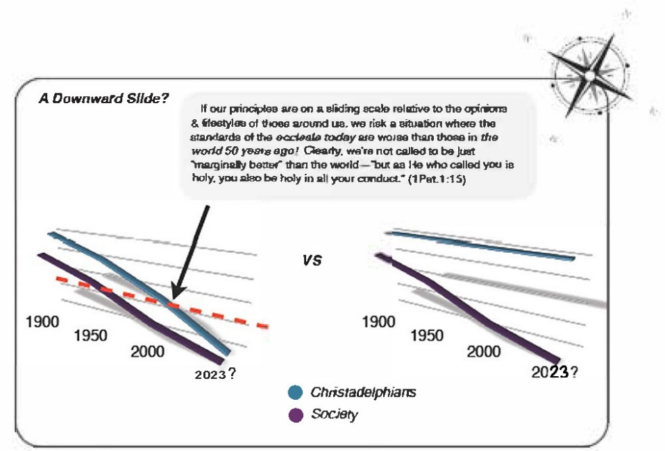
- What are some ways we can ensure that our personal, family, and ecclesial compass always points “true north”? (use scripture to support your answer)

- Not only was the ecclesia letting things slide, but the leaders were actually promoting the problem by setting a poor example: “they were foremost in this trespass”. Imagine being in an ecclesia where your arranging brothers were marrying women of this world and allowing your children to be brought up in the Churches. This is the “Doctrine of Balaam” at work! Take a look at 2Pet.2:13-15; Rev.2:14 (cp. Num.25) and do a brief study on this phrase and what it means. Bonus marks for spotting connections to Balaam/Num.25 in Ezra or Nehemiah (e.g. Neh.13:1-3).

The Doctrine of Balaam?
None of us are perfect and we all have areas of weakness in our lives. But we should never trivialize or gloss over sin because it is considered “normal”. For example, a quick perusal of some Christadelphian Facebook sites reveals that it is apparently okay for us to swear, go drinking with school friends, and enjoy explicit music and movies. Is this “normal” behavior for Christadelphian young people? Its one thing to have shortcomings you’re working on, its another to promote them as an acceptable lifestyle. By our own actions in the pursuit of fulfillment we could be selling out our brothers and sisters by influencing them to go the way of the world. Are our friends becoming the unintended casualties of our pursuit of the “pleasures of sin”? Maybe the Doctrine of Balaam is closer to home than we think.

- Consider some areas of your life where you could be unintentionally encouraging this downward slide by normalizing an un-Christ-like lifestyle in your CYC or ecclesia, then list some ways you can stop being a Balaam and instead be a force for good like Ezra.

- Read Malachi 2. In the context of intermarriage with unbelievers, Malachi lays a condemning accusation at the feet of the priests and spiritual leaders of the nation: “You have departed from the way; you have caused many to stumble at the law. You have corrupted the covenant of Levi.” This “covenant of Levi” is also mentioned in v.5, where it is referred to as a “covenant of life and peace”. This is another echo back to Num.25:11-13. What was happening in Num.25? Who was the covenant made to, and why was it made?

- So, in Ezra and Nehemiah’s day there was a dire need for a “modern day” Phinehas, one who had the qualities of Mal.2:5-7. What were these qualities?

These characteristics could easily be used to describe the Lord Jesus Christ, our great High Priest (who turned many away from iniquity!), but they could also be perfectly applied another priest, a direct descendant of Phinehas— Ezra! The one who had prepared his heart to seek the Law of the LORD, and to do it, and to teach it!
- When worldly lifestyles become “normal” and accepted in our ecclesias, we need people like Phinehas and Ezra; men of depth, integrity, and sincerity to stand firm against the tide—not only by what they say, but most importantly, by how they live. No doubt when you hear the word “leadership”, the first thing that comes to your mind is an older brother who sits on your arranging board, or speaks at Bible schools. But leadership is so much closer to home than that! For instance, leadership could be as simple as encouraging spiritual conversation at CYC, or not playing worldly music in your car on road trips. Reflect on what Ezra’s example of leadership means to you. What are some practical ways which you can follow that example?

- How can younger brethren show leadership in resisting the ‘downward spiral’? How about sisters?

- Ezra is visibly distraught at the news; he rends his clothes and tears out his hair! What does this action express? (e.g. Job 1:20— think about what Job had just experienced)

- Ezra was devastated by the news of Judah’s waywardness, but he doesn’t react angrily or lash out at people who he could have easily condemned. Instead, his response is tempered by serious reflection and focused by prayer. Too often we tend to respond in the heat of the moment and our reaction is harsh and instantaneous. No doubt the best policy in ecclesial life is an objective response after careful consideration and prayer. Develop some scriptural principles on this subject. Here are a few verses just to get you started— Prov.16:32; 21:23; Psalm 106:33, 2 Pet.1:5-7, Gal.5:15, James 3

He who rules his spirit...
It is significant that Ezra fasts all day until the evening sacrifice. You can almost hear people saying ‘why doesn’t he just do something!’ But we must not mistake Ezra’s patient and tempered approach for an unwillingness to take action. Ezra did not act rashly in the heat of the moment when he was upset, but took the matter to God in prayer. Sometimes ecclesial life requires quick, decisive action; at others a patient, tempered approach is needed. Indeed, ecclesial leaders must show temperance, gentleness and patience, and be able to control their own emotions— especially during controversy (Titus 1:7-9; 1 Tim. 3:2-7).
- The remainder of chapter 9 records Ezra’s heart-felt prayer. Carefully read vs.6-15 and try to summarize the main points.

- Read Ezra 9:6-15: Ezra says some incredible things which show just how deeply his mind was rooted in God’s Word (e.g. v.8!). Summarize his prayer below:

- Read Ezra 10:1-6: That evening, as Ezra was weeping and praying, a very large assembly of the Exiles began to gather around this priest who had just arrived from Babylon. The people, we are told, wept “very bitterly”. Who else in scripture wept bitterly, and why? Do you think there’s any comparison to how Ezra was feeling?

- In vs.2-4 a man named Shechaniah encourages Ezra to be strong and take action. “Yet now there is hope in Israel in spite of this,” Shechaniah says. Later, in Neh.8, Ezra’s own advice to the people was “do not sorrow, for the joy of the LORD is your strength” (v.10). All of us have experienced the wave of shame and guilt which sweeps over us when we realize how far short we have fallen of the glory of God. But like Shechaniah, we must realize that we can still turn to God for forgiveness and build anew. Study 2 Cor.7:8-11 to define “godly sorrow” and explain how it can “lead to salvation”. In contrast, explain how “worldly sorrow” can eat us up if we’re not careful.

In v.5 Ezra arises and compels the leaders of the priests, the Levites and the people to swear an oath that they would commit to taking drastic steps to heal their nation before it decayed from the inside out. Incidentally, we read in v.18 that even some of Ezra’s own relatives had been implicated in this trespass. This was not a theoretical problem for Ezra— it was emotional and close to home.
- Ezra 10 is a difficult section of scripture to understand. Appendix M reviews some of the relevant scriptural principles on intermarriage with unbelievers and the issue of putting away. You may find it helpful to read through Appendix M before answering the next few questions.

- Read Ezra 10:7-17 and fill in the table below:
‘NO ONE CAN STAND BEFORE YOU BECAUSE OF THIS’ (9:15)
QUESTION | REFERENCE | COMMENTS
What was their plan to restore the spiritual integrity of the ecclesia? | 10:3,11
Whose advice were they acting on? | 10:3,10-11
Was this in accordance with God’s will, or not? | 10:11
In what way was the plan to be implemented? | 10:3
What law is being referred to? | Deut. 24
Who was to be put away: just the unbelieving wives, or their children as well? | 10:3, 44
Who else was to be separated from? | 10:11
Who supported this plan? Did anyone resist it? | 10:12,15-16
What was the goal of this plan? | 10:14 | (cp. Num.25:11)

And so, Ezra and those “who trembled at the commandment of our God” issued a proclamation in vs.7-8 for all the descendants of the Exile to gather in Jerusalem. Within three days, all the Jews had assembled in the open square before the Temple. Ezra arose and laid the guilt squarely at the feet of the Exiles. He exhorted them to confess their sin, and turn back to God by separating from the peoples of the land and putting away their unbelieving wives.
It was now early winter, and cold rain drenched the people as they sat trembling before the house of God. With the rain came a solemn resolve to begin anew, to retrace the wayward steps they had so foolishly tread.
And so, on that rainy day, the work of healing the nation began in earnest. A special ‘committee’ of Arranging Brethren was formed to lead the effort. Men who had married foreign wives and their wives were forced to make some major decisions and after four months the spiritual integrity of the nation was restored.

20. If they simply forced all men with foreign wives to separate, it could have been done in a week. Why do you think this procedure took four months?

How many men in the end had to put away their wives?

How many were priests and Levites?

If there were about 50,000 exile men who returned so far, does it appear the problem of marriages with unbelievers was as bad as first thought?

Although the Law of Moses accommodated the putting way of Jewish wives (Deut.24) because of the hardness of their hearts (Matt.19:8), a provision which Ezra uses here to solve this bad situation, this doesn’t mean that brothers today should divorce all their unbelieving wives!
Here’s a Case Study to consider: Five years ago a sister in your meeting was baptized as a result of the Learn to Read the Bible Effectively seminars. She has two young children who she has been bringing to Sunday School. However, her husband is blatantly antagonistic towards the Truth and constantly ridicules the Bible in the home. Recently he has been preventing the children from attending Sunday School, insisting that they not waste their weekends with religion. Not only that, but whenever she struggles to pray or read her Bible she is deflated by a derogatory comment from her husband. The Truth is becoming a source of contention which is tearing apart their family. Things have gotten so bad that she wonders how much longer she can survive spiritually in this situation. Should this sister use the precedent of Ezra and the Exiles to separate from her husband for the sake of herself and her children?

- How does 2 Cor. 7:10-16 influence your decision in this matter? What about the example of Abigail in 1Sam.25?

  - Conclusion
We leave Chapter 10 with Ezra, like his role model Phinehas, standing in the gap and turning away God’s wrath. Indeed, as Shechaniah had said, there was still hope in Israel despite of this. Ezra had narrowly averted disaster, but there still work to be done and he would continue to nurse his suffering ecclesia back to spiritual health.
  - Optional Exercise
The latter part of chapter 10, verses 18-44, is an account of the many in Judah who had sinned in the matter of intermarriage. Many of the children of the people who initially returned in zeal with Zerubbabel and Jeshua, are implicated here.
If you were to color in all the families in Ezra 2 that showed up in Ezra 10, what would become obvious is that there are a lot of families that are hurting from the intermarriage of their members.
Optional Exercise: Color in the names which occur in both Ezra 2 and Ezra 10. Use the material in Appendix H as a reference.

Summary and Conclusion to Part 1
Looking back over the ground we’ve covered so far, we can see an interesting pattern. The sequence of events concerning these exiles is very similar God’s purpose for all believers as revealed in Christ. Think of how the following can apply to us.
Pattern:
  - Call went out
  - Altar was built
  - Foundations were laid
  - Opposition and Adversity
  - Prophets’ message of hope and encouragement sustains the exiles
  - Temple completed

The most important part of building the Temple wasn’t actually the construction of the physical building, it was the construction of the people, working together, becoming a strong and fortified ecclesia that put God in their center and opposed the wickedness around them. In a way, the actual Temple was only a means that God used to work on his chosen remnant, to mold and shape them into a house that he could live in. So it is with us.

Have a rest and then get ready for Part 2
It’s not as long as part 1!

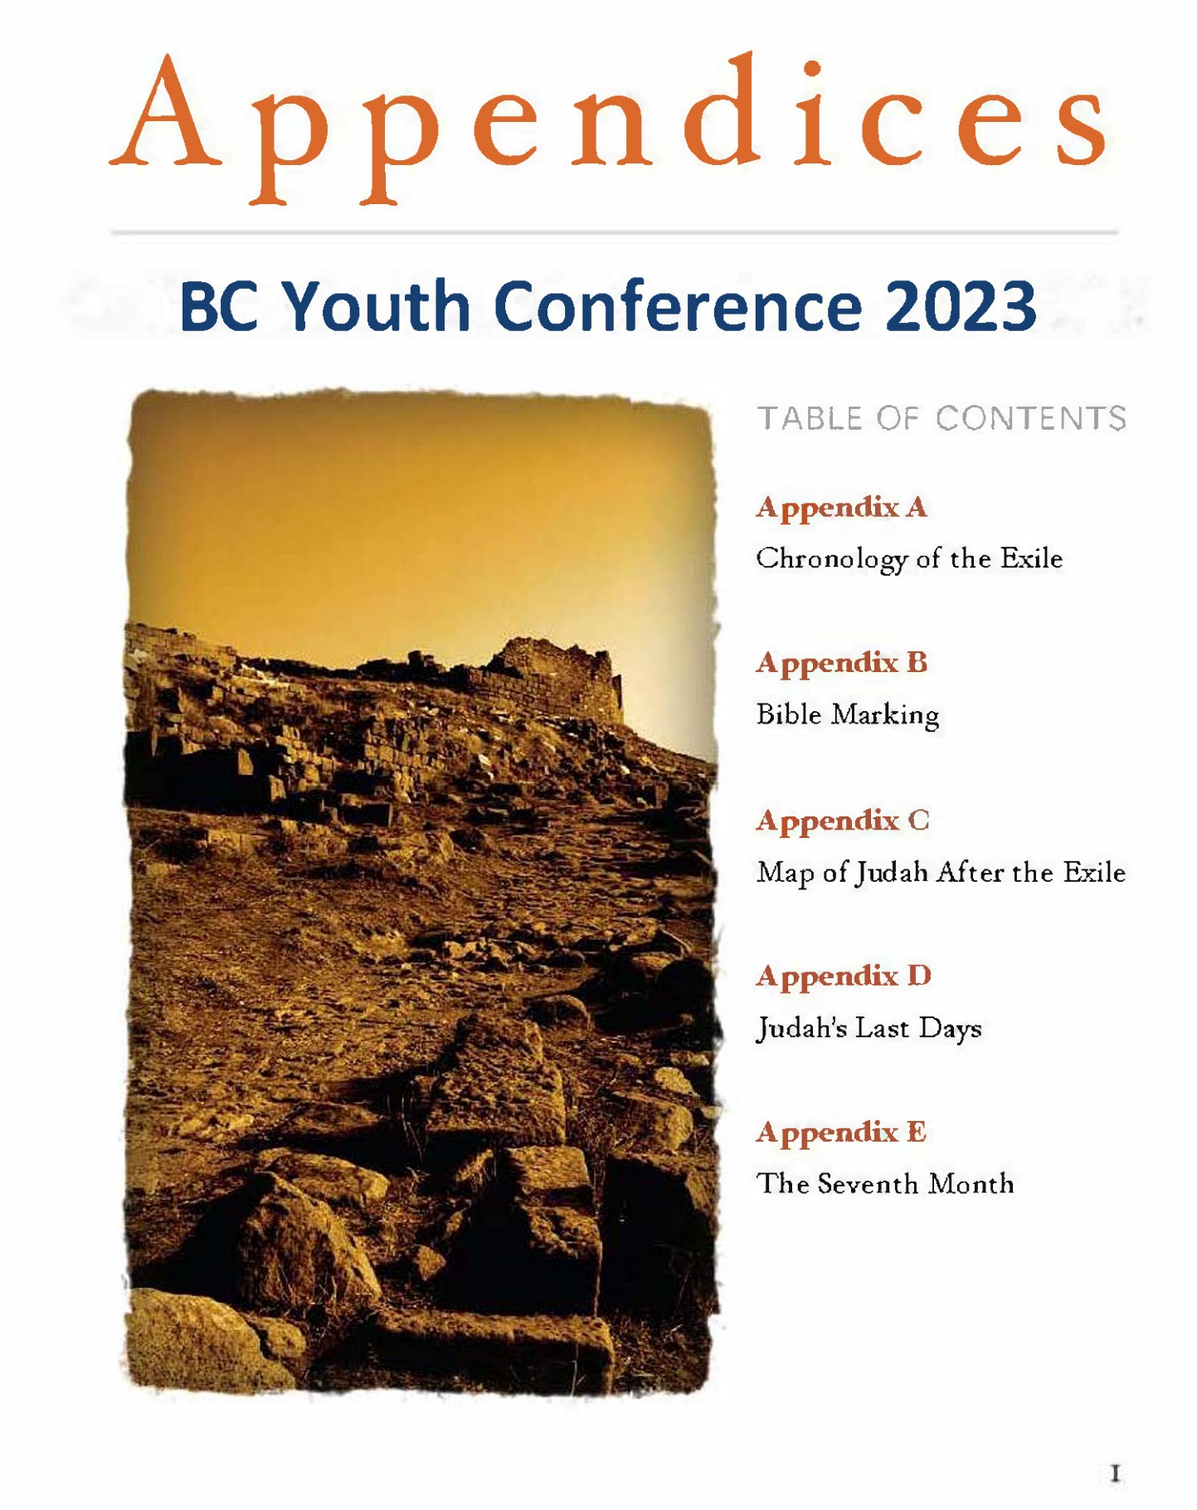

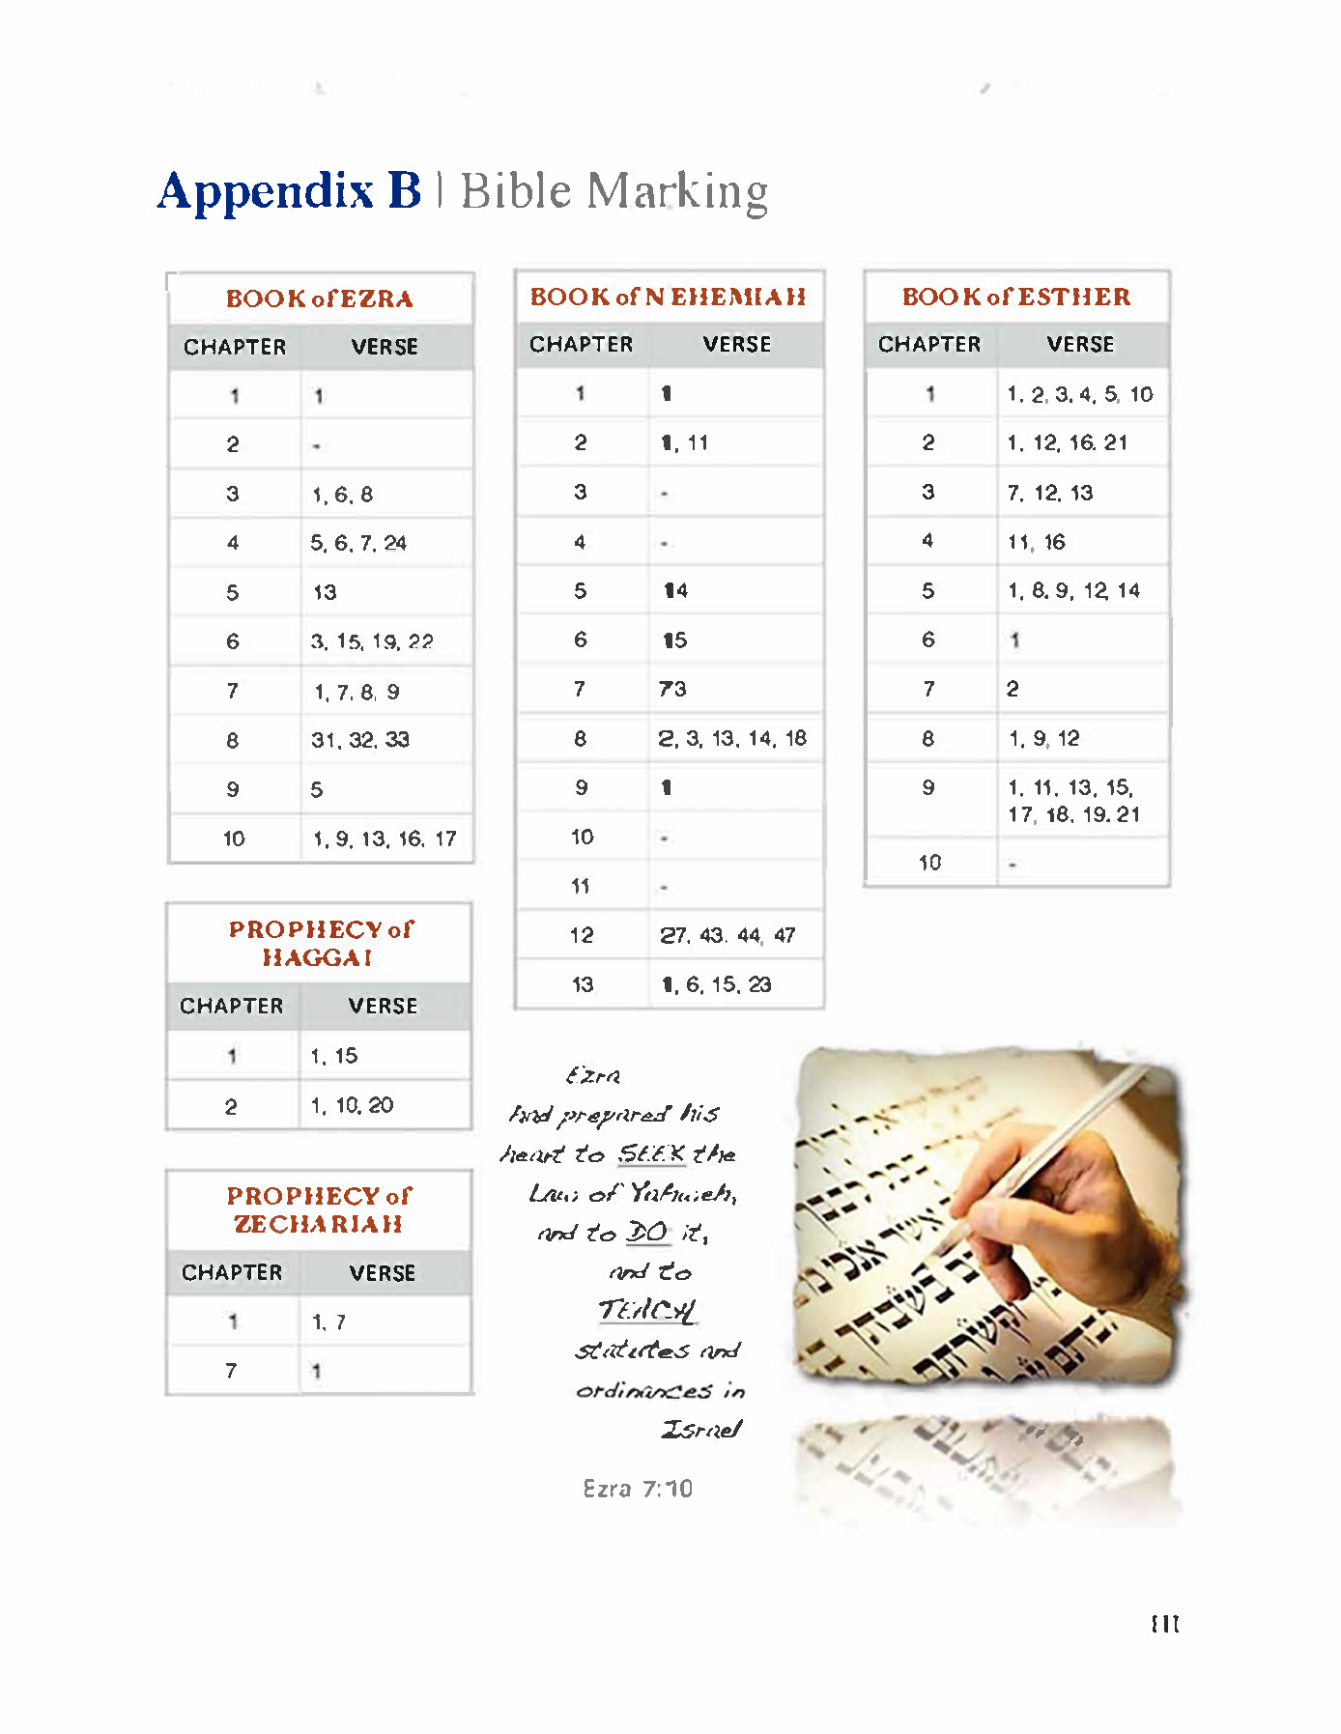
California Youth Conference 2013
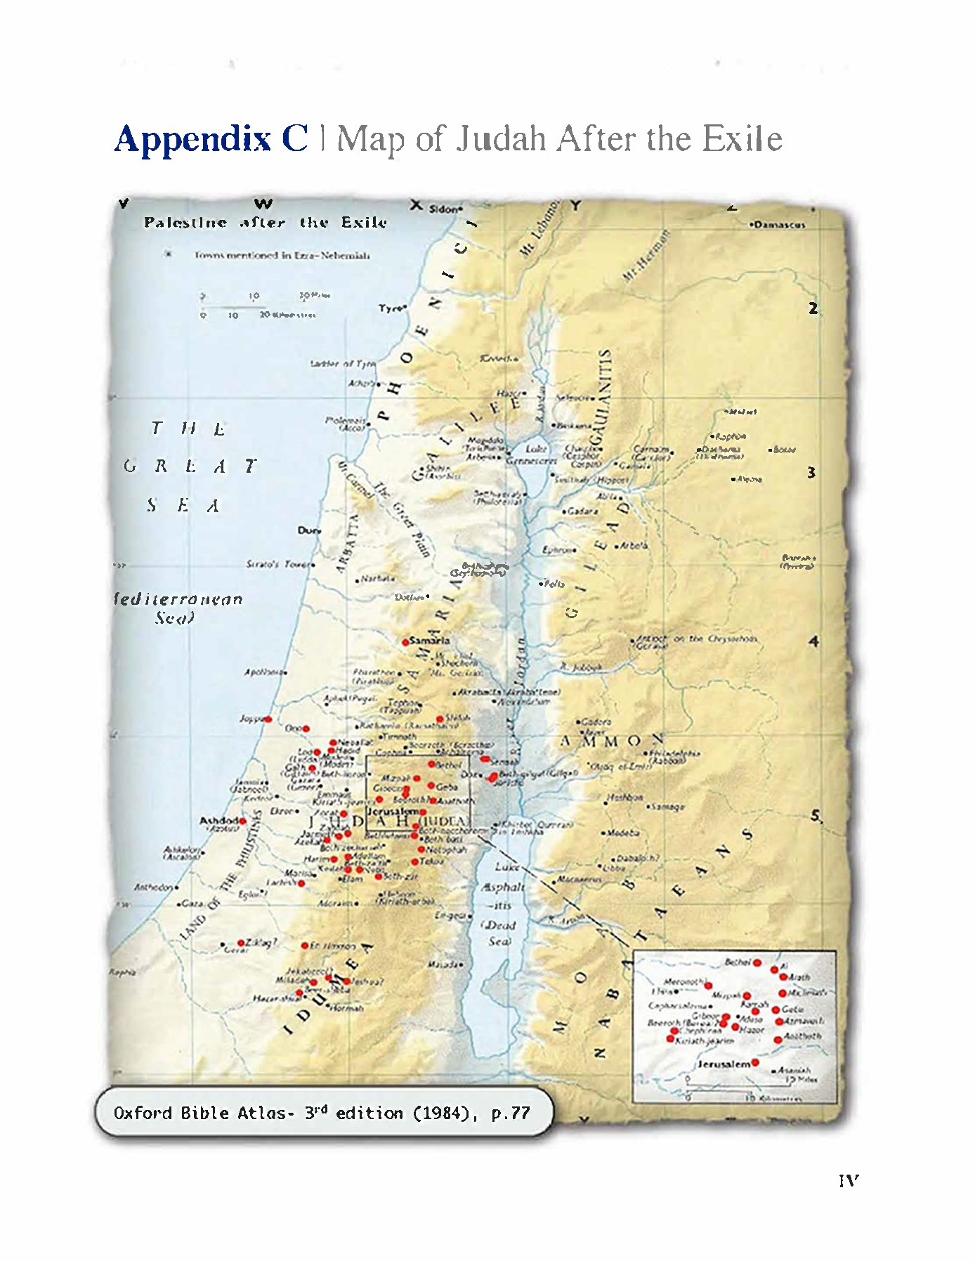
California Youth Conference 2013
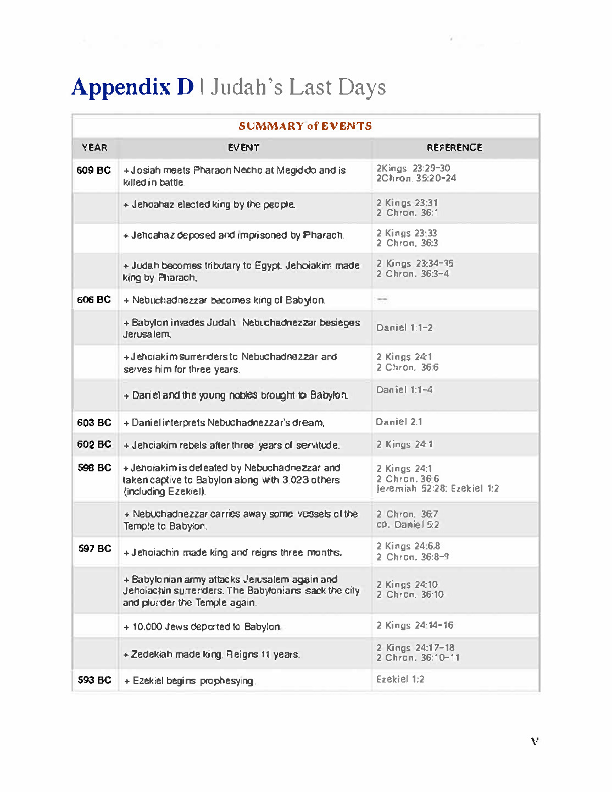
California Youth Conference 2013
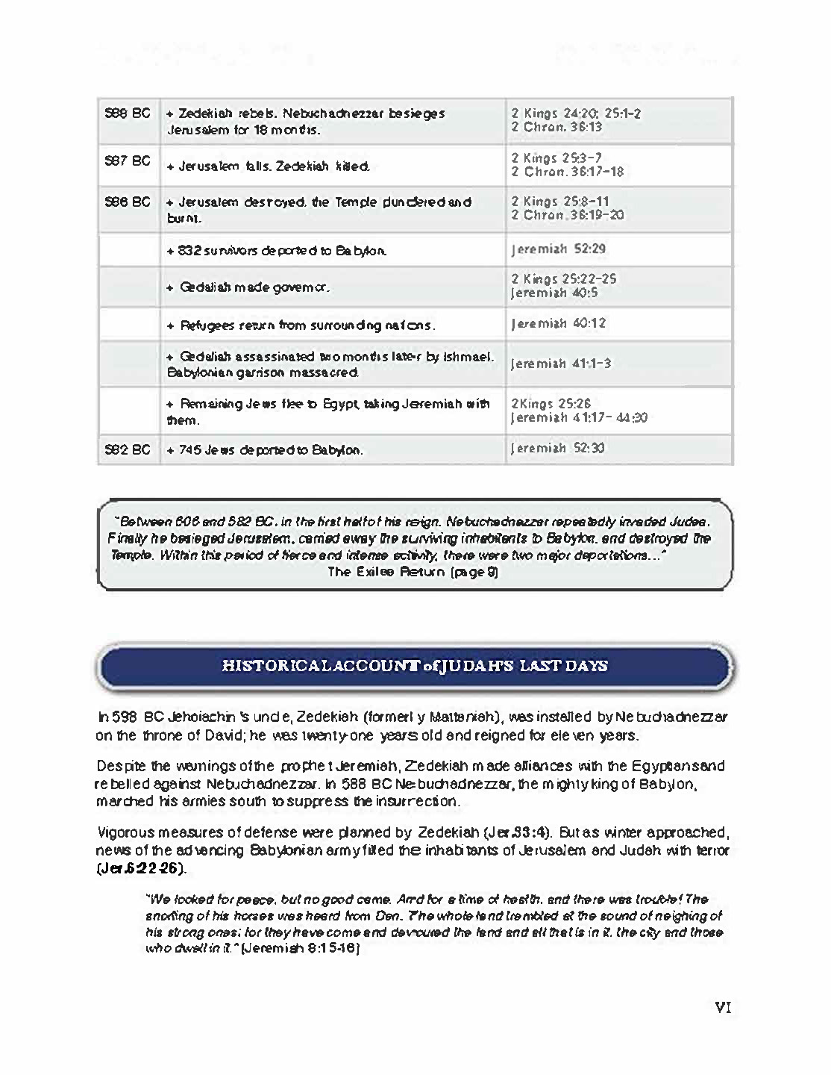
California Youth Conference 2013
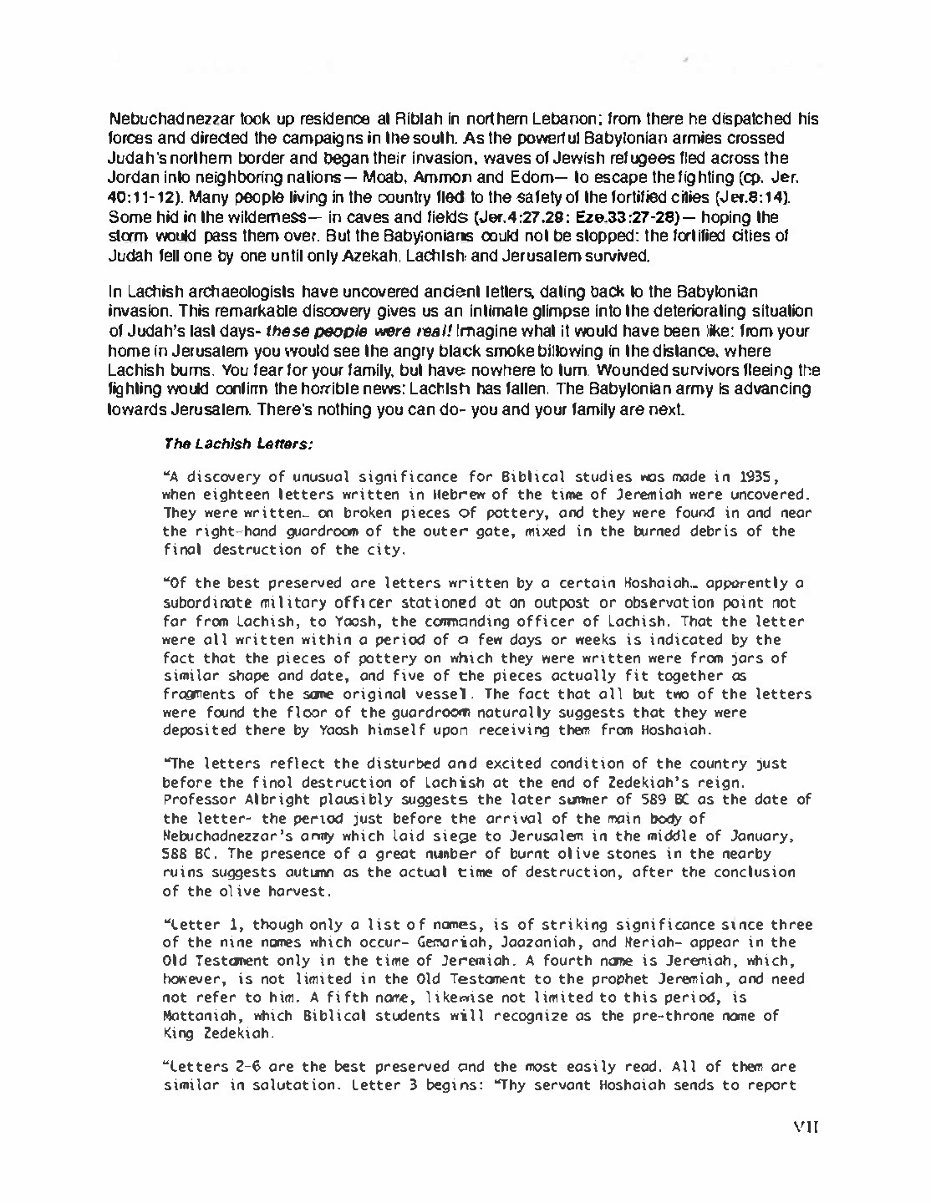
California Youth Conference 2013
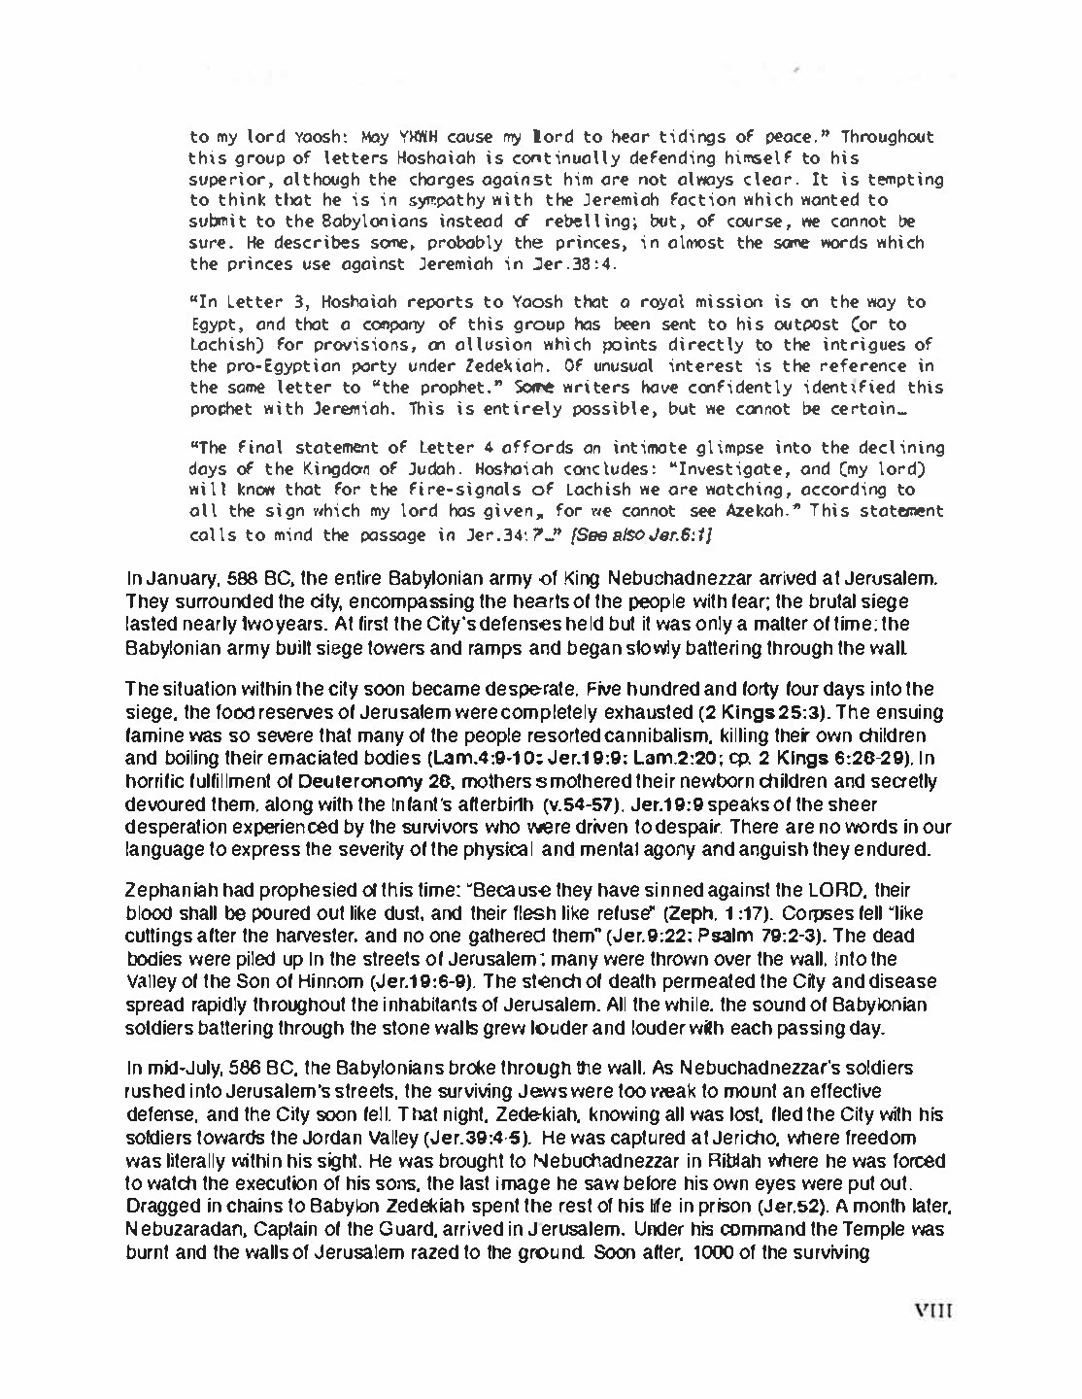
California Youth Conference 2013
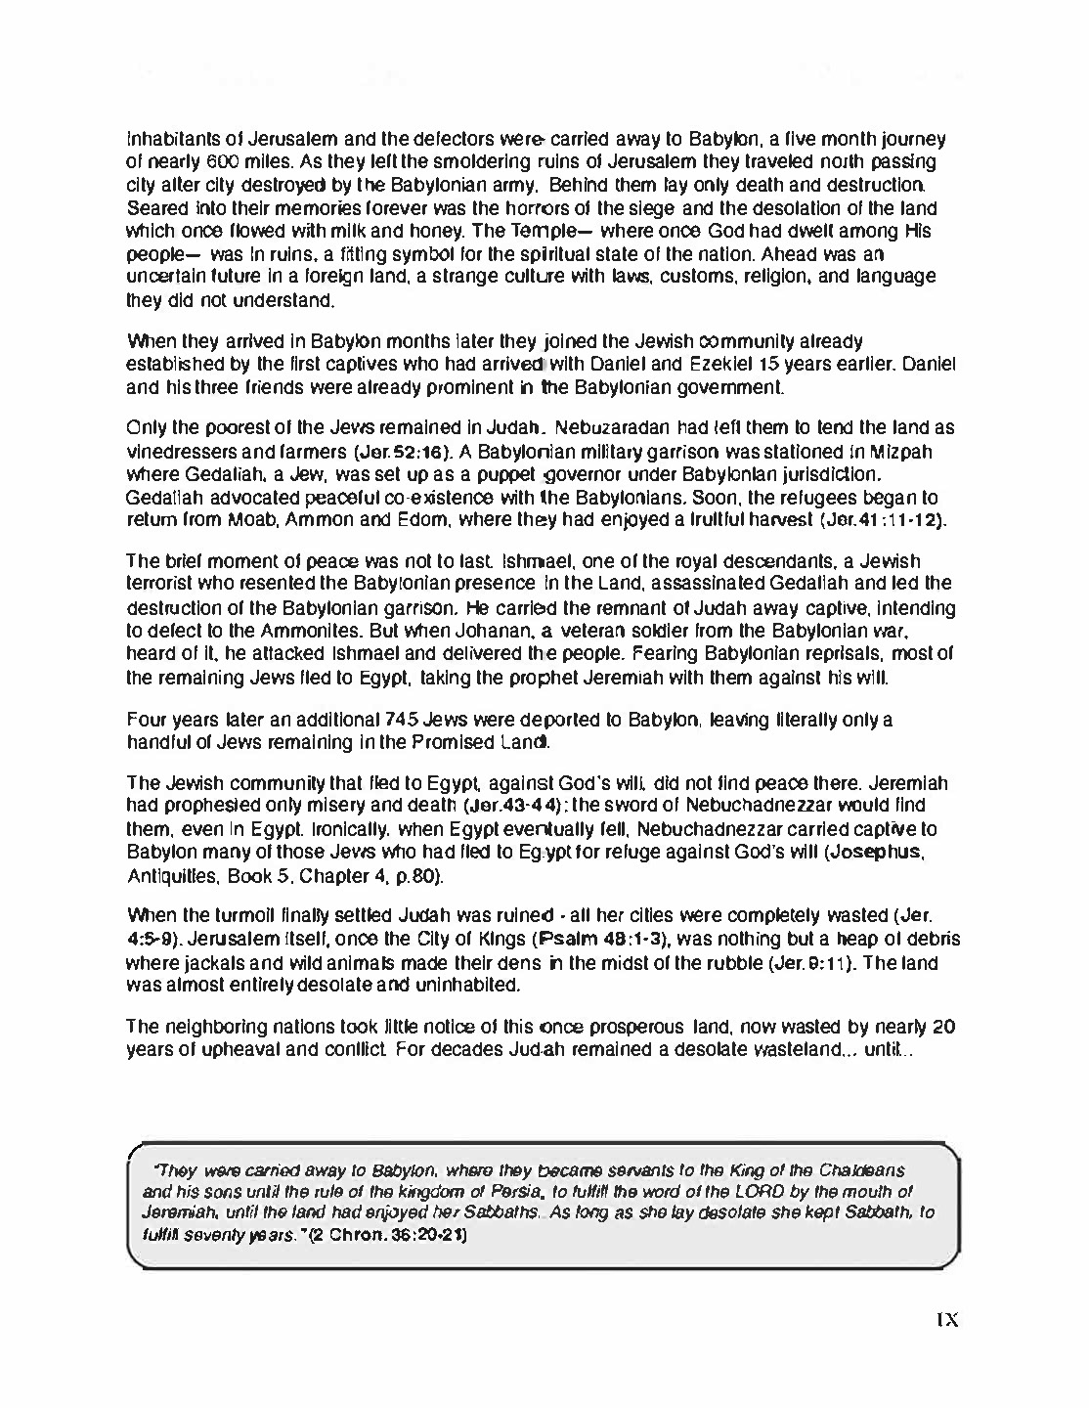
California Youth Conference 2013
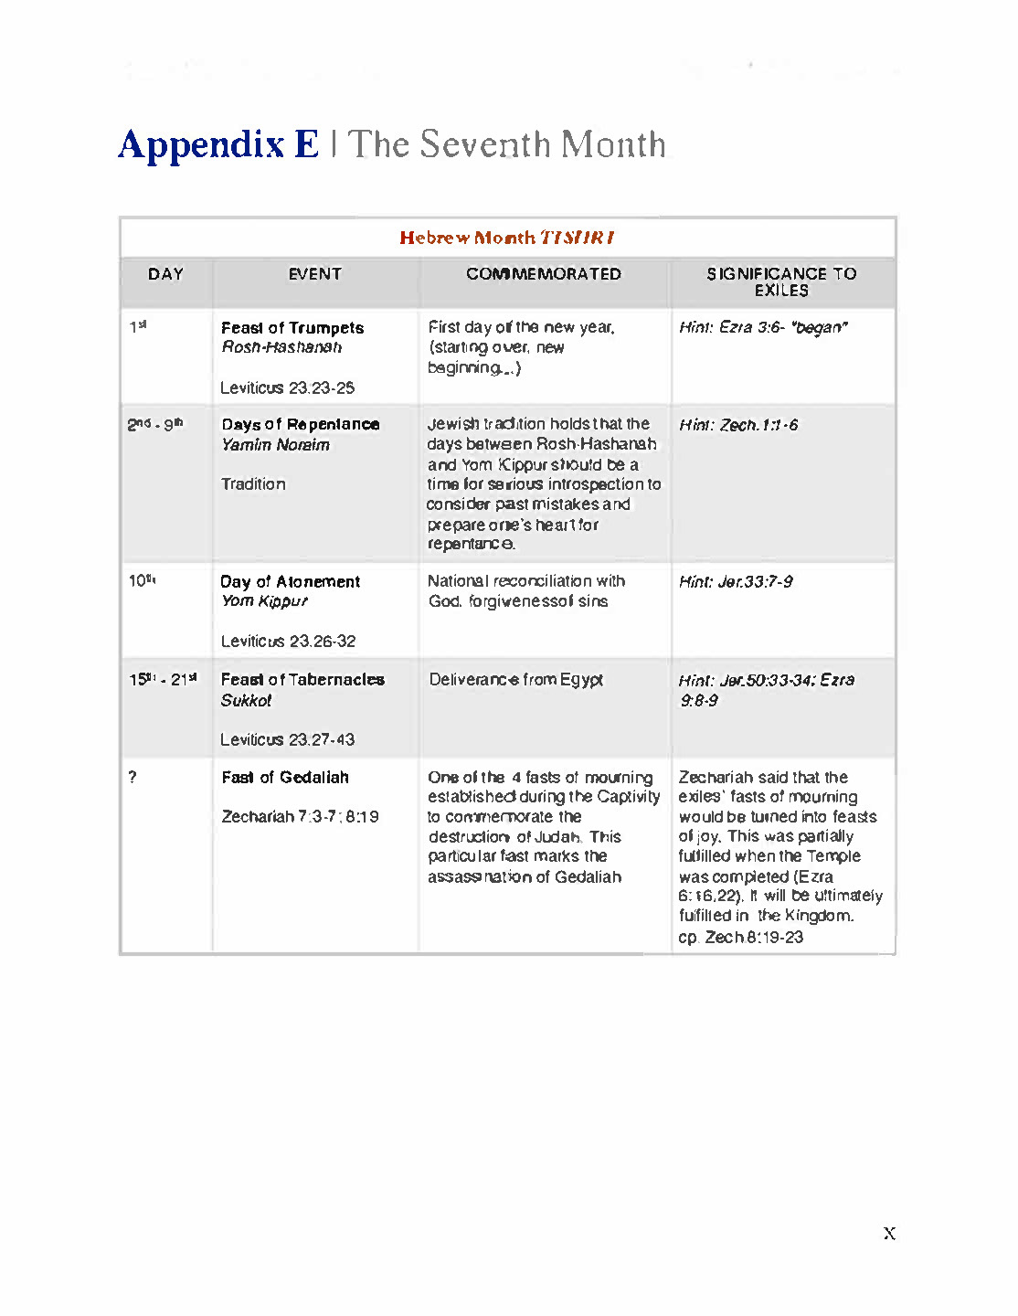
California Youth Conference 2013
Appendix F: Detailed Chronology of Ezra, Nehemiah and Esther
As suggested by bro. H. P. Mansfield

The above chronology, which gathers together most of the references to time periods in these contemporary books, is based upon the suggestion that Darius, Ahasuerus and Artaxerxes are titles assumed by one king – Hystaspes. A slight confusion is apparent in a few cases were months are numbered according to their position on the calendar instead of from the time when the king began to reign. For example, “Adar” of Ezra 6:15 is the twelfth month of the sacred year, whereas the “first month” of v.19 is the first month of the ensuing year. Both occurred in the sixth year of Darius, for his sixth year overlapped the Jewish sacred year. The above chronology is an attempt to synchronize the events of Ezra, Nehemiah and Esther, and appears the most logical and consistent when all problems are considered. It also explains some very interesting facets of this period of Bible history, as will be revealed as our story of the period unfolds – H. P. Mansfield

