Introduction - Part Two
Congratulations on making it this far! Hopefully you were able to capture some practical lessons from the experience of the exiles in the first few chapters. We’ve now come to Part Two where we hope to delve head-first into a study of the life and work of two phenomenal men of faith― Ezra and Nehemiah. In the first part, we covered the background of the exiles and then covered chapters 1-6. Now we’re going to move into Esther, then finish Ezra, then cover Nehemiah.
Part Two
# | Workbook Section | To get the context, read….
9 | God Motivates more Exiles to Return | Esther
10 | Nehemiah Returns | Nehemiah 1-2
11 | Let us Arise and Build | Nehemiah 3-6
12 | Renewal, Dedication & Reforms | Nehemiah 8-12
13 | Principles of Separation | Nehemiah 13

Section 9 – God Motivates More Exiles to Return
Objective:
- To understand who Esther & Mordecai were & how they fit into our study of Ezra & Nehemiah
- To experience how God worked in the lives of His people to encourage them to make good decisions – return to Israel!
- To get excited about Part 2 so you will finish the workbook!

‘For Mordecai the Jew was second to King Ahasuerus, and was great among the Jews and well received by the multitude of his brethren, seeking the good of his people and speaking peace to all his countrymen.’ Est 10:3

Overview
The Temple has been built and the encouragement and labor of the prophets has paid off! The people have celebrated with the keeping of the feast of Passover, such a fitting event, considering they had once again been brought out of captivity and been brought to a land where they were free! Now, under the watchful eye of God and his active hand upon them, they had completed the symbolic spiritual center of their world – the Temple. Their celebration was much needed! They had before them the tangible results of their faith and trust in God, their ability to work as ‘one man’ and their humility to be led and persuaded by spiritual leaders. And, in contrast to Ezra 3:12-13, the joy and celebration was unanimous! No longer were the people divided in their loyalties, some preferring the Temple of Solomon and some only experiencing this new Temple. Now all were celebrating together the good hand of God that had united them through chastening and trouble – and we understand that it is not the pleasant journey that brings us together in the end, but a bunch of tough, real-life situations that help us to appreciate God and each other. Peter tells the ecclesias in the Diaspora, ‘Beloved, do not think it strange concerning the fiery trial which is to try you, as though some strange thing happened to you; but rejoice to the extent that you partake of Christ's sufferings, that when His glory is revealed, you may also be glad with exceeding joy’ (1 Peter 4:12-13).
But the spiritual challenges and troubles were not over, as we shall see in the second part of our study – but neither was the praise to God or the spiritual growth of many of the individuals. Ezra probably returned right after the dedication of the Temple and with his spiritual leadership the nation would get at the root of some of the problems they were dealing with. Up to now, not a word has been said in this account about marriages to the nations around them. Neither has reading or praying together been a focus. But this man, with God’s strength, is about to lead a spiritual building of the altar and Temple in their hearts, and it will prove to be very difficult. Here comes a man into the ecclesia that has ‘prepared his heart to seek the Law of the Lord, and to do it, and to teach statutes and ordinances in Israel’ (Ezra 7:10). And that is saying nothing of Nehemiah who would come about 13 years after Ezra, as another great spiritual and team leader to unite the ecclesia again and deal pragmatically and efficiently with many problems that had cropped up in the ecclesia yet again. We will see that God’s purpose with these leaders was to bring His people closer to Him by removing their sin through their repentance and change of conduct. Such is the lot that we are in. Such is the challenge that we are faced with.

The Timing of Esther
Although many of the Jews had returned to the land of promise, there were still others who had stayed behind for one reason or another. Mordecai and his younger cousin, Hadassah, were just such an example. We will get into the details and lessons of this book, but first, let’s get our bearings. The story of Esther falls into the time of Ahasuerus, the king of Persia, who is most likely the same king as Darius Hystaspes in the book of Ezra.
- In what city do most of the events in Esther take place? (Esther 2:5) Where else in scripture is this place mentioned? (Hint: Dan.8:2) Look briefly at a Bible encyclopedia and comment on the importance of this place.

- Where else were some Jews located, besides Israel? What kind of a people are they? (Esther 3:8-11)

- Where was the genocide of the Jews supposed to take place? (Esther 3:12-14) Where did the people defend themselves at? (Esther 9:2) From understanding this, how widespread was the deliverance that Mordecai and Esther’s courage brought?

- Where did Nehemiah live? (Neh.1:1) Would he have probably known Esther?

- In Nehemiah 2:6, why do you think Scripture mentions “the queen also sitting beside him (King Artaxerxes)”

In the book of Esther, the Jews are saved by the courage and faith of Mordecai and Esther. The Jews are allowed to defend themselves from all those who hate them – the recurring theme of the Jewish existence. Esther 9:1-5 relays the events that took place across the empire as the Jews destroyed those who would have exterminated them. It is very possible that Nehemiah, from Shushan, would have been involved in this amazing deliverance from the enemies of the Jews.

- Even though the Jews had been saved by their loving Father, the nations around were clearly not happy. According to Neh.4:23 what happened after the deliverance? Why do you think this happened?

You can see that there is a lot packed in between Ezra 10 and Nehemiah 1. The dramatic events of Esther all happen within this time period, showing us the opposition the Jews continued to face, and the wonderful deliverance that God worked out for his chosen people.

The Book of Esther
The whole book is a microcosm (like a small history) of the story of the Jews – near extinction and ruin to a glorious end and salvation. God shows Himself powerful through the instrument of a delicate and beautiful woman, Esther, who finds herself at the very center of the most powerful nation on earth at that time. God redeems His people through the work and faith of Mordecai, and also triumphs over Haman (a descendant of Amalek) through him.

- It is important to understand the characters that are in this account.
  - How would you describe Esther from these verses: 2:7-18; 4:4-16; 5:1-8; 7:1-8; 8:3-7; 9:12-13. Why would you love to have her in your ecclesia?

  - How would you describe Mordecai from these verses: 2:19; 3:2; 4:1-14; 4:16; 6:10-12; 7:10; 8:2; 8:9; 8:10? Why would you love to have Mordecai in your ecclesia?

  - How would you describe Haman from these verses: 3:1-15; 5:9-14; 6:4-14; 7:1-10? Explain why or why not you would want Haman in your ecclesia.

- Esther found out from Mordecai that all the Jews were going to be murdered and annihilated because of Haman. The way that she approached the king to persuade him to change this verdict is very helpful to us. After reading 5:8; 7:3-6; 8:5, explain how you think Esther is amazing to you. Girls, how can you emulate Esther? Guys, write down how this kind of a response is easy to respond to in a positive way.

- List 3 ways Esther shows her faith throughout her trials and deliverance.

10. Mordecai is an awesome foreshadowing of our coming King! Just let the following verses wash over you and be amazed at the beauty of God’s word 8:15; 9:4; 10:2-3. Write down as many parallels to Jesus as you can.

We see then, “the end intended by the Lord – that the Lord is very compassionate and merciful”. He had saved his captives and brought them relief through His good plan. The end of Esther, ends on a note that speaks to us of Christ’s return and our salvation: “For Mordecai the Jew was second to King Ahasuerus, and was great among the Jews and well received by the multitude of his brethren, seeking the good of his people and speaking peace to all his countrymen [or seed]” (Esther 10:3). When Christ rules this world in righteousness and peace, he will be second to the Great King, his Father – ‘when all things are made subject to Him, then the Son Himself will also be subject to Him who put all things under Him, that God may be all in all’ (1Cor.15:28). And He will seek the good of his brethren and He will be well received by them all.
Thus the interlude between Ezra 10 and Nehemiah 1 has been given a small amount of attention. What a message of hope would have reached the ears of the free Jews of Jerusalem who would also have been under the threat of persecution and annihilation! We don’t know for sure but we can imagine them praising and offering sacrifices of praise upon their altar at the Temple to thank God for being so gracious to them and once again saving them from death and ruin. For His mercy endures forever!

Section 10 – Nehemiah Returns
Objective:
- Understand how Nehemiah felt about his brethren in Jerusalem
- Get to know Nehemiah and brainstorm about spiritual leadership
- See Nehemiah’s faith in action with the king
- Understand Nehemiah’s method of convincing others to build
- Learn how to stand up for the Truth!

“Now these are Your servants and Your people, whom You have redeemed by Your great power,
and by Your strong hand.” Nehemiah 1:10

The state of Jerusalem
In Jerusalem, the ‘survivors’ were in ‘great distress and reproach’ and ‘the wall of Jerusalem is also broken down and burned with fire.’ It appears that all the work finishing the temple didn’t continue into building up the ruined city of Jerusalem. When Nehemiah comes, the Temple has been built, the altar for sacrifice has been set on its bases and used, but the walls lie in ruin. This leaves the people in a state of fear.
In Neh.1:3 we have the Jerusalem report that Hanani brings to Nehemiah when he is in Persia serving the king. Let’s take a look at some of the words he uses:
- What does ‘distress’ mean? It seems there may be more to this word than first meets the eye. How else is it translated?

- What does ‘reproach’ mean? Was this ever used about the children of Israel in the past?

- The ‘wall of Jerusalem’ was destroyed by Nebuchadnezzar. Why were walls important to a city? (Hint: 2Sam.5:6-9; 1Ki.3:1; 2Chron.32:5; Zech.2:5)

Nehemiah comes on the scene
- So who is this Nehemiah? His name means ‘consolation of Yah’ or ‘Yahweh comforts’ – one of those fitting names in scripture. Read 2Cor.1:3-7 and comment on similarities between Paul and Nehemiah.

- After reading vs.4-11 and understanding how Nehemiah responds to this bad news about Jerusalem, write down what kind of a man you think Nehemiah was, as he responds to hearing about the state of Jerusalem. What were his priorities?

- One of Nehemiah’s first reactions is to pray to God – do you do this as a first reflex? Why or why not? Write down the main elements in this prayer. (ex. v.5 - extolling God’s greatness)

Nehemiah was a man of the Book – he studies God’s word in order to live acceptably before Him. To establish how well Nehemiah knew his scripture, we need to look into this prayer. It is both a cry to God and also an insight into Nehemiah’s heart and mind. First off, there are so many ties to Daniel’s prayer in Dan.9:3-19, it’s hard to keep track of how many! This makes perfect sense, as we see that Nehemiah probably looked up to the memory of faithful Daniel who had prophesied about the return of the Jews, and even greater things beyond.

Here are some of the prayers of Nehemiah throughout the book. Write down a one sentence summary explaining what each of them is about:

Prayers of Nehemiah
1:5-11 | Asking the Lord to remember his promises with Israel and to help his brethren in Jerusalem as well as himself before the king
2:4 | (Hint: use your imagination!)
4:4-5
5:19
6:9
13:14
13:22
13:29
13:31

In v.11 Nehemiah tells us his occupation - He was THE cupbearer – what is that? How important of a job was it? Use a Bible Encyclopedia to help you.

Like Daniel, Joseph, Esther, Mordecai or Ezra, he was a man clearly held in high esteem by the rulers. And the moment came for Nehemiah to answer the same question that Mordecai had posed to Esther in Esther 4:14, ‘who knows whether you have come to the kingdom for such a time as this?’

Godly leadership
As we study Nehemiah, we will see the qualities of a great and godly leader. We will see a man who led by serving. We will see a man who was able to conquer his doubts and fears, a man who would stand up for God when he needed to, a man with a goal in his mind and a way of including everyone in it.
- List some characteristics of great leaders - what are the qualities that make them great? It would be great if you have scripture to back you up, but you don’t have to. Jot down as many things as you can.

Going before the king boldly
- For how long had Nehemiah been fasting and praying? (Hint: 1:1; 2:1 – refer to the Hebrew Calendar in Appendix I)

- When we say that Nehemiah’s prayer in front of the king in 2:4 was quick, keep in mind that Nehemiah had been praying, fasting and meditating on this day for many months before! Much preparation and thought goes into the ability to make quick and godly decisions on the spot. List some situations that you might find yourself in where you would offer a quick prayer to God.

Nehemiah the cupbearer goes before the king with sadness written on his face. He could no longer hide the deep empathy he felt for his brethren. Sadness in front of the king could bring instant death! No wonder it says that Nehemiah was ‘dreadfully afraid’! Even so, he came boldly to the throne. Is he scared? Yes! Does he know how things are going to turn out for sure? No, but he is prepared after prayer and communion with his God – he leaves it in his Father’s care.
- In 2:3, what is Nehemiah’s primary reason for being so depressed? Why is he so preoccupied with this? Why should WE be preoccupied with similar thoughts? (Hint: Psa.122; 125; 137; 102:14; 87)

- In V.5, Nehemiah teaches us a valuable lesson about manners. How does he preface his question? Who else uses similar words to help obtain something? (Hint: Est.7:3; 8:5). What is the lesson here when asking our parents, our friends or others for a favor?

‘So it pleased the king to send me’ – the word ‘pleased’ is the same as in v.5 where it says ‘favor in your sight’ – Nehemiah had gotten exactly what he asked for!

- What are the 3 main things Nehemiah (boldly) asks the king for in v.5-8?

Nehemiah saw all these events ‘according to the good hand of my God upon me’ (v.8) as Ezra did earlier in our studies – both men saw God’s providence clearly!
- Think about how the good hand of God has been upon you and come prepared to discuss this:

The journey home
So Nehemiah begins his journey to Jerusalem. He was not alone though – as the governor, he was given an escort from the king in v.9.

- This was very different from what Ezra had done when he had come back in Ezra 8:21-23. Why do you think they did this differently? Is one more right than the other? Explain.

On Nehemiah’s journey to Jerusalem, he would have come from the north through Samaritan country. We are introduced in v.10 to two men who eye Nehemiah as a threat - Sanballat and Tobiah. They are ‘deeply disturbed that a man had come to seek the wellbeing of the children of Israel.’ That phrase alone tells us a lot about these two individuals. Mordecai did the same thing as Nehemiah – Est.10:3.

- We really need to get a handle on Tobiah and Sanballat because we will be constantly coming up against them as they oppose the Jews time and time again in the book of Nehemiah. Using a Bible Encyclopedia and a concordance, jot down some notes on each: who they are, where do they come from and what are the ways that they oppose the Jews:

With great secrecy at night, Nehemiah travels around the city to inspect the walls. Look how well he knows the city from vs.13-15 – it’s like giving someone directions to the house you’ve lived at all your life! He knows every landmark – in the dark! He names off gates, wells and pools as if he grew up in Jerusalem!

- What does this tell us about Nehemiah? (Hint: Psalm 48:13). What does this tell us about ourselves who have never seen the kingdom?

- Nehemiah first examines the state of the city secretly, before he begins working on it (2:13,15). Why do you think he did it secretly? Why do you think it was wise to examine everything first? What is the lesson for us? (Hint: Prov.27:23 – look up how the word ‘state’ is translated)

Formula for winning others over
From what we can see, things are about as bad as Hanani had reported. But Nehemiah is optimistic – better than optimistic, he is faithful! In vs.16-18 we have an incredible example of how to impress others to join in a Godly plan. Nehemiah needs to convince others of how important it is to have walls for protection and security. In the chart below, fill in the details of the steps he took to unify Judah:
Verse | Step | Details
17 | Identifies a need
17 | Provides a solution
17 | Gives a goal
18 | Encourages them spiritually
18 | Their response
Key Principle
Often, a situation in our life can feel like this – we see problems without solutions, we have concern or fear for what the future will be like, we feel confusion about what course of action to take. We may feel frustrated because we see problems, but can’t seem to fix them. We may feel that we have no one to look up to or that everyone else doesn’t care about the Truth. If we feel like this, we have identified with these men and women who were wringing their hands in an ecclesial crisis. There was a physical problem: no walls for defense and security. But there was an even bigger spiritual problem: lack of faith, prayer and action to build spiritual homes. And here we learn a critical principle that God would have us learn: We CANNOT respond to physical problems in our lives with a physical solution – We MUST respond to physical problems with spiritual solutions. Prayer, spiritual encouragement and reading God’s word will help us do just this!
‘Let us rise up and build’! The people had been won over by Nehemiah’s spiritual thinking and practical plan. They were united in purpose! ‘Then they set (or strengthened) their hands to this good work’.
- Read Matt.7:24-27! Perhaps Jesus was thinking about this very instance. What is the lesson for us in light of Nehemiah and his brethren? How do we do this in our daily lives?

Nehemiah empowered the people to take ownership of their lives by providing spiritual guidance – this led to incredible fruit after the building of the wall was complete – we’ll see that from Nehemiah 6-12.

Nehemiah sets the stake in the ground
And then right away, Judah is hit by the mockery and disdain of the nations around that hear of their plans to build the walls of Jerusalem. They oppose Nehemiah and the workers by questioning their authority to build – ‘what is this thing you are doing? Will you rebel against the king?’
- In v.19, another adversary is introduced who worked so actively against the Jews: Geshem the Arab. Using an Encyclopedia and a concordance, sketch out a similar biography of this man, as you did with Tobiah and Sanballat.

- Geographically, these three with their followers definitely surround the small Jewish enclave that had returned from captivity (refer to Appendix C). These three come together to laugh at the beginning of the building of the walls – they despise these Jews. List others in scripture that were laughed at and despised for their godly faith and obedience. (Hint: you can start with Job 30:1). What things in your life could seem ridiculous to others, simply because you are trying to be faithful to God?

- Nehemiah says that the ‘God of heaven’ would prosper their way. This title for God is a pretty unique phrase which is heavily used in Ezra (1:2; 5:11,12; 6:9,10; 7:12,21,23). It seems almost as if Nehemiah has heard Ezra say it and he decides to use it to identify his God as the One who looks down on the earth from above – all powerful and all seeing. Find where else this phrase is used.

- There is not a HINT of compromise in Nehemiah’s answer. This is what he says: ‘you have no portion, nor right, nor memorial in Jerusalem’ (v.20). Look at these 3 pieces closely:
  - No portion:

  - No right:

  - No memorial:

- We may be asking, ‘isn’t it harsh how Nehemiah answers these people?’ or ‘but I don’t know when to use this no-compromise approach to separation’ or ‘this wouldn’t really help these men to see the love of God would it?’ What would you say to that? Why did Nehemiah answer so negatively? Was it right? (Hint: think about if these 3 men came into your ecclesia – what would you do?)

Key Principle
Isn’t this the same thing that Jesus faced in the Pharisees, Sadducees and Lawyers of his day? The ‘spiritual’ leaders were so like Tobiah, Sanballat and Geshem. They mocked Jesus, they laughed him to scorn and they opposed his faith in God. He would rebuke them so sharply, yet comfort and encourage an adulterous woman. It was ‘Woe to you!’ to the scribes and Pharisees', but ‘fear not little flock, for it is your Father’s good pleasure to give you the kingdom’ to his disciples. His emotions were compassion and care for the multitudes that came to hear him teach the gospel, but anger and frustration at the teachers of the law that hated his healing on the Sabbath and led others astray by their legalistic religion.
- So when something opposes our God, what do we do? If someone who is not Christian told you that your ‘Bible-thumping’ was old fashioned, that it impeded the progress of our society, that your intolerance and your exclusivity is stupid, that your teaching that sex before marriage is wrong and so impractical, that your God is clearly a myth and you’re trying to uphold his standards is ridiculous, what do you say?

Section 11 – ‘Let us arise and build’
Objective:
- See the ecclesia HARD at work on the wall
- See that there are always problems in ecclesial life, even in the background
- Understand how we are building the walls of our Jerusalem
- Feel the challenge of dealing with opposition from within and without
- Understanding Nehemiah’s personal trials and triumphs

“And it happened, when all our enemies heard of it, and all the nations around us saw these things, that they were very disheartened in their own eyes; for they perceived that this work was done by our God.” Nehemiah 6:16

Introduction
With the words ‘Let us arise and build’ coming from the people and not JUST Nehemiah, the effort to do God’s will became a national initiative. Nehemiah had changed the perspective of the Jews who had lived fearfully with broken down walls for years. Now, the ecclesia began to take responsibility for themselves in the sight of God. Their Father had already done so much – the fact they were back in the land should have amazed them every morning they woke up and realized they were not in captivity! And now the action starts in Nehemiah 3.
The parallels between Christ’s ecclesia and the events in Ezra and Nehemiah are almost unparalleled in scripture. There are so many ties with the NT about spiritually building up ourselves and our ecclesias. 1Cor.12 just oozes with echoes to Nehemiah building the wall with his brethren (1Cor.12:18,19,22,26-27). And so that is what we are going to talk about now – an ecclesia that has risen to build!

An ecclesial snapshot
Many of these builders work hard because they understand that ‘the Lord loves the gates of Zion, more than all the dwellings of Jacob. Glorious things are spoken of you, O city of God!’ (Psalm 87:2-3). In faith, they knew the promises that God had given to David in 2 Samuel 7:16 and knew that the right thing to do was build! But an ecclesia is not perfect – as long as humans are in it! This is a snapshot of the ecclesia, ‘warts and all’. Please look at the verses in the chart, look at the connecting verses and then write a little about these characters. Ask questions like these: Where are they from? What was their job? What else did they do other than build? Good or bad or in between? Lessons for us?
Neh.3: | Group/Individual
1 | Eliashib - 3:20-21,28; 13:3-8,28
2 | Men of Jericho - 7:36  *ironic that Jews who occupied the former city whose walls were destroyed came to help! Build!
4 | Meshullam - 3:30; 8:4; 6:18-19
5 | The Tekoites - 3:27; 5:6-9; 1Cor.1:26-31; 1Tim.6:17-19; Mark 10:42-45
6 | Jehoiada and Meshullam (Hint: they were probably both sons of the Nethinim - Ezra 2:49) - 3:26; 2 Chron.2:17-18
7 | The men of Gibeon - Josh.9:3,4,27
8 | Uzziel - 3:31,32; Mal.3:2-3; 1Pet.1:7
8 | Hananiah - Ex.30:25; Rom.15:1-3; 2Cor.2:14
12 | Shallum - Ezra 10:24; Ex.35:25; Acts 21:8-9; Phil.4:3; Psalm 144:12

Key Principle
You can see that the ecclesia in Israel at the time of Nehemiah had many similarities to our very own: Diversity of culture and ethnicity; Diversity of occupation; Diversity in gender. ‘For you are all one in Christ Jesus’!

Building the Walls of our Jerusalem
In Revelation 21:9, an angel comesto John and says, ‘Come, I will show you the bride, the Lamb’s wife.’ And what does the Lamb’s wife look like? The ‘great city, the holy Jerusalem’ (v.10)! The Lord’s bride which is the multitude of saints from every generation are likened unto Jerusalem, the city of peace! We are a city, where God dwells, where the spiritual center of our lives resides. So the question is, how are we building that New Jerusalem? That’s our job now in the 21st century.
- Read 1Cor.3:5-18. Explain the parallels from this passage with Nehemiah and the builders on the wall. Then explain the lessons that these verses help us to understand.

- What is the purpose of building walls around a city? What is the spiritual analogy to us? (don’t say it’s keeping out everybody, since Jesus has asked us to go ‘into all the world and preach the gospel to every creature’). Please be as detailed in your thoughts here as you can be.

Cruel mockings
In Nehemiah 4, we come across some of the largest challenges that the team of builders in Jerusalem come across. This chapter was happening at the same time as Nehemiah 3 – not after. We will witness some of the most hateful, angry and godless men in scripture in this chapter. In Neh.4:2-3 Sanballat and Tobiah mock and make fun of the Jews – this is never a good idea!
- In v.1 Sanballat is FURIOUS and very indignant that the Jews would even THINK of rebuilding the walls of Jerusalem! How dare they! In v.2 he calls the Jews ‘feeble’. Why would he have thought this? (Hint: Zech.12:8)

- Show some examples about how God chooses the weak to demonstrate his strength. (Hint: look at 1Sam.14:11-12; 17:43-44 to start off with)

- Bringing the point home to us, what do you make of 1Pet.2:4-5? What is Peter trying to tell us here?

- In v.3, Sanballat’s ‘sidekick’, Tobiah, joins in the mockery. What does he say here and what happens in Nehemiah 12 that would see Tobiah singing a different tune?

- With all these crushing insults and mockings, how does Nehemiah respond in Neh.4:4? Can you think of anyone else who suffered the same fate that Nehemiah prayed his enemies would come to? (Hint: Est.9:25)

Key Principle
God Himself states in Num.23:23 the rules about persecuting or manipulating His chosen people: ‘For there is no sorcery against Jacob, nor any divination against Israel. It now must be said of Jacob and of Israel, ‘Oh, what God has done!’’ No one can bring anything against His people if he has not commanded it. Let that be a warning to any nation in our day that comes against the seed of Abraham! As Nehemiah knew very well from Zechariah’s prophecy in 2:8, it is like touching the eye of God!

Their strength is failing
Neh.4:10-12 describes the general feeling of the people – real fear and weakness. These workers and families were tired out, exhausted and their nerves were rubbed raw from the constant fear that they felt and the constant vigilance they had to show day and night.
- In v.11-12 do you think the threat was real or imagined because the people were fearful? Explain the dangers of acting out of fear and find one or two other occurrences in scripture of where this happens. What was the outcome in these examples?

God’s strength made perfect in weakness
We have already seen in Neh.4:4,9 how Nehemiah combats opposition and mockery with prayer – that is his FIRST line of defence. Before making strategies of protection, or pep talks to the people, he bends his knees with the people before his God. He is an incredible example of this: ‘Unless the Lord builds the house, they labour in vain who build it; unless the Lord guards the city, the watchman stays awake in vain.’ (Psa.127:1)
- After praying, Nehemiah puts into action a thorough strategy of defence if they are attacked at any time, day or night, on the wall or in the city. Outline the steps that Nehemiah went to in order to ensure the safety of the people in Neh.4:13-23.

In v.17 those building on the walls and those carrying burdens ‘loaded themselves so that with one hand they worked at construction, and with the other held a weapon.’ This explains a great balance in ecclesial life – building together and defending and fighting together! Both are incredibly important. TSK says this: “Every man was as much a soldier as a builder.”
- Read these verses 1Cor.16:13; 2Cor.6:7; Eph.6:11-20; 2Tim.2:3; 2Tim.4:7 and explain their relevance to these soldiers/workers and to us.

- In v.19 Nehemiah realizes the work was extensive and great (very broad, wide) – they were spread out - they were vulnerable to the world. Paul expresses the condition of being a Christian in 2Cor.4:7-8,17 – ‘hard pressed on every side, yet not crushed…’ v.20 is the formula for an ecclesia! It is a stronger unit than we possibly could be by ourselves! Explain the relevance of 1Cor.12:12-27 and Heb.10:24-25 to the builders.

- How critical is the ecclesia to your spirituality? Explain from what you see in Neh. 4 what would build the ideal ecclesia for God’s glory? Does your ecclesia do this?

- In v.20 Nehemiah declares, ‘our God will fight for us’. Where is Nehemiah getting this phrase from? List at least 2 verses of when this phrase was used and explain who used it and about what.

- Nehemiah’s personal vigilance and work was an incredible example to the rest. V.23 shows how obsessively Nehemiah and his brethren worked. How does Rev.16:15 tie into this and what is the lesson for us? Any other interesting scriptures on this that you can find?

Key Principle
“There are few Christadelphians today prepared to leave the comforts of their Persian palace for the hardships and difficulties of the wall-building in the Jerusalems of the West Indies and South America (in this part of the world). All too often, family ties, job possibilities and the amenities of the American way of life are more appealing than the open door of preaching in the mission fields. Nehemiah was not only a man of faith and prayer, he was a man of action, prepared to do. Let us emulate his example! Many a Jerusalem awaits the Nehemiahs.” (Ron Abel, Let Us Arise and Build, 19)

Oppression from within
For the time being, the enemies of the Jews had been held off – but Nehemiah and the rest of the builders were on constant watch against them in case any surprise invasions should happen while they were still vulnerable without a fully functional wall. The trumpet was ready.
But all was not good within the walls. Nehemiah 5 shows us that, just when we think things may be bad enough, there is still more things to go wrong - at least according to what WE consider ‘wrong’. These pressures and difficulties of life are the very things God uses to shape our character so that we manifest His glory. Let’s take a look at the other side of the wall – the inside.
- What we have in v.1 is an ‘outcry’ from the people against their Jewish brethren. In v.2-5 we have two main problems the poor Jews are crying out about (we will come back to these in a bit):
  - Debt and Usury – v.2-4 – What does the law tell us about this?

  - Slavery – v.5 – What does the law say about this? Even more sinister and against the law is what is being conveyed in this: ‘some of our daughters have been brought into slavery.’ This time the word slavery is different – what does it mean and what is the implication? (Hint: Est.7:8)

Stimulus – PAUSE - Response
As soon as Nehemiah hears about this, he is incredibly angry as v.6 says. His emotions probably were telling him to throttle whoever these rich Jews were that would be so ungodly and unmerciful towards their very own friends and relatives. But he doesn’t act on his anger as James 1:19 and Eph.4:16 teach. Instead, Nehemiah ‘took counsel with himself’ (ESV). The TSK says ‘my heart consulted in me’ and the Hebrews words literally mean ‘I reigned over my heart’. This is a HUGE point for us to think about.
- List 3 other Bible characters who also experienced anger? (Hint: Mark 3:5).

- List 3 things that have made you incredibly angry in the past.

- Anger can lead to a lack of self control, as we can see from Cain – his anger led him to kill Abel, his righteous brother. We know that anger can lead us to take positive, loving action or to take negative, vengeful, selfish action. So the question is, how can we, like Nehemiah, process anger in a positive way that honors God?

The spiritual answer to a natural problem
What are some things that Nehemiah would have been possibly thinking about during the time that he took to think before acting? He probably thought about what exactly it was that the ‘Jewish brethren’ had done wrong against God and their poor brethren. Had these evil ‘shepherds’ done wrong according to what God thought as recorded in the law? This might not be as clear as it seems at first. Fill in this chart to gain a clear understanding of what scripture says is allowed and not allowed:
Verse | Allowed | Not Allowed | Verse
Lev.25:14-16 | Sell or mortgage things to your neighbor |  | Lev.25:8-10
Ex.21:1-11 |  |  | Ex.21:1-11; Lev.25:39-42
Ex.21:7-11 |  | Prostitution | Lev.19:29
Ex.22:25 |  |  | Ex.22:25; Deut.15:1-6
- |  |  | Lev.25:14,17

- What do we learn from this? The SPIRIT of the law! Explain what the Spirit of the law is to you.

Lesson
Usury for us is anything that saps the resources/energy of the ecclesia. 1 Cor.13:5 says that real love does not keep account of wrong or evil. We can’t think with a ‘transactional’ attitude – you owe me this, I owe you this. Instead, we GIVE freely, without expecting anything in return, as Luke 6:34-35 teaches. Be motive by something greater – God is ‘kind unto the unthankful and evil’.
- After reigning over his heart, how does Nehemiah respond? List and explain some verses that teach us when and how to do this in the right way. (Hint: Prov.27:5 for starters)

- Then he calls the whole assembly together AGAINST these nobles and rulers. Was that the right way to tackle the issue? Explain why or why not, from scripture. (Hint: Gal.2:11-21; 1Tim.5:20)

- What Nehemiah says next in v.9 gets to the crux of the matter – why doing these things was really wrong. Explain this. (Hint: Lev.25:17 may help)

In v.11, Nehemiah not only tells them to stop taking advantage of the poor, but tells them to restore what they had taken from them – their inheritance, their croplands, their homes, and the interest that they had previously charged (the ‘hundredth’). And they agree to it! They recognize the error of their ways, agree to restore all and the priests even promise openly to do it.

Sacrificing for others
We would expect nothing less than what we find in v.14-19 – Nehemiah is harder on himself than he is with others. He demands of his own behavior the generosity that goes beyond generous! Nehemiah understands the principle that Jesus teaches us in Mark 10:42-43 – ‘whoever will be great among you will be your minister’ or your servant.
- Nehemiah is like Paul in so many ways! Explain 1Cor.9:1-14 the similarities between Nehemiah and Paul.

- According to v.15, why did Nehemiah do all this?

Generosity is something that God wants us to be clear on, since he is the one who gives us everything we have. He wants us to meditate on that and then reflect it as we interact with others in our lives. In order to understand what God loves to see in us, read these verses and comment on the overall picture of hospitality that we should pursue – Acts 20:35; Rom.12:9-13; 1Tim.3:2; Tit.1:8; 1Pet.4:9; Heb.13:1-2; Luke 6:33-35.

Nehemiah in the crosshairs
Are we done with the uphill struggle in Nehemiah 6? Well, there definitely is success – the walls are completed in v.15 and the enemies are disheartened because of this. But there is more danger and intrigue before then – this time pointed directly at Nehemiah himself. Just like in Paul’s day, Nehemiah is being scrutinized since he is a leader to so many. There are three main ways that Nehemiah is threatened in this chapter: (1) an Invitation to Ono – v.1-4; (2) an Open letter with threats – v.5-9; and (3) the deceit of Shemaiah the ‘mole’ – v.10-13.
What we see in this chapter is how Nehemiah deals with personal challenges – not ecclesial ones. We see the way he reacts when his personal safety is threatened, or his integrity is questioned. And as we would hope, he is incredibly faithful and strong throughout! Let’s learn from a brother struggling with trials in his life.

Threat #1 – Invitation to Ono
The enemies need to step up their attacks now that they have heard that the walls are all joined together – only the gates need to be hung. Their window of opportunity to sabotage the Jews’ efforts is getting shorter by the day.
- Contrast the mood of the adversaries in Neh.4 to their mood in this chapter – do you think anything has changed? Why or why not?

So the two nice gentlemen, Sanballat and Geshem, send a pleasant invitation to meet Nehemiah in the plains of Ono for tea. The plains of Ono were located on the very border of Judah’s territory at this time, in the northwest corner – bordering Ashdod and Samaria (look at Appendix C). Let’s pick apart this gracious invitation from Sanballat to meet together in the spirit of ‘collaboration’.
- Why would Nehemiah be skeptical about the invitation to meet?

These two men were anything BUT agreeable to each other – they were enemies in every way. And so, Nehemiah feels absolutely no need to meet.

- Nehemiah’s answer could be summed up in one word: priorities! He tells his enemies that he doesn’t intend to leave the construction site and come ‘down’ to them. Why is this interesting from a spiritual perspective? (Hint: start with Luke 10:30-37)

- Sanballat and Nehemiah saw eye to eye on one thing – time was of the essence. So Sanballat sent 3 more similar letters to wear him down. This is the way our flesh works – day after day, week after week it can leave us weak and helpless. Where else in scripture do we see this and what do we learn about trying to combat this kind of daily pressure? (Hint: Judges 16:6-20)

Threat #2 – Open letter and threats
After being snubbed by Nehemiah, Sanballat sent an ‘open letter’ – so that whoever it came into contact with it could read exactly what it said. Sanballat was trying to incite distrust, suspicion and disloyalty to Nehemiah through lies and deceit.
- What are the 2 main ‘rumors’ that Sanballat charges Nehemiah with in v.6-7? Any similarities to Jesus? (Hint: Luke 23:2)

- After reading Zech.9:9; 14:16 does it make sense what Sanballat is saying? Why or why not? If these passages are not talking about Nehemiah, who are they referring to and when did/will they happen?

Nehemiah’s answer back to Sanballat is simple, to the point and honest. He didn’t even feel like answering in detail – he was too busy building anyway! Nehemiah doesn’t give the time of day to those who hate him because he’s too busy doing God’s work.

- Nehemiah does however pray to God in v.9 for strength. How can you incorporate this into your life?

Threat #3 – The deceit of Shemaiah the Mole
2 trials down, 1 to go. Nehemiah is being attacked from every angle. He knows he has enemies outside the gates, but this third threat comes from within.
- Nehemiah read right through this plot to get him into the temple. What do you think Nehemiah means when he says, ‘Should such a man as I flee’? Explain the relevance to John 10:11-15

- Was it wrong for Nehemiah to hide in the Temple? Why or why not? (Hint: Num.3:38; 2Chron.26:16-23)

- Nehemiah was being scrutinized for any weakness that could be found. Find where Jesus’ adversaries did exactly the same to him. (Hint: start with Matt.16:1)

Key Principle
The enemies had tried every tactic in the book – pleasant invitations, threats, coercion, secret informers, fear tactics… they maximized their effort to make Nehemiah fear and it was all absolutely useless on this spiritual rock. As the Pulpit Commentary says, ‘Nehemiah’s influence depended greatly on the weight of his moral character. One false step, and he would have been lost; his influence would have been gone; and the work on which his heart was set would have come to naught’ (Pulpit Commentary, Vol.7, pg.63). Nehemiah was operating on a different plane, using spiritual principles that could not be swayed by the flesh. He was impenetrable because he was a dedicated servant of God. There is no compromise for men like Nehemiah; there is no questioning what the Bible says about right and wrong; there is no need to re-evaluate your decisions – those choices were made and committed to long ago. The Truth has been the same since the beginning of time. And real sacrifice that glorifies God cannot be measured. It goes to the very end, as Nehemiah was willing to do, as Christ was willing to do.

52 long days
52 days of labor were behind them – the walls that they had built and repaired were now towering above them. They were safe and secure inside. They had completed the vision that Nehemiah had given them back in Neh.2:17, ‘that we may no longer be a reproach.’ What an incredible moment it must have been to hear silence – no more work! But we can see their smiles and their gratitude to God and to their great leader, Nehemiah! It feels so GOOD when something in your life is accomplished! You put long, hard work into something and then when it’s done, you take a step back, admire the completeness of it, feel satisfied and thank the Lord for it. There must have been some joyous emotions within those walls and praise to the one who was the ‘fire all around’ Zion and ‘the glory in her midst’ (Zech.2:5).
But not all were happy and cheerful. The time was finally up for the enemies of Nehemiah who dwelt outside those strong walls. V.16 says that they were ‘disheartened in their own eyes’, or, as Rotherham says, ‘they fell greatly in their own eyes’.
- What was the main reason for why they were disheartened? Who were they really fighting against this whole time? Who else learned this? (Hint: Josh.5:1 for starters, but there are a lot more)

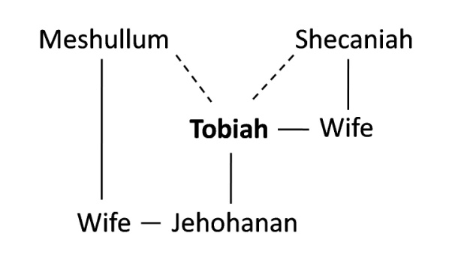
- Sadly, there were even those inside the walls who were not all as on board as Nehemiah was with separating from the world. The nobles of Judah were secret informers for Tobiah. Why did they do this? (Hint: ‘for’ in v.18 speaks volumes). What did it lead to?

- Is there a danger in us doing the same thing with others? Perhaps one verse that sums it up is ‘Do not be deceived: Evil company corrupts good habits’ (1Cor.15:33). Has this happened to you or someone you know? Share your experiences and how hard it was to still maintain obedience and faith to God.

Key Principle
Why have walls if you fraternize with the enemy outside? Why go to all the trouble? What was the point of the whole exercise in separating yourself from the enemies of the God of heaven if you make them your companions for life and marry them? This was like Judas – Psa.41:9; Lk.22:1-6,48. Nehemiah was put at risk and made incredibly vulnerable because of the carelessness and selfishness of those in the ecclesia who decided it was ok to be close to the enemies of the Truth. We can never underestimate the impact on the Truth that our bad relationships with the world could have. Our loyalties are divided and our focus is off. We must remember this no matter how tough life’s road is. God will provide what we need.

Section 12 – Renewal, Dedication and Reforms
Objective:
- Witness an ecclesia focusing not on its fear but on its faith
- See the power of God’s word on this teachable nation
- See the spiritual growth of the Jews in Jerusalem
- Understand the importance of covenants
- Feel the joy of the people celebrating the dedication of the wall!

“And at the same time some were appointed over the rooms of the storehouse for the offerings, the firstfruits, and the tithes, to gather into them from the fields of the cities the portions specified by the Law for the priests and Levites; for Judah rejoiced over the priests and Levites who ministered.” Nehemiah 12:44

Introduction
Nehemiah 8 is a beautiful chapter about brethren and sisters and anyone who can understand, reading God’s word. They listen carefully to Ezra read the law and then they obediently keep the Feast of Tabernacles – the best that they had kept ‘since the days of Joshua’! Nehemiah 8 is the foundation that Nehemiah 9 sits on – the confessional prayer of individuals who can now discern right from wrong. Take a brief look at Appendix J – Judah is reaping the benefits and blessings of God because of their or righteous choices and hard work! This prayer and the ensuing covenant occur directly after the reading of God’s law.

Ezra reads the Book of the Law of Moses
- In Neh.8, where does the reading take place? What is the significance of this? (Hint: Deut.32:2)

- Read v.3-6. How did the people approach God’s word and how can we adopt this attitude towards worshipping God?

- In v. 9-10, what happened when the people heard the word read and expounded? What’s the relevance to Hebrews 4:12-13?

Prayer of the people: Nehemiah 9
This prayer is very much like both Psalm 106 and Acts 7 – it recounts the general history of God’s chosen people. There are some great themes that we do well to trace in this prayer – it could help us keep our prayer life fresh as we speak with God about our life and the things that we are concerned about and amazed at. Fill in the main themes, as you see them from these verses:
Themes in the people’s prayer | Nehemiah 9
God’s greatness! | v.5-6,32
 | v.17,19,27,31,32
 | v.19-21,30
 | v.28,
 | v.33
 | v.33
 | v.16-18,26,28-30
 | v.32-37
 | v.38

- After reflecting on the main themes and the beauty of this prayer to God, list three major lessons you get out of this that will help you to serve God (there are plenty!). Go into detail.

Those who sealed the covenant
- What is a covenant? Name 2 covenants in scripture.

- From 10:1-27, who are the main groups of Jews who seal the covenant? Is this a pretty good representation of all the people? What does it mean to ‘seal’ the covenant?

Those who entered the covenant
- In vs.28-29, who else followed the lead of the group from vs.1-27? Why is this significant?

- It says here that the people ‘joined’ (NKJV) or ‘clave’ (KJV) unto their brethren. How could this word be better translated and where else is it used? Explain how this is a beautiful thing in the ecclesia. (Hint: Deut.11:8)

- Overall then, who initiated this covenant – God or the people? Historically, who initiated past covenants? What does this tell us about the people working with Nehemiah? Were things spiritually good or bad and why?

‘Be separate’
In the Bible, separation is used from the beginning to the end. Separation is something that God wants us to understand very well – what are we separating from? And what are we separating ourselves to? We will come back to this subject in Section 15 when we see all the different ways separation to God can be critical.
- The classic separation passage is 2 Cor.6:11-18 – ‘be separate’. There is something stopping the Corinthians from opening their hearts wide to Paul and others in the Truth – ‘your own affections’ (v.12). What is the context of this chapter? Paul says they are ‘restricted’ – what does this word mean and how do our ‘affections’ do that to us?

- Paul admonishes them sharply in v.14-18. This goes through EXACTLY what the people in Nehemiah’s time were doing! What is the lesson Paul is trying to teach here?

The Covenant’s Details
Fill in what the details of the covenant were, as well as how they broke it later on in Nehemiah 13:
Neh.10 | Detail | Law of Moses | Covenant broken…
v.29 |  | Deut.30:15 (ch.28-29)
v.29 |  | Deut.5:1,32
v.30 |  | Ex.34:11-16; Deut.7:3
v.31 |  | Ex.12:16; 20:8-11
v.31 |  | Ex.23:10-11; Lev.25:4-7
v.31 |  | Deut.15:1-3, 7-9 | Broken earlier in Ezra 5:3-5
v.32 |  | Ex.30:11-16 | X
v.34 |  | Lev.6:12-13; Josh.9:27
v.35-37 |  | Lev.27:30-34; Num.18:23-32; Deut.12:17-19; 14:22-28
v.38-39 |  | Num.18:26-28

The Purpose of a Covenant
- Thought Question: We need to answer the question posed in this last section – what is the purpose of a covenant if all we do is break it? Using your knowledge of God’s word, counsel from others, or any other source you can think of, answer this question to the best of your ability. This question has many different answers which could all lead to profitable discussion. As you answer this question, jot down practical ways to help you keep your covenant to God (if you are baptized) or practical ways to start keeping a covenant to God (if you are unbaptized).

The dedication of the wall – the desire accomplished
In Nehemiah 12, there was joy inside the completed walls, while on the ‘other side of the tracks’, the enemies of the Jews heard the ‘joy of Jerusalem… afar off’ (12:43). God had allowed the Jews to do what they had thought impossible, until His messenger, Nehemiah had challenged them. ‘Come, let us arise and build’ had cut through their complacent lives and jolted them into spiritual growth and physical action. All the while, it was the Lord who watched over them, who made sure that they were protected from their enemies at their most vulnerable moments.
- Now that the walls were completed in Nehemiah 6, what had the Jews inside the wall been able to concentrate on in Nehemiah 7-11? Take a look at the Appendix J. After viewing this chart and seeing the progression of the ecclesia, write some thoughts on what the walls accomplished spiritually.

- Discuss how you see this as an analogy to the spiritual growth and development of a believer in general. Use scripture to support your answer.

Thanksgiving Choirs
And so from 12:31-42 we have the procedure of how the 2 thanksgiving choirs worked as they started out in opposite directions about the walls of Jerusalem and then met near the Temple mount.
- Choirs are very important in scripture because of the way they can reach God in a very special way. Find 2 choirs and explain the context of when they sang and why. (Hint: 1Chron.16:4-42 could be one of them but you can find them throughout scripture – even in Revelation)

It can be a little confusing how the procession moved around the walls. They are doing, in ceremony, what was instructed by the sons of Korah in Psa.48:12-14 – ‘Walk about Zion, and go all around her. Count her towers; mark well her bulwarks; consider her palaces; that you may tell it to the generation following!’

At the House of God
‘I rejoiced with those who said to me, ‘Let us go to the house of the Lord’’ (Psalm 122:1). This Psalm was probably another one that was on the lips of those two thanksgiving choirs as they met at the house of God to ‘sing loudly’ as v.42 says, or as might be a better translation, ‘made their voice to be heard’! Jerusalem was now a ‘city compacted together’ as Psa.122:3 says – the best proof of that was that one could walk ALL the way around it on top of the wall, without ONE breach!
- In 12:43, who was there at the Temple? What did they do once they got there?

- Contrast this chapter with Ezra 3:13, when the Temple foundation had been laid. Based on this and any other evidence you have, would you say the ecclesia has grown spiritually?

- Based on all that we have learned so far or anything you have seen in your own ecclesia, what really helps an ecclesia grow spiritually?

Rejoicing over the Priests and Levites
It could be argued that Nehemiah 12:44-47 chronicles the pinnacle of spirituality in the nation of Nehemiah’s day. ‘At the same time’ as the rejoicing with great joy was going on, at the same time that they were offering ‘great sacrifices’, the religious structure of Judah was being built – to LAST.
- List the things that were reinstituted to encourage permanent change in Judah in vs.44-47. Explain why each of them is important (we will talk more about tithing in the next section, but feel free to share whatever you want to here).

Key Principle
At the end of Nehemiah 12, what is the tenor of the ecclesia? Fired up? Clicking? Firing on all cylinders? Spiritually motivated? Thankful? Diligent? United by love? Centered on God? Dedicated to Him? All these and more! How did they get there? Well, that’s easy to see now that we’ve covered the rest of Nehemiah! Through a LONG and hard journey they had come to a point of spiritual growth and maturity where they were working side by side to bring God glory and rejoice together in the Lord. EVERY major part of the ecclesia was working. Were they doing things for the right reasons? Absolutely! Were they perfect? Of course not! Were they moving with momentum in the right direction? Without a doubt! Was the Lord on their side? V.43 states that it was HIM that caused them to rejoice with great joy! Would you like to be a part of this ecclesia? We would! But unfortunately, some underlying weaknesses in this ecclesia once again manifest themselves when Nehemiah, the great leader of these reforms, goes back to Persia for an unknown reason. ‘When the son of man comes (back), will he find faith on the earth?’ We shall see in our next section.

Section 13 – Principles of Separation
Objective:
- Understand separation in a positive way and as God’s idea
- See the difficulties of not separating
- Learn what to separate from in order to draw near God
- Learn to ask God to remember us for good!

“Did not Solomon king of Israel sin by these things? Yet among many nations there was no king like him, who was beloved of his God; and God made him king over all Israel. Nevertheless pagan women caused even him to sin.”

Nehemiah 12:44

Introduction
We have come to the last part of our workbook. Like the chapters of real lives, the book of Nehemiah wraps up rather abruptly, without a ‘fairytale’ ending. If the book was to close after Nehemiah 12, we would all be smiling and feeling rather chuffed. However, God, in His infinite wisdom, made sure that Nehemiah 13, a chapter all about the principles of separation, was included. After reading it, we may scratch our head, wondering if spiritual growth can really be sustained… if perhaps there are dangers in relying too heavily on men in our ecclesia like Nehemiah… wondering HOW an ecclesia could slip into so many problems after such high spiritual ground was covered! Hopefully by the end, although we may not feel satisfied in loose ends that are left hanging, we feel the need to rely on God’s word and His strength in our lives to persevere, no matter the highs or lows in our lives or in the lives of others. And hopefully, after finishing this book, our prayer, along with Nehemiah, is that our Father in heaven will remember us - for GOOD!

Separation© is God’s idea
Before we get into Nehemiah 13, we need to discuss separation overall.
- Using verses, define what godly separation is. (Hint: 2Tim.2:22 could be helpful to start you off)

- When we look at Ezra and Nehemiah, we see separation EVERYWHERE if we just review some of the key verses. It is a HUGE theme within these books. Find at least 4 ways that we see separation in these two books. What were they separating from? Spiritually was it a good thing?

Tobiah the splinter
- In 13:4, a character comes up that we have not looked at since the building of the wall in Neh.3 – Eliashib, the High Priest. Define what the role of the high priest was as God intended it to be and provide scripture to back up your answer. (Hint: stuck? Lev.21; Mal.2:7 are key but there are many more!)

So then, we should see Eliashib popping up all over the record just like the High Priest Jeshua in the book of Ezra…right? But we don’t…. he’s nowhere to be seen or heard from. Where is Eliashib the High Priest during Ezra’s reading of God’s law? Where is he when the Levites led in the national confession of the people? Where is he when the most prominent leaders sign and seal the covenant to be pure and obey God’s laws in spirit and in word? Where is he when the dedication of the wall is occurring and all of Jerusalem is shouting for joy? His spiritual leadership is not mentioned and his representing the people to God is not alluded to – ANYWHERE! Most incredible of all is that the record is absolutely silent about Eliashib at the moment when he was needed most – when the people would have sought the law from his mouth in Nehemiah 8! Where is he when he should have represented God’s holiness and taught the people about the God who he was privileged to meet in the Most Holy? All that we know about him is his close connections to Tobiah in v.5, and that his grandson had married the daughter of Sanballat (v.28)!
- In v.4 what does the word ‘alliance’ mean and in what other situations is it used? (Hint: Lev.25:25; Ruth 2:20).

- In light of what we’ve already looked at in 2 Cor.6:14 is it possible to maintain this kind of an ‘alliance’ and still function on all spiritual cylinders in the Truth? Explain the relevance of Hos.7:8-11 to this situation.

- Please explain (without getting too angry) what Eliashib had ‘prepared’ for Tobiah in Neh.13:5. Contrast this with what OUR God has ‘prepared’ for us from the foundation of the world – Matt.25:34; 1Cor.2:9.

- What had been taken out of the Temple to accommodate Tobiah’s stuff? Explain the significance of this (Hint: 1Kings 7:51):

- In v.8 we have Nehemiah’s response. It grieved him bitterly. Not just grieved but ‘bitterly’! The word means ‘vehemently’ or ‘intensely’. Why? Who else was grieved ‘bitterly’ in scripture? What’s the overall emotion that these individuals felt? (Hint: for starters, check out Gen.6:6; Mark 3:5)

- Have you ever felt like this over something that has occurred in your ecclesia or with your friends? What did you do about it? Was it a fleshly response or a spiritual one?

- In v.9 what does Nehemiah do after throwing out Tobiah’s stuff? Jesus provides a personal lesson about this in Matt.12:43-45. Explain the parable. What happened to this man in the end?

- The spiritual lessons come out strong when we look at 1Cor.3:16-17; 2Cor.6:19; 2Cor.6:16. What are these verses saying to you when we keep in mind what Nehemiah had just done at the Temple?

Key Principle
Have you cleaned out your temple lately? What things have you been working on to rid yourself of the unclean spirits? What are you identifying as things that make it easier for you to sin? Do you have an action plan for getting rid of these things in your life? They could be REAL objects like a computer that you have in your room which enables you to surf pornography, or romance novels that allow you to escape. It could be sinful thoughts, selfish habits or words that you speak.
And then the question is: what are you filling your temple with? The evil household stuff of Tobiah the adversary or the golden vessels of the sanctuary? With the deceitfulness of our hearts or the frankincense of the Levites? We want to fill our minds with God’s word and brim over the top with ways to combat our flesh and fill our bodies with thoughts of love, peace, joy, self-sacrifice for others, with an eye that looks to the future when God’s plan will be realized, with forgiveness on our lips, with a mind that daydreams of the kingdom and of doing God’s work every day. The whole idea of baptism and change is to ‘renew’ our minds.

Spiritual Decline sets in
Sin multiplies and creates a ripple effect, just as we saw spiritual growth does between chapters 6 to 12. It may be helpful to refer to Appendix L for this section. Many of the pieces of the ecclesia that had been worked on and sweated over were falling apart while Nehemiah was absent. We know that after 12 years as governor in Judah, Nehemiah was recalled to Shushan by king Artaxerxes. We do not know why. The problems in Judah did not start while Nehemiah was away – they were probably issues that families faced during the week, that they were able to hide from the ecclesia… a little alliance with the world here, a little disobeying of the law of the Sabbath there. A little compromise here, a little smile at the dedication of the wall there. But however it went down, we know that one of the lynch pins of the whole spiritual machinery of Judah during the time from Mount Sinai until Nehemiah was the tithing of the people to the Levites and from the Levites to the priests.
- What does Nehemiah 10:32-39 have to do with Neh.13:10-13?

- Because the Levites had no land to cultivate and grow crops on, they were incredibly vulnerable. They could not do their job of teaching the people about God if they were busy planting and harvesting crops – hence the tithe. In Deut.14:29; 26:12-13, who were the Levites lumped in with? Why do you think this was?

- Malachi is almost certainly contemporary with this time period. What did he accuse the Jews of in Malachi 3:8? Although these tithes literally kept the Levites alive, who REALLY owned them?

The principle of the tithe was that God actually possessed EVERYTHING you had. But because he was merciful and caring, he only expected 10% of what you owned to be given to him – as a representative of the whole. When you brought your tithe to the priests and Levites, you were saying, ‘God, you own everything that I have – here is 10% to acknowledge that.’
Nehemiah remedied the problem by putting faithful men in charge of collecting, storing and distributing the tithes from Judah to the Levites. And with the spiritual foundation back in place, the nation was on the right track to recovery.

Intermarriage – again
As Nehemiah is closing his chapter on separation, the problem of intermarriage with foreigners comes up again. We saw that Ezra had to deal with it in Ezra 9-10. They decided that putting away their foreign wives was the right course of action.
In Neh.13:23-28, the details are given of these intermarriages. We are going to cover some ground work before dealing with this section, to establish a greater understanding of marriage, being yoked with the world (a theme that keeps popping up throughout our studies) and the importance of a ‘godly seed.’ (Hint: Appendix M has a lot of information – and many of the answers to the questions below!)
- Was it wrong to be joined to the abominations of the nations around them? (Hint: Lev.18). Are God’s commandments in this chapter ambiguous or straightforward?

- Since we know how you answered above (yes, it was a loaded question – our apologies), why then are there exceptions in scripture about gentile people being included in Israel, even MARRIED to the Jews? Rahab? Ruth? This is critical to answer so spend some time on this one!

- What was God’s goal in marriage according to Mal.2:15? What was he looking for in a loving relationship between man and woman, from Adam and Eve to our time?

It would seem that the reason that God wants one man and one wife is because it is the best possibility and the most secure situation for them and their seed to manifest His glory – not two men, not two women, not one parent, not communal guardianship, but one husband with one wife, one mom and one father.
- So now we come back to Nehemiah 13:23-28. We see that we have a very similar situation Ezra 9. What was the outcome of the marriages outside of Judah? Comment on the language problem – what’s the big deal? What is the bigger picture?

- Nehemiah deals with those who intermarried differently than Ezra does. Why? (Hint: it may help to think about what had changed since Ezra’s day; Mal.2:12 in the NKJV might also help). What does this mean to you?

- In v.26, what example of marriage with unbelievers does Nehemiah use? Was it effective?

Key Principle
We have talked a lot about separation and living faith to God. We know there will be oppositions in our lives. That we can’t change. But what matters, and what God is looking at, is HOW we respond to these different oppositions and oppressions from within and without. Everyone who has loved God has struggled with this. God reassures us and tells us there is something that we will NEVER be separated from in Romans 8:31-39 – we do well to think on these verses as we live our lives wholeheartedly to our loving Father!

‘Remember me, O my God, for good’
Nehemiah chooses to end his book with these words.
- If Nehemiah is asking God to remember him, what can we assume about Nehemiah’s belief in the resurrection?

- Do we ask God to remember us? Before we answer, we may want to ask this question first: How can we, as sinners and transgressors, ask God to remember us? (Hint: it may help to think of the different attitudes towards God, as displayed in the publican and the Pharisee in Lk.18:10-14 or understanding Hebrews 11:13-16)

In Luke 23:40-43 we come to a scene in a place near Jerusalem where the Savior is on a cross, in the last moments of his life after years of desiring to do God’s will and not His own. And he is there between two men – both thieves. The one thief understands that he is there because he deserves death since he has done something deserving it. He is not named, but we can see his heart in the exchange that he has with Jesus in these last few moments of their lives.
- What does the thief ask of Jesus?

- What is Jesus’ response?

- If Jesus promises to remember a thief when he returns to set up his ‘paradise’, can he remember you? The choice is yours.

REMEMBER US, O OUR GOD, FOR GOOD.
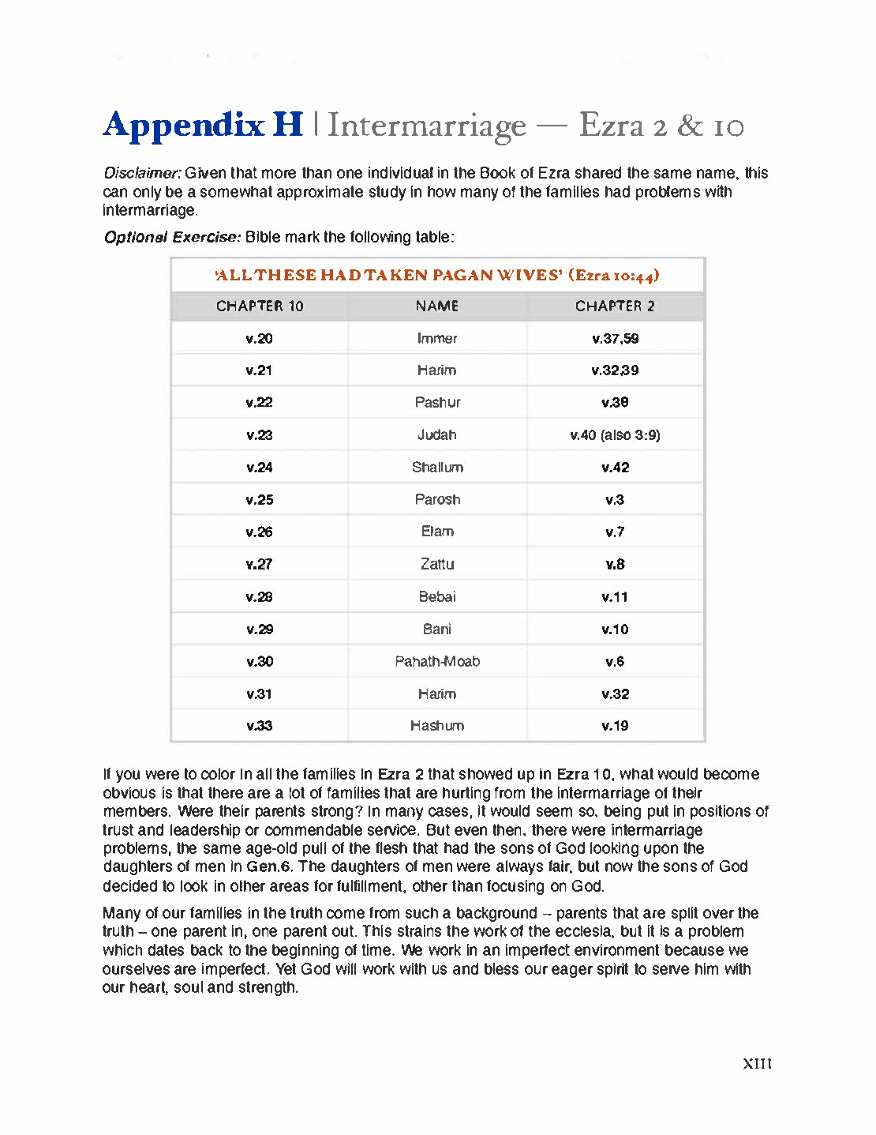
California Youth Conference 2013
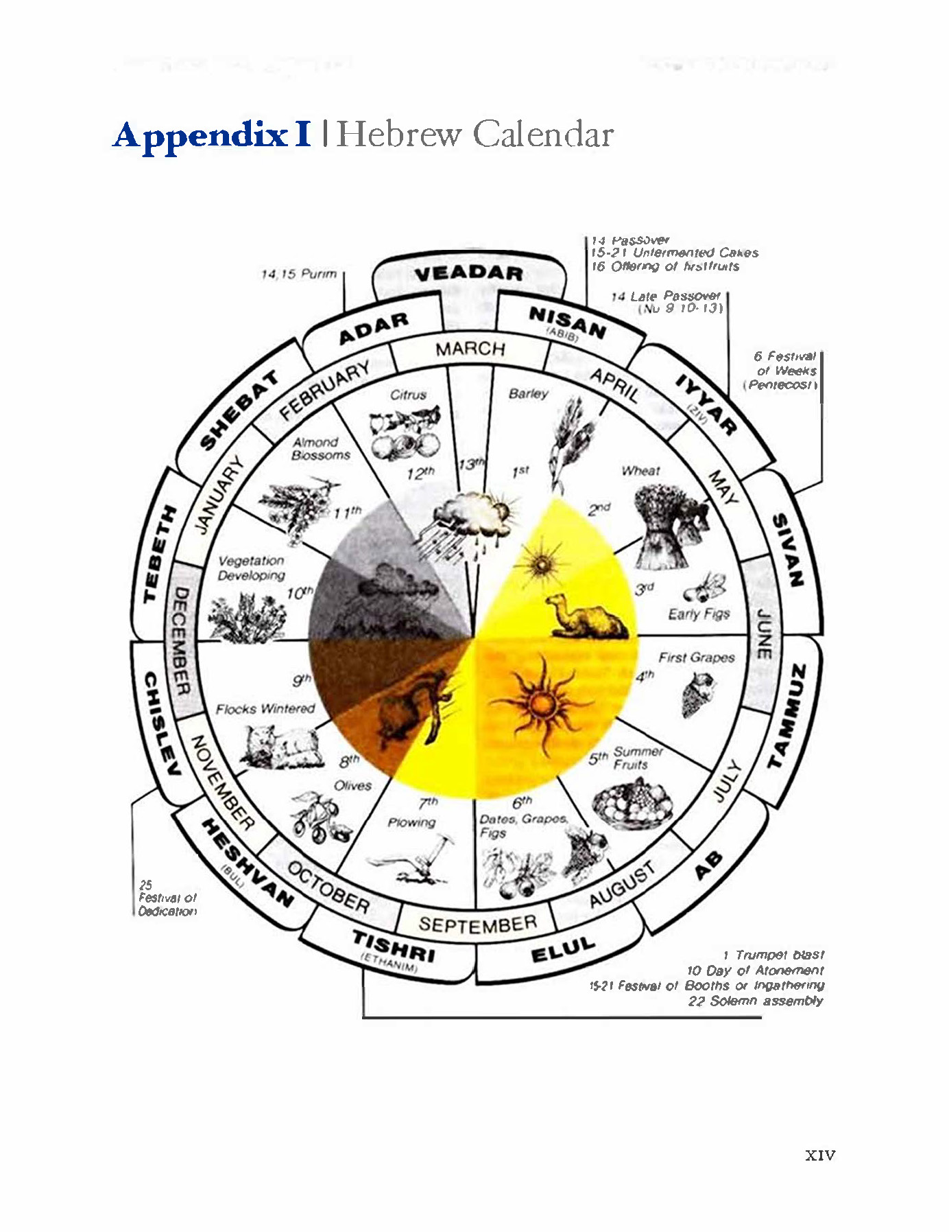
California Youth Conference 2013
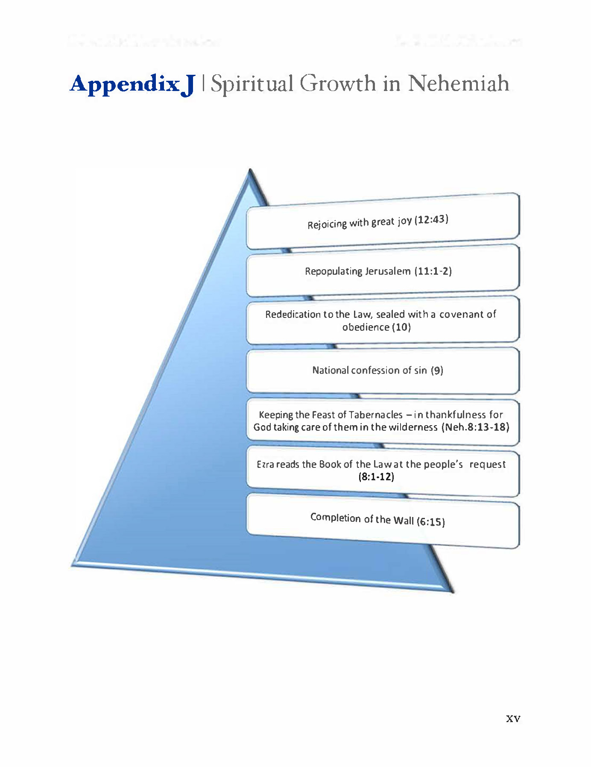
California Youth Conference 2013
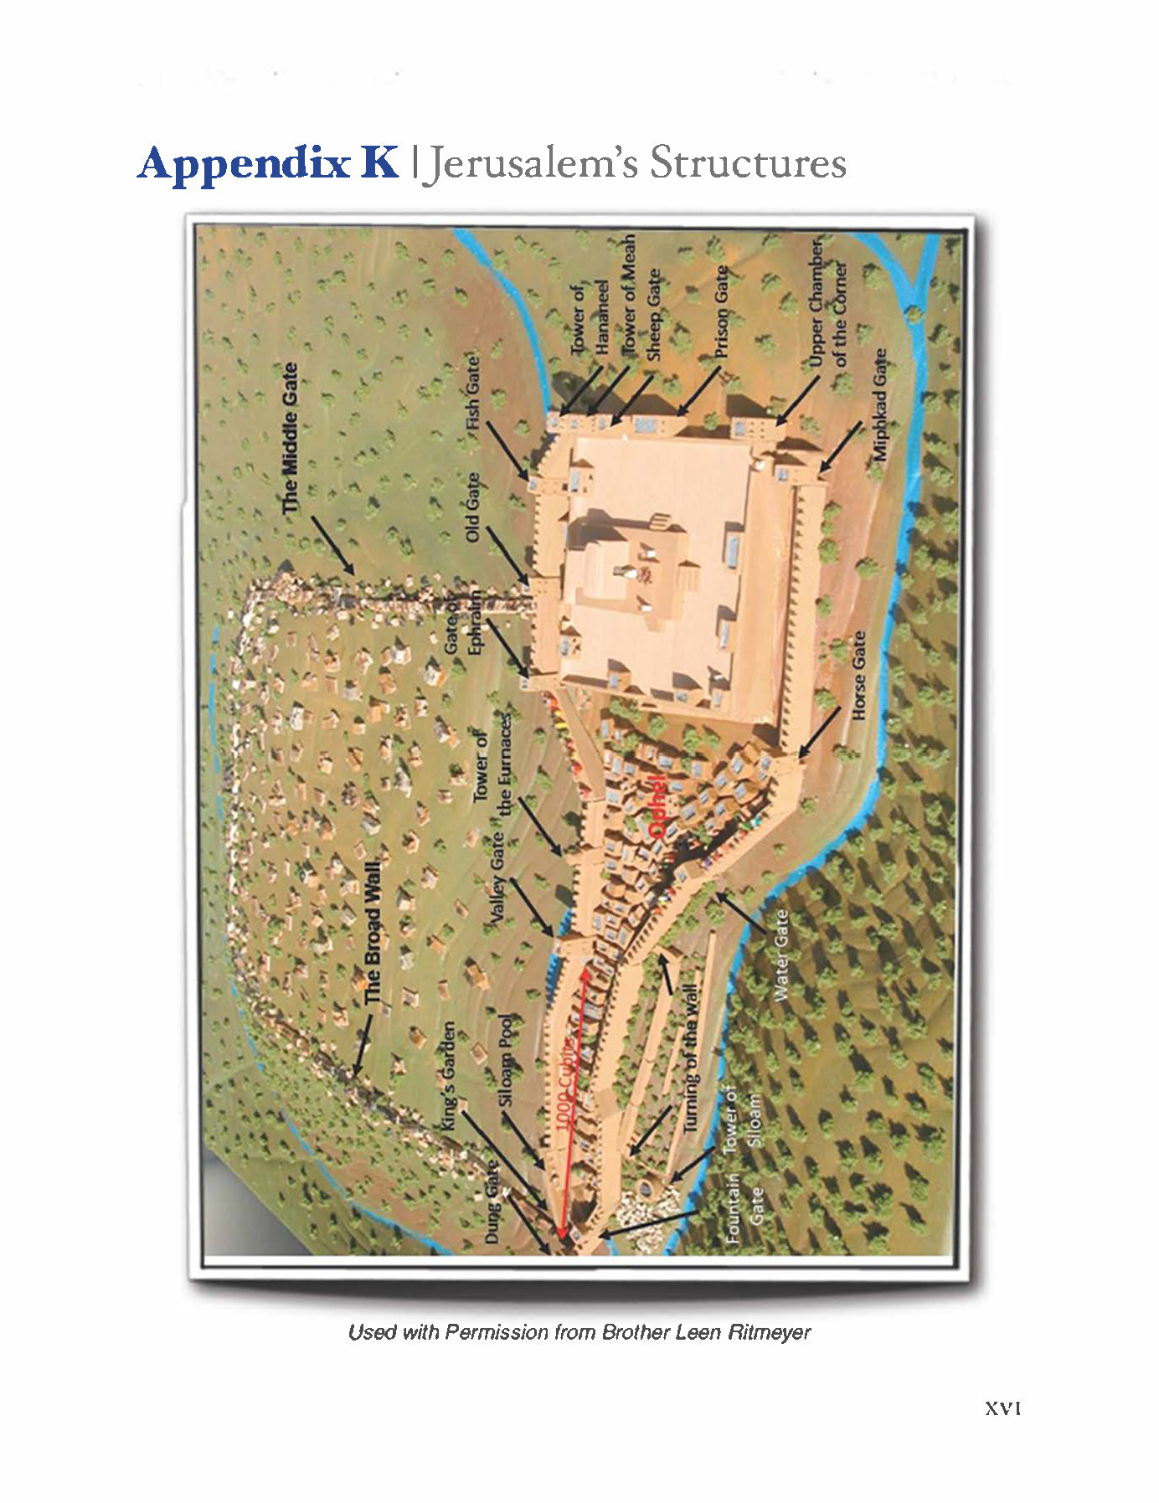
California Youth Conference 2013
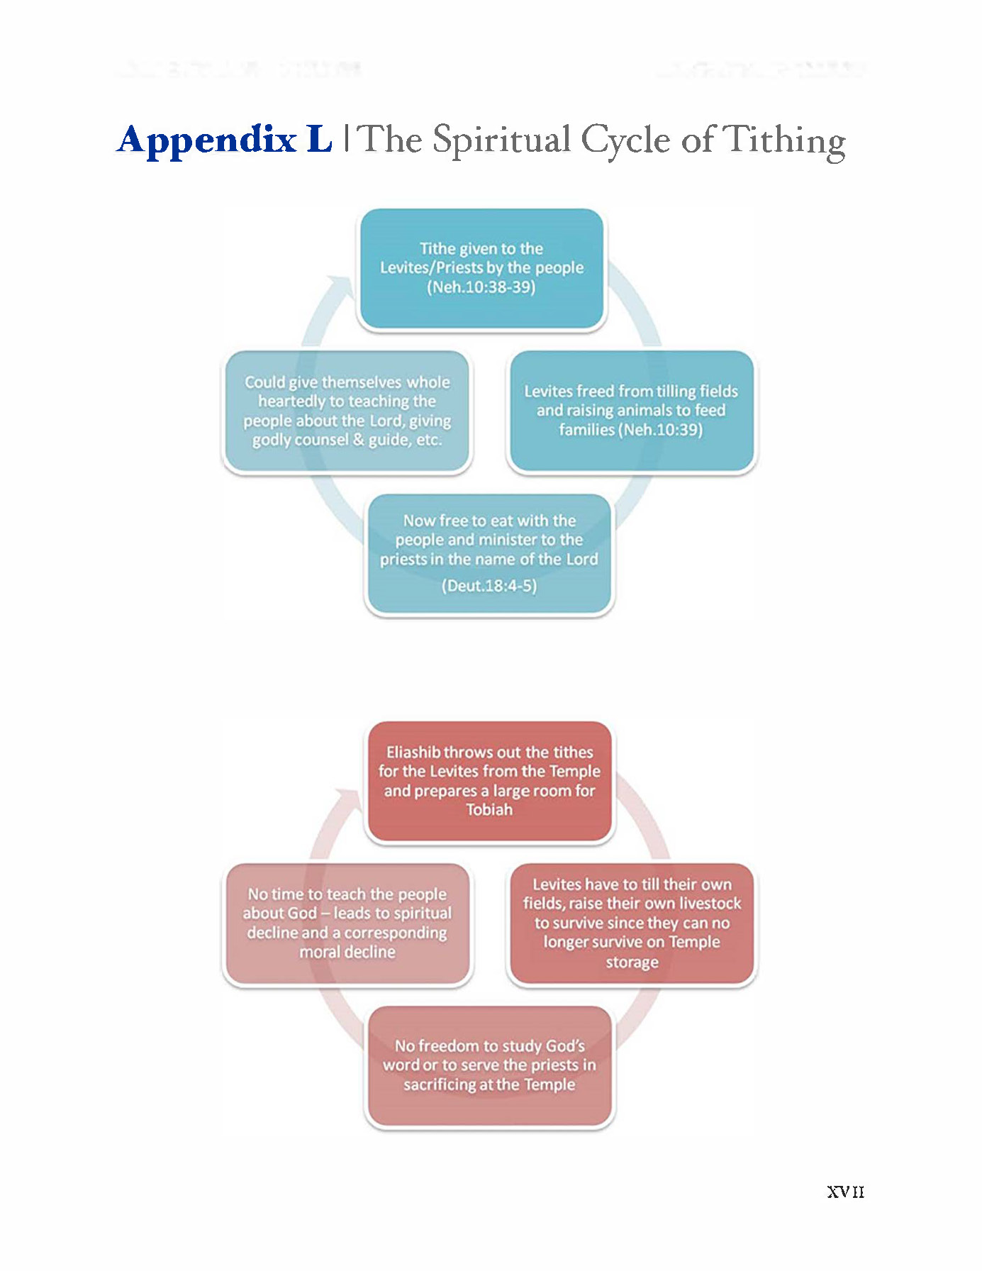
California Youth Conference 2013
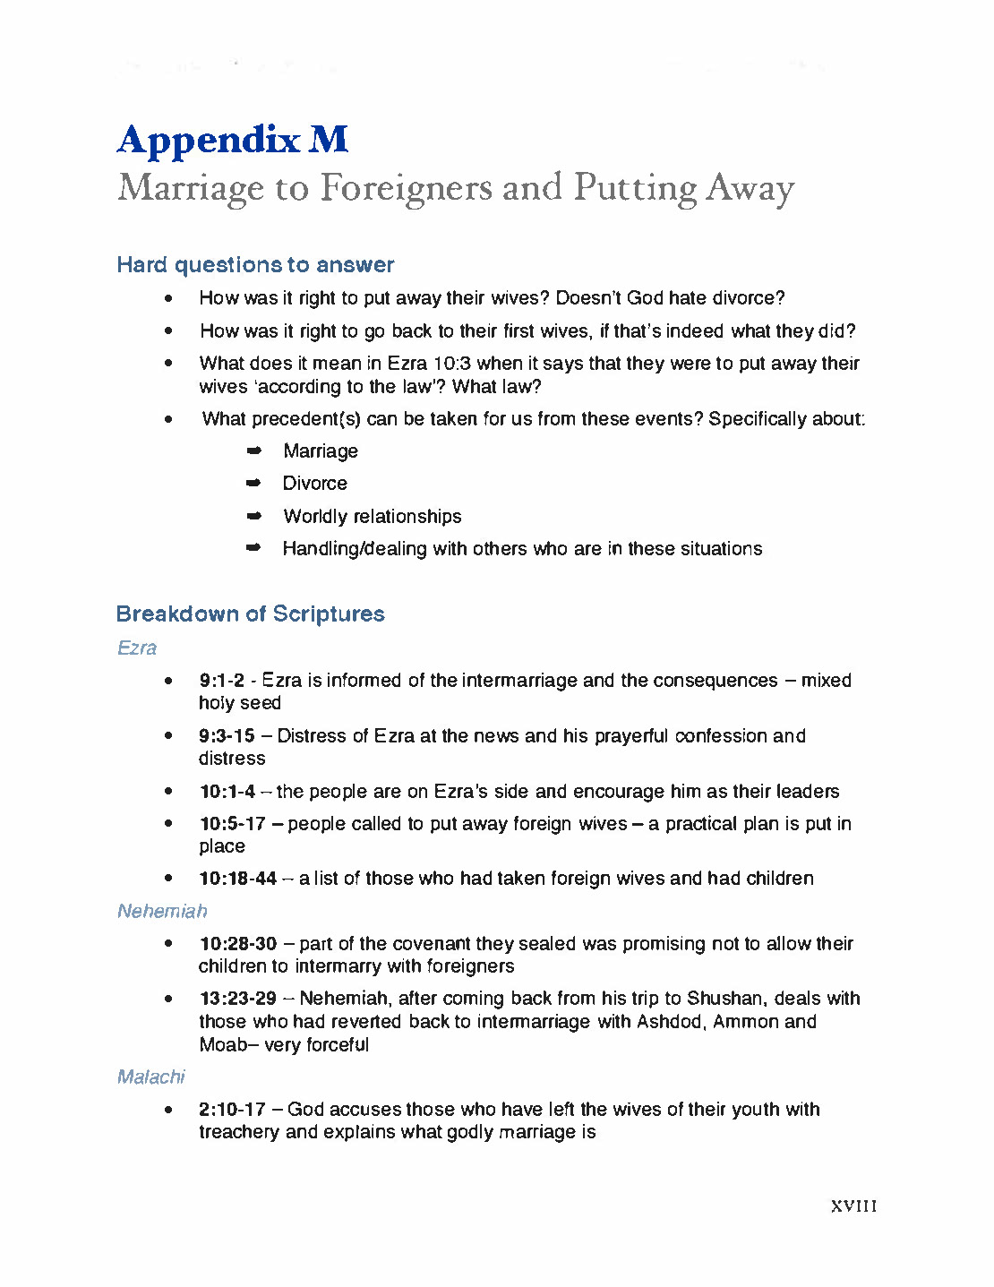
California Youth Conference 2013
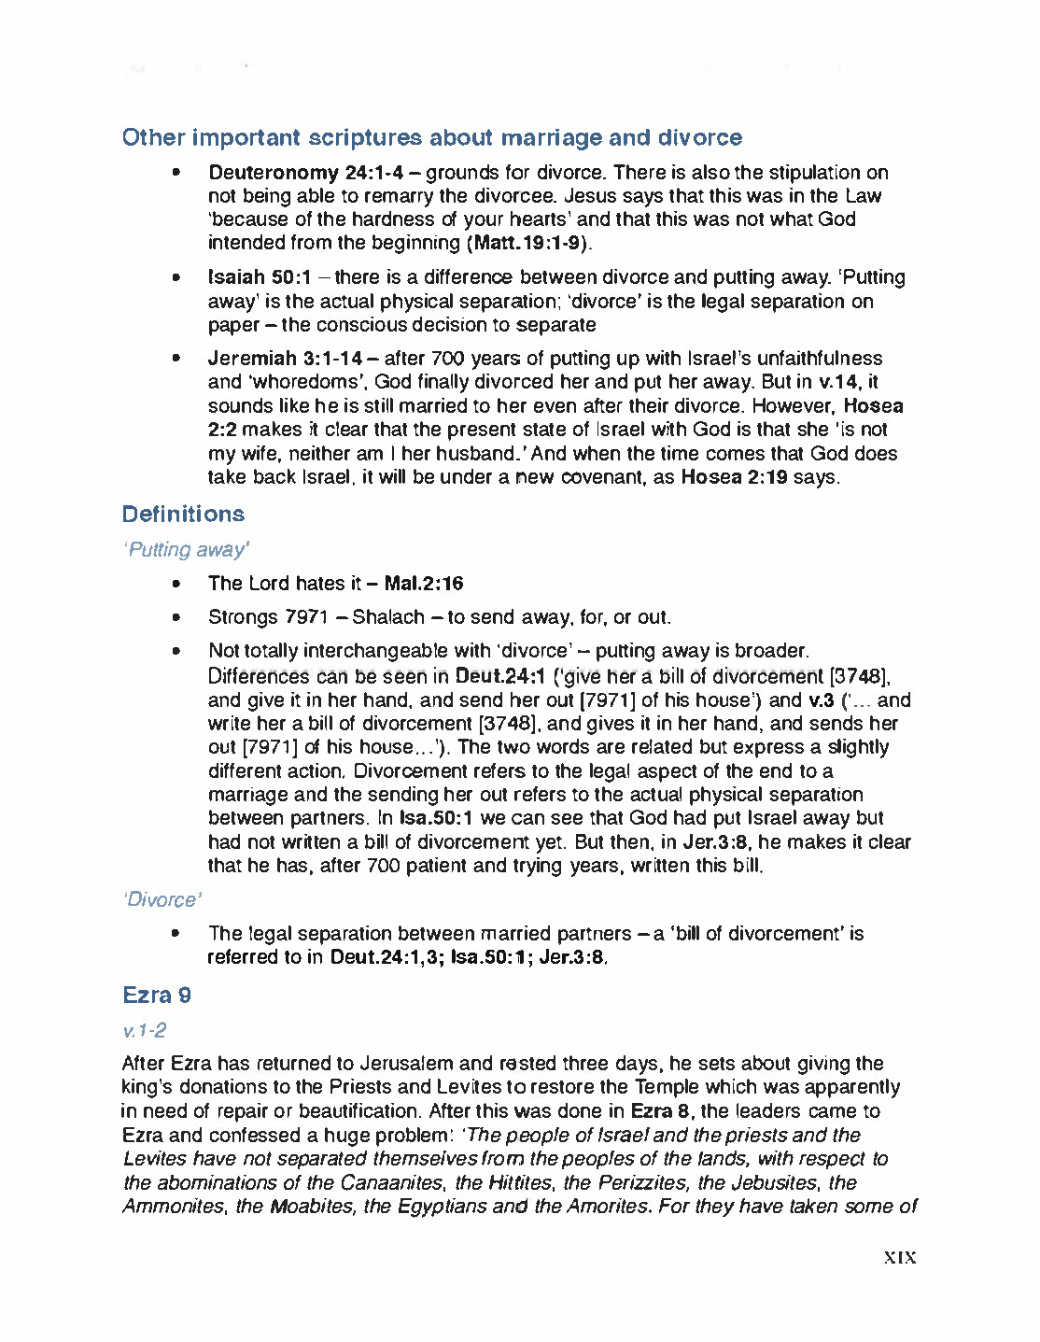
California Youth Conference 2013
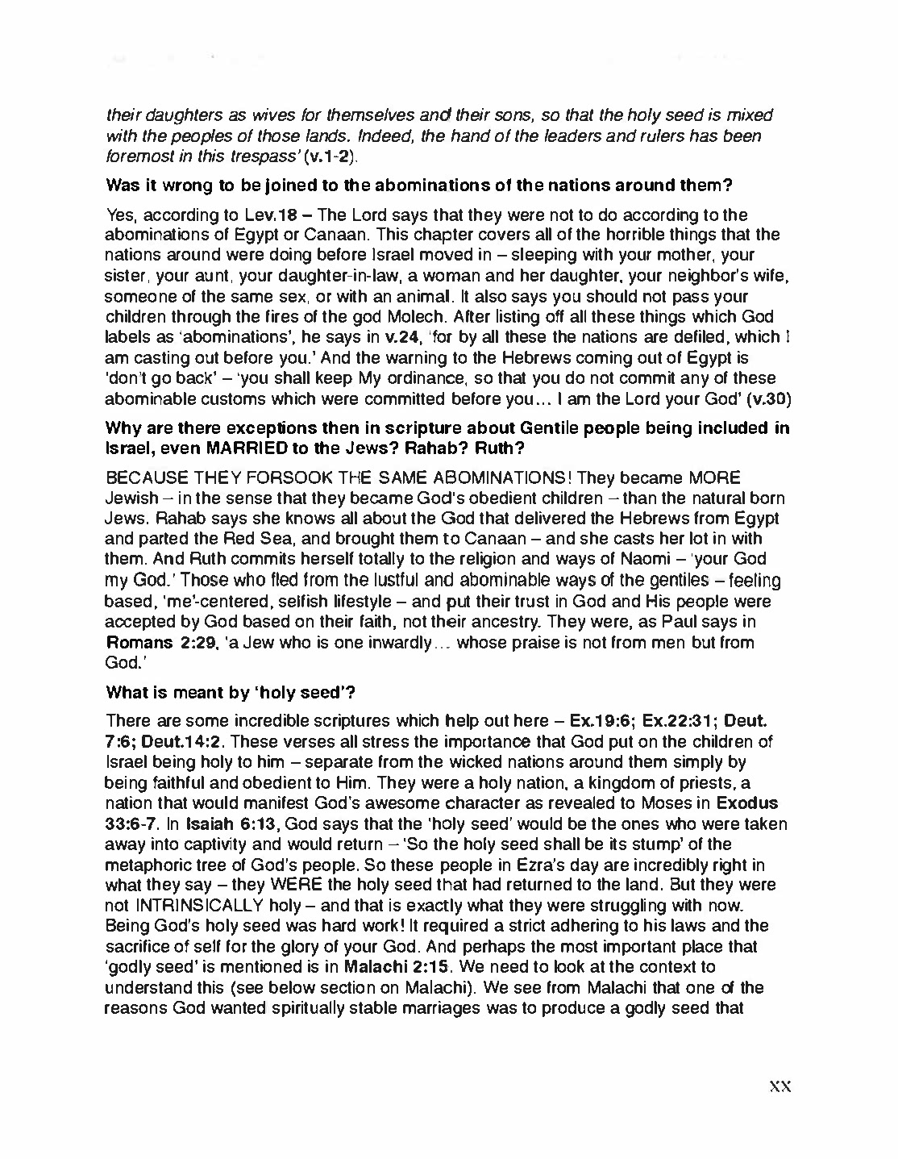
California Youth Conference 2013
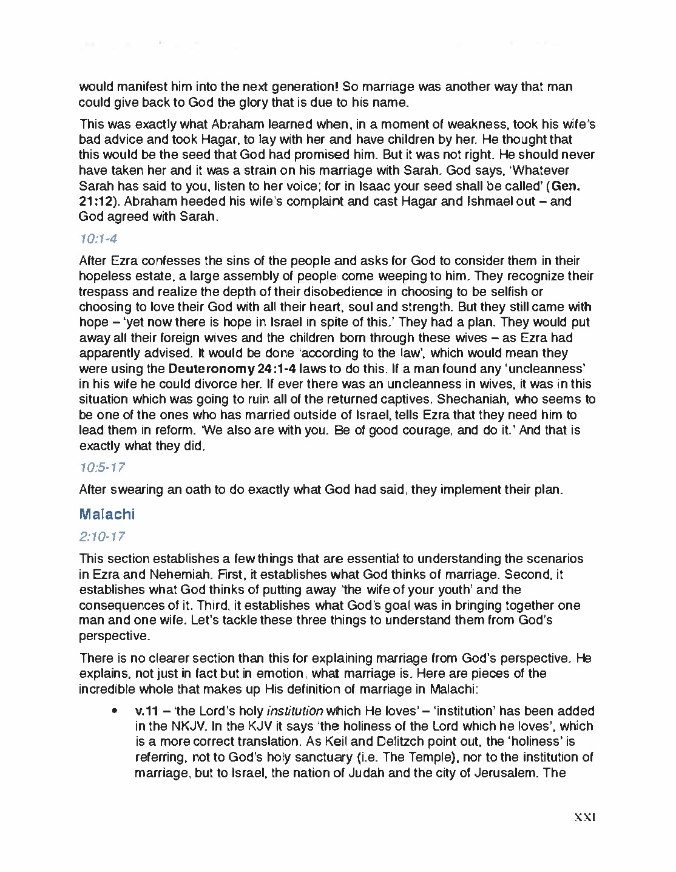
California Youth Conference 2013
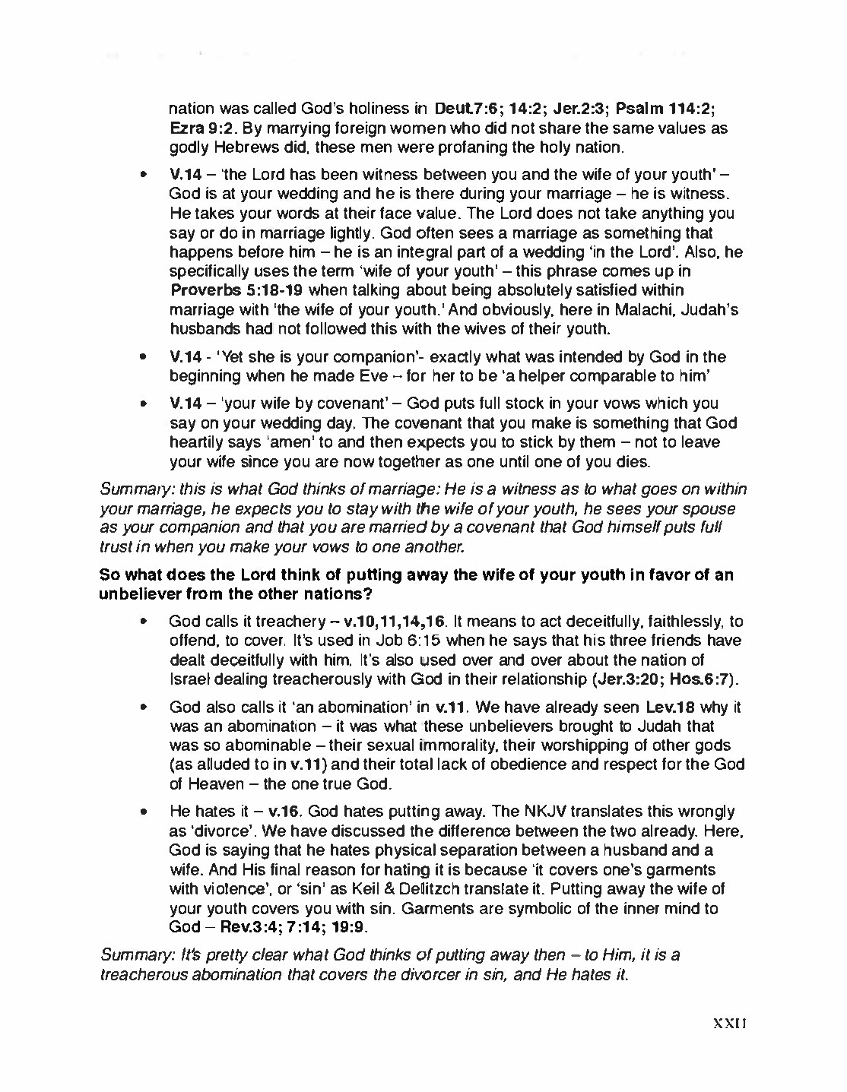
California Youth Conference 2013
California Youth Conference 2013
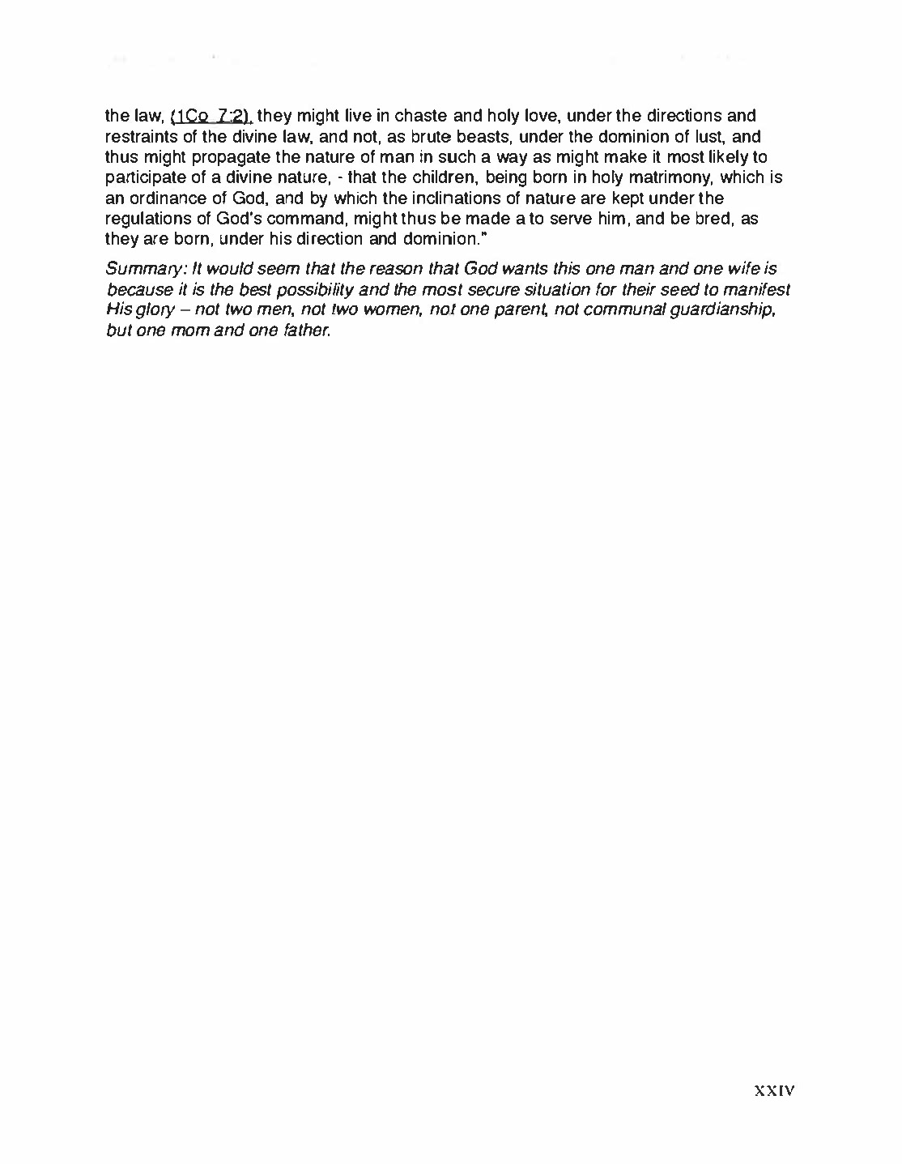
California Youth Conference 2013

